**Auction**

**Lake LBJ Marineland going out of business after 50 years.**

**F&F Auctioneers: 325-372-1717**

**Saturday – December 16, 2023 - 9 AM.**

**Item Inspection: Thur. Dec 14th & Fri. Dec. 15th – 12 p.m. to 6 p.m. & Sat. 8 a.m. to Auction Time.**

**Location: 13902 W Hwy 1431, Kingsland, TX 78639**

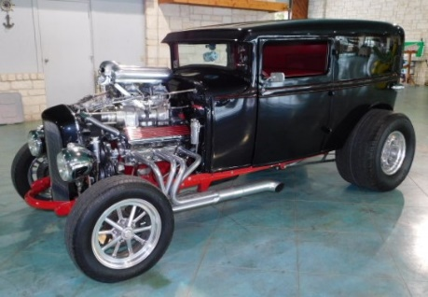**Vintage/Collectibles:** 1948 Chris Craft Vintage Boat - bought 8 years ago & has been used as a show piece since then. Running when parked. Trailer conveys with boat. Various collectible snow globes- numerous Disney globes.

**The Grim Reaper:** 1931 Ford with 383 Stroker engine. This car is titled and was featured in Hot Rod magazine at one time. We have a build book on the car. Call 325-372-1717 for more info.

**Trailers/Parts:** Various boat trailers - some titled, some not. Tires & Wheels. Trailer lights.

**Fishing & Boating Items Galore!** Many items new in the box. Marine Air Conditioning 16000 BTU (never used), Various types of lake floats, Numerous boat props (aluminum and stainless steel), Boat seats, Lights, iPod/MP3 systems, Speakers, Bowies, Assorted fishing tackle, Life jackets, Boat stands, 21 Walkways, 29 Sets of steps, Signs, Boat steering systems, Bimini tops, Oil, & Boat cleaning items. Parts for boat repair: too many to list them all!

**Home/Office:** Office furniture, mini fridges, couches, safe, decorative items, coke machine, white acrylic free standing tub 67x31 ½ x23 (new in the box).

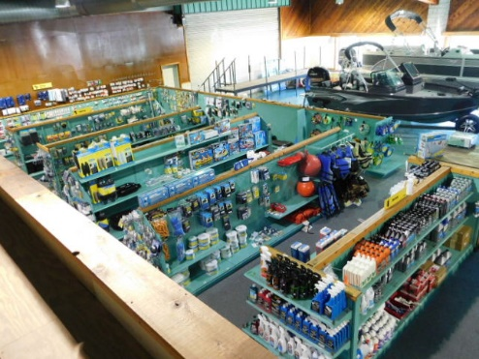**Misc:** Bolt Together Paint Room (Standard Tools and Equipment Co. with paperwork), Ingersoll-Rand 3 phase compressor, Multiple other compressors, 12’ garage door with chain hoist, Overhead Crains, 8) 55-gallon drums of red diesel, 55-gallon drum tan gel coat, MEKP catalyst, Hundreds of feet of shelving- metal and wood, Tool box, Electrical box (new in box), Assorted tools; Multiple shop fans, Metal spin-the-wheel, Rope, Fire extinguishers, Arrowheads and more.

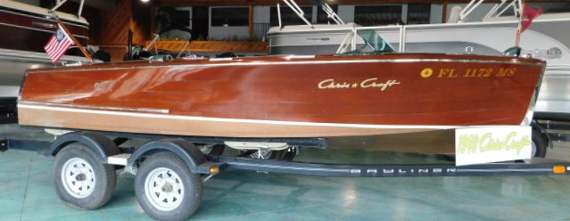**Too many items to list them all!** Online pre-bidding available on certain items at **fandfauctioneers.hibid.com**. Contact us to leave anabsentee bid!

Check us out on facebook: **F&F Auctioneers: David Fry**. Auction will be conducted simultaneously on both sides of Hwy 1431 thus contact us about leaving an absentee bid. Close parking is limited so come early. Auction will go on rain or shine. Limited concession onsite. David: 325-372-1717 Kayla: 325-372-1716

**TERMS/CONDITIONS:** All Items Are Sold As Is Where Is Without Warranty Or Guarantee. Any announcements made auction day shall take precedents over any previous printed material or announcements. Complete payment due on day of sale. Must have current Texas tax or resale number on file for tax exemption prior to opening of sale. Buyer’s premium $0-2K 10%; $2000.01-10K 5%; $10000.01+ 3%. Online pre-bidding plus 3% on buyer’s premium. There will be a 3% processing fee on all debit/credit cards. David Fry TX License # 17647. Edward Forehand TX Associate TX License # 17802.