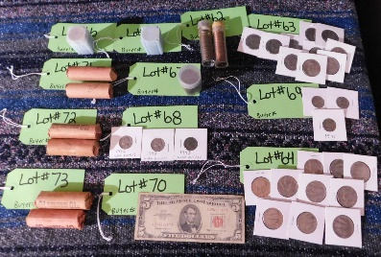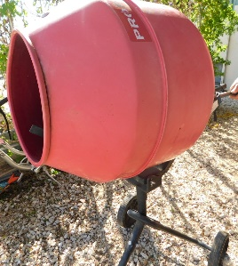**Estate Auction**

**F&F Auctioneers: 325-372-1717**

**Saturday – October 29, 2022 -10 AM.**

**Item Inspection: Fri. October 28th – 12 p.m. to 6 p.m. & Sat. 8 a.m. to Auction Time.**

**Location: 16028 S Hwy 16, Cherokee, TX 76832**

**Firearms:** Browning 20 Ga Over & Under; Stevens 410 Model 94C; Ruger 10/22 (new in box); Ruger MK III Hunter w/ 6 clips; Ruger 357 New Model Blackhawk; Ruger22 Single Six w/ magnum cylinder; VR82 RIA Imports 20 Ga w/ 6 clips (new in box); CO2 BB gun pistol. Browning hi power; HK P7; Ruger #1 7mm; Sako finnlight; .300 WSM; Remington model 58 sportsman; Remington 700 tactical 223 bull barrel; Ruger 10/22 bull barrel with 3 scope dials for bullet weights; Springfield Model 1903 30-06; Springfield model 1903 .22 trainer; Multiple shotguns. **Ammo:** 38 special; 357; 22 LR; 20 Ga; 410. **Vehicle:** 1989 GMC 1500 Truck SLE Sierra.

**Equipment/Tools:** 1991 Case Skid Steer, cummings powered with foam filled tires; 1976 Mahindra 450 2 wd with new tires; Spreader; Post hole digger; Shredder; Gandy seeder; Tiller; Plow; 5 ft Disc; T-post driver; Extension cords; Trowels; Measuring tapes/rolls; Wood clamps; Quick grips; 4-way lug wrenches; Slide in hitches; Levels; Pry Bars; Milwaukee work stand w/ rollers; C-Clamps; Slap stapler; Assorted drill bits; Electrical tester; Ridgid electrical sewer snake; Transit stand & stick; Joist hangers; Draw bar; Pear burners; Electric drills; Palm sanders; Milwaukee handheld band saw; Dewalt metal nibblers; Milwaukee multi-bay charger; Poter cable 20V sander pack- charger & batteries; air hose; angle grinders; Hitachi chop saw with laser; multiple chain saws; Echo & STIHL hand held blowers; Senco air compressors; jack stands; Wheel scotches; greese guns; Brail floor blower; Floor jack (aluminum frame); Milwaukee Angle head drill; Apollo Pex 3/8-1” crimper; Porter cable router (practically new) & bits; Pro series jump box; Bosch jigsaw; Hilti Ram set; Electric stapler; Porter cable plate joiner; Senco Finish stapler (practically new); Roto zip; Bosch battery powered cordless hammer; Senco battery powered nail gun; Senco stapler; Du-Fast stapler; Bostitch brad nailer; Husky air compressor & tile saw; DeWalt Table saw; Torin Big Red Jacks parts washer; ProForce cement mixer; Craftsman jigsaw/saber saw, 19.2 V drill set, 10 in. table saw, & mitar saw; Numerous battery powered drills; Assorted wrenches, sockets, hand tools, air tools & sockets, bench grinders, pipe wrenches, welding helmets, tool boxes & tools; battery chargers; drill doctor; DeWalt Chop saw; Pole saw; BlueHawk router, table & bits; Hammer drill w/ bits; Senco Brad nailer; Coil Roofing nailer; Milwaukee angle drill & bandsaws; Ridgid scroll saw; Torch hose & gauges; Blower, Weed eater; Sprayer; Assorted hand tools.

**Misc Items:** Stacyc 12-in bike with battery & charger; Copper tubing; Folding tables; Assorted oil, car cleaning items, subfloor lock tight caulk; Push mower; Orange plastic netting; Floor box (electrical) kit; Quick-fix window/door sealing tape; Aluminum ramps; Tailgator by Dish; Aluminum gas tank; Water Fountain; Calio bicycle; Chicken feeders & Waterers; dog feeders; Stanley propane heater; Bolt on jack stand; Boat motor engine stand; Assorted trailer wenches, hitch, jacks & steps; Sprayers; Lighted wooden mini saloon; Adjustable mud flaps; Oxygen & Acetylene bottles; Shop Vacs & lights; Electrical boxes & wire; 2 Burner cooker; Weed eaters; Small engine, Wood slab; Metal storage cabinet. **Outdoor:** Assorted rods, reels, & tackle; Trolling motor; Gun case; wicker chairs; yeti coolers; Outdoor paper towel holder; Outdoorsman Cooker; Hilsport gun mattress for a jeep; ATV gun racks; Napoleon gas fire place. **Household:** Electrical & plumbing items; Beef tanned cowhide; Surface mount fixture; Wardrobe lift; Under cabinet lights; Boot jacks (numerous, handmade, custom built); Ventilation fan with light & heater; U-Line Echelon ice maker; hanging light & kit; Water filter; Pro 14 foam dispensing gun; Danby Designer Mini fridges; Mop buckets & Mops; Cool box/ice chest; Ficus trees; Other Assorted/Various household items. **Coins/Currency:** Half Dollar pieces; Saskatchewan Dollars; War Nickels; Wheat Pennies; P-58 Pennies; $5 bill Red Seal; Bicentennial Quarters.

**Too many items to list them all!** Online pre-bidding available on certain items at **fandfauctioneers.hibid.com**. Contact us to leave anabsentee bid! Check us out on facebook: **F&F Auctioneers: David Fry**. Auction will go on rain or shine. Concession onsite.

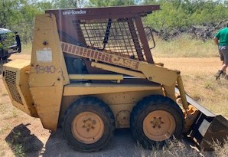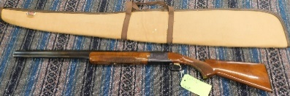David: 325-372-1717 Kayla: 325-372-1716

**TERMS/CONDITIONS:** All Items Are Sold As Is Where Is Without Warranty Or Guarantee. Any announcements made auction day shall take precedents over any previous printed material or announcements. Complete payment due on day of sale. Must have current Texas tax or resale number on file for tax exemption prior to opening of sale. Must be 18 yrs old to buy a rifle & 21 yrs old to buy a pistol. Out of state firearms buyers & those having it shipped will need to have a transfer via a Federal Firearms Dealer & background check. Buyer’s premium $0-2000.00 10%, $2000.01-10,000.00 5%, $10000.01+ 3%. Online pre-bidding plus 3% on buyer’s premium. There will be a 3% processing fee on all debit/credit cards. David Fry TX Lic # 17647. Edward Forehand TX Associate TX Lic # 17802.