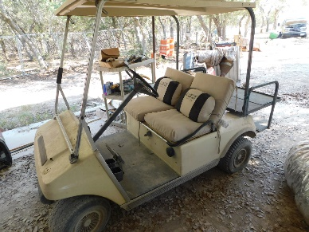
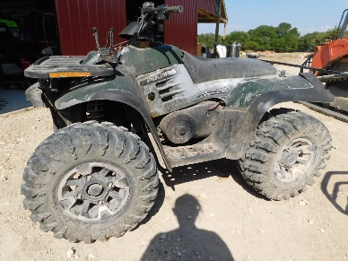
Living Estate Auction
F&F Auctioneers: 325-372-1717
Saturday – August 6, 2022 - 9 AM.
Item Inspection: Fri. August 5th – 12 p.m. to 6 p.m. & Sat. 8 a.m. to Auction Time.
Location: 411 Sunset Ridge, Blanco, TX 78606
Items with Wheels: E350 Super Duty V8 Box Truck (has title, was running when parked); 1987 Gas powered ClubCar golf cart; Polaris 330 four-wheeler (2WD, 4 stroke, New Tires); Craftsman 42” Riding mower; Briggs & Stratton rear tine tiller; 20’x7’ Cargo Trailer (bill of sale only, no title).
Equipment/Tools: John Deere Fertilizer/Spreader, Craftsman push mower pull start with bag (needs battery for electric start); Jet 1632 Sander; Delta Shop master dust collector; Jet planer & bandsaw; 3 phase Powermatic wood lathe; Delta Wood shaper & radial arm saw; Rockwell wood lathe 4 speed; Gasoline pile driver; Coats Tire Changing Machine; 275 gal. oil tank; 10’6” Tapco metal brake; Yates No. 2 ½ American R-2302 PTO driven molder; L.F. Seyfert’s Son’s Inc. 3 phase “ joiner; Sears & Roebuck Table saw; KNAACK roll around, locking, toolbox; Mastercool by Champion Cooler Evaporative cooler; Fork lift charger (Ferrocharger); various water storage tanks (300-550 gallons); 12 ton hydraulic pipe bender; Harbil 56-HD paint mixer; Metal chop saws; Assorted hand tools- palm sanders, miter boxes, , skill saws, Sawzall, DeWalt, Makita, Chicago electric and more; DeWalt laser level; Hilti hammer drill with accessories; Flooring saw; ram sets; CST/Berger transit; pneumatic nail guns; Belsaw blade sharpener; roll around tool carts; assorted electronics; Ashton Arc welder; cordless framing and finishing guns; tile saw; bench grinders; extension ladders; Assorted wood working & plumbing items; various nuts, bolts, spray paint & concrete anchors; 60 gal. electric air compressor; Cubcadet riding mower (needs some repair).
Electrical items: panel boxes, fittings, plug boxes, cover plates, wire, & more- too many items to list them all.
Misc: Wood (2”x6”; 2”x8” &2”x10”); Ice machine (working when disassembled); Assorted radio equipment; Decorative metal stand; Metal table; Drum sets including one 1964 Ludwig with xylging symbols; windows; potable AC; various scooters; semi tarp approximately 20’x50’; assorted tin & aluminum signs; approximately 300sq. ft of pecan flooring; assorted old longleaf wood; hickory wood; 9 bags of insulation; Wood feed shed/building (you are responsible for moving it); 16’ gate; Roll around laundry carts; various fencing material; Assorted shoulder mounts: dall sheep, mule deer, whitetail, pronghorn, moose, elk, angora, caribou, sheep.
Home Items: Assorted household items; vacuums, lamps; solar path lights; True refrigerator/cooler; Fuji camera; water keg; dehumidifier.
Antique: sleds (one from 1911), hay rake, kitchen items & meat slicer.
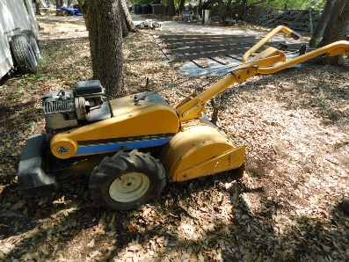
This is a partial listing - too many items to list them all!
Online pre-bidding available on certain items at fandfauctioneers.hibid.com.
Contact us to leave an absentee bid! Check us out on facebook:
F&F Auctioneers: David Fry. Auction will go on rain or shine. Concession onsite. David: 325-372-1717 Kayla: 325-372-1716
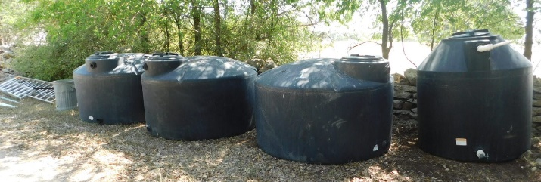
TERMS/CONDITIONS: All Items Are Sold As Is Where Is Without Warranty Or Guarantee. Any announcements made auction day shall take precedents over any previous printed material or announcements. Complete payment due on day of sale. Must have current Texas tax or resale number on file for tax exemption prior to opening of sale. Buyer’s premium $0-2000.00 10%, $2000.01-10,000.00 5%, $10000.01+ 3%. Online pre-bidding plus 3% on buyer’s premium. There will be a 3% processing fee on all debit/credit cards. David Fry TX Lic # 17647. Edward Forehand TX Associate TX Lic # 17802.

