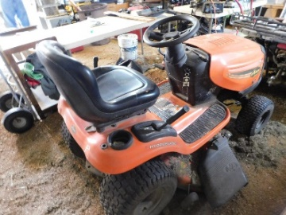**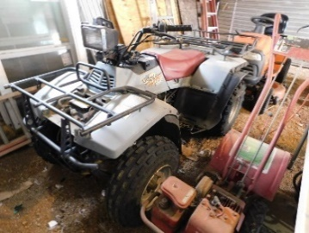Estate Auction**

**F&F Auctioneers: 325-372-1717**

**Saturday – May 15, 2021 -10 AM.**

**Item Inspection: Fri. May 14th – 12 p.m. to 6 p.m. & Sat. 8 a.m. to Auction Time.**

**Location: 1780 N Hwy 16, San Saba, TX 76877**

**Firearms/Reloading Equip.:** SR9C Ruger 9 mm pistol; T/C Compass .243 w/ Nikon 3-9 scope threaded for suppressor; T/C Compass 5.56 Nato/223 REM w/ Nikon 3-9 scope threaded for suppressor; 2) 4-10 Snake Charmers; Benjamin Pellet gun; Ithaca 20 Ga; Winchester .22 Model 06; Remington .22 Nylon Apache Black Diamond; Henry Arms .22 Survival; Smith & Wesson .38 Special 5 shot; S&W .38 Special + P; S&W .357 Pro series; Browning 20 Ga Pump; All firearms are in nice condition. Reloader & equipment: 3 die sets: 45-70, 30 Carb, .38 Special; 2 die sets: 270 Winchester; Lee universal shell holder; Universal hand priming tool; Primers; Bullets; Shell casings; Powder. **Ammo:** .22; .243; 22 mag; 22-250; .223; Winchester AA 12 Ga; 4-10; .357; .38 Special Round nose & JHP.

**Sporting Goods:** Fishing poles & tackle: several boxes’ w/ contents; Deer Feeders; Pop up blind; Single trees; Motor guide trolling motor; Sleeping bags; Cross bow; Arrows; Turkey decoys; Gun locker.

**Trailer:** 2006 12’x5’ bumper pull trailer- titled. **4-Wheeler:** Quad runner 250 (works).

**Equipment/Tools:** Gas powered generator; Air compressor w/ hose; Lincoln electric 225 ARC welder; Step & extension ladders; Numerous assorted hand tools; Hatachi nail gun w/ nails; Metal & wood chop saws; Radial arm saw; Bostitch coil nailer w/ nails; battery charger; Assorted Ryobi tools- drills, blower, saw, nailer & more; Multiple electric power tools- grinders, drills, reciprocating saws & more; Dewalt circular & table saw; Pressure washers; Saw horses; True power table saw; Metal break; Assorted painting items, air paint guns, electrical & plumbing items; Gas powered pole saw; High lift jack; Jack stands; Assorted extension cords; Laser level; Floor jack; Multiple hand tools- hammers, pry bars, c-clamps, vices & more; Portercable brad nailer; Transit; Bench grinders; Craftsman 10in Band saw; Cummings pro drill press; Saw blades; Dewalt radial arm saw; Hydraulic jack; Welding helmet & supplies; Jumper Cable- in box; Drop hitch & trailer balls; ½ in Craftsman drill; Tool belts; Tap & die set; Assorted individual & sets of wrenches, drill bits, Allen wrenches, screw drivers, socket sets, torque wrench.

**Lawn/Garden:** 42” Ariens Precision riding mower (works); Rear tine tiller; Sprayers; Troy- bilt tiller; Tomato cages; Fertilizer/seed spreader; Gas powered weed eaters; Wheelbarrow; Flower hanger; Chimenea; Swing; Ryobi Electric push mower w/ charger & battery.

**Misc.:** Assorted plywood; Wood & metal shelving; Dry wall panel hoist; BBQ pit; Folding table; Aluminum ramps; Hitches; Receivers; Stainless steel beverage cooler; ratchet straps; Truck box; Roll around pull cart; Trailer lights; Assorted metal; Toolboxes; Airless paint sprayer; 25 Gal propane bottle; Nuts, bolts, nails, staples; lock box; Roll around rack; Caulk; Multiple sizes shapes & colors of tile; Roll of plastic; Golf clubs; Shop vacs; Granite top 27”x16 ½”; Child’s rocking chair.

**Home Items:** 25+ Metal folding chairs; Multiple working window units; Amana washer; LG dryer; Canning jars; Electric Smoker; Pellet grill; Screen door; Assorted window screens; Hot plate; Silverware; Assorted lighting fixtures; Serving trays; 8 Mini Blinds in boxes (45” W x 25” L); Electric heater; Assorted door knobs; Shower only faucet in box; Trash bins; 15 Fluorescent 4 ft bulbs; King, Queen & 2 Full size bed frames; Dressers; Lamps; Bedside & Side tables; Yarn; Quilts; Pictures; Paintings; Frames; Curtains; Fan; Suitcase; Tea dispenser; Sheets; Trinkets & more; Office chairs; Roll around chair; Trunk; Sewing machine; Walker, Crutches; Champ top hat; Folding Chairs; Water jugs; Upright freezer; Chest freezer; Hide a bed couch; Computer; Lap top; Wicker shelving; Electric reclining chair; Kitchen table & 4 rolling chairs; Round table w/ 2 leaves & 6 chairs; Roll top desks; Fridges; Mini fridge; Stove; Misc. Kitchen items; Desks; Love seat; Rocking recliner; Tread mill; Singer stand, books, records; Granite top table; Mirrors; Grandfather clock; Numerous assorted household items.

**Collectibles/Antique:** U.S. Royal Farm Tires metal sign 9’11” x 35”; Metal trunk; Cabbage patch dolls; Coca-Cola shelf.

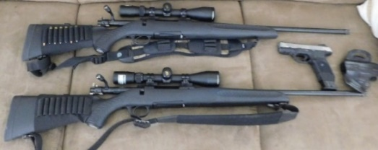This is a partial listing - too many items to list! Online pre-bidding available on certain items at fandfauctioneers.hibid.com. Contact us to leave anabsentee bid! Check us out on facebook:

**F&F Auctioneers: David Fry**. Auction will go on rain or shine. Concession onsite. **David**: 325-372-1717 **Kayla**: 325-372-1716

**TERMS/CONDITIONS:** All Items Are Sold As Is Where Is Without Warranty Or Guarantee. Any announcements made auction day shall take precedents over any previous printed material or announcements. Complete payment due on day of sale. Must have current Texas tax or resale number on file for tax exemption prior to opening of sale. Buyer’s premium $0-2000.00 10%, $2000.01-10,000.00 5%, $10000.01+ 3%. Online pre-bidding plus 3% on buyer’s premium. There will be a 3% processing fee on all debit/credit cards. Must be 18 yrs old to buy a rifle & 21 yrs old to buy a pistol. Out of state firearms buyers & those having it shipped will need to have a transfer via a Federal Firearms Dealer & background check. David Fry TX Lic # 17647. Edward Forehand TX Associate TX Lic # 17802.