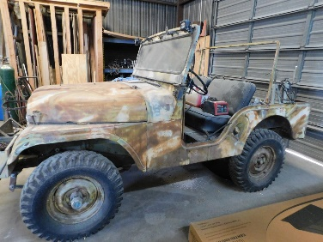
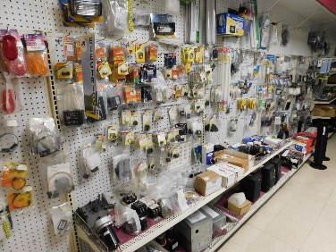
RV Repair Shop Retirement/Estate Auction
F&F Auctioneers: 325-372-1717
Saturday – April 10, 2021 -10 AM.
Item Inspection: Fri. April 9th – 12 p.m. to 6 p.m. & Sat. 8 a.m. to Auction Time.
Location: 1400 S U.S. Hwy 281, Marble Falls, TX 78654
Vehicles: 1955 Willis Jeep (titled).
Firearms/ammo: Taurus .44 mag; Sears 12 Ga; 20 Ga; Benelli shotgun over & under 12 Ga; 30-30 winchester model 94 lever action; Marlin 30-30 with JM circled on it; Black Powder 50 cal Thompson Center; .25 Cal pistol Raven Arms; 300 Winchester mag model 70; .243 New Haven Mossberg; .22 rifle with magazine; Daisy pump pellet gun pistole; Taurus G2 Millennium 9mm with 2 clips & Blackhawk holster. Owner may add more firearms. Ammo: .44 mag; 300 mag; 22-250; .243; .22; 12 Ga; 30-30; 25 auto; black powder possible bag.
RV Parts: RV Parts & Accessories of all kinds including but not limited to- numerous electrical items, adaptors, cords, plugs; plumbing; AC parts; vents; rugs; cookstoves; replacement lenses; hubs; breaks; fuses; lights; jacks; spring lifts; gas props; faucets; hitches; brass fittings; levelers; locks; door holders; window & door hardware; screen door slides; propane regulators & extender hoses; patio awnings; pull straps; tie downs; various sewer items (adaptors, seals, drain connectors); towing mirrors; brake assembly; mounting clamps; bolts of all kinds; awning arms; port a cools; folding couch; heaters; AC units; stove; fridges; assist rails; HDTV atennas & much more! The gentle man was in business for 31 years & has a huge inventory supply list.
Equipment/Tools: Forklift (4 tier, propane, caterpillar); challenger lift; scaffolding; lifts; metal bender; table saw; tool box; hitches; equalizers; stabilizers; ridged saw; plainer; belt disc sander; ladders; drill press; hydraulic lift; compressors of various kinds (3 phase IR, black max 5 hp 2 stage & others); OHV KG 200 generator; jacks; dollies.
Trailers: 16 ft Bumper pull trailer (no title); gooseneck cargo trailer (titled); bumper pull food trailer (titled); 22ft boat trailer (no title); gooseneck flatbed trailer (no title).
Home/Office: Multiple office desk sets; file folders; filling cabinets; gondola/shelves; fridge, microwave, table, chairs, dishes, mini fridge, standing washer & dryer.
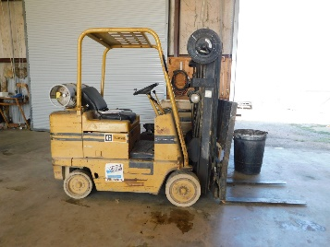
Misc.: Cushman (no title); assorted lumber; metal cabinets; office counter; bolt bins; hand tools; metal shop table; shop lights; scooters; rubber roofing & rack; approx. 250 ft wrought iron fencing with caps; metal panels; electrical cords; John Deere tractor with blown motor; 38 V electric cart; lawn chairs; gaskets & materials; insert molding; numerous tire covers; pet products; taser; T-Zoid golf clubs; game camera; scopes; smart bracelets; carpet blower; assorted cast iron; porcelain; pontoon boat.
Collectibles: Texaco lighted sign; Interstate battery metal sign; Cash register from Siden Stickers in Marble Falls; vintage adding machines.
This is a partial listing - too many items to list! Pre-bidding for certain items at fandfauctioneers.hibid.com. Contact us to leave an absentee bid! Check us out on facebook: F&F Auctioneers: David Fry. Auction will go on rain or shine. Concession onsite.
David: 325-372-1717 Kayla: 325-372-1716 Edward: 325-248-5775
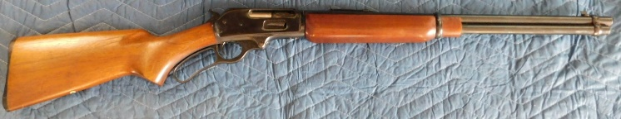
TERMS/CONDITIONS: All Items Are Sold As Is Where Is Without Warranty Or Guarantee. Any announcements made auction day shall take precedents over any previous printed material or announcements. Complete payment due on day of sale. Must have current Texas tax or resale number on file for tax exemption prior to opening of sale. Onsite buyer's premium $0-2000.00 10%, $2000.01-10,000.00 5%, $10000.01+ 3%. There will be a 3% processing fee on all debit/credit cards. Must be 18 yrs old to buy a rifle & 21 yrs old to buy a pistol. Out of state firearms buyers & those having it shipped will need to have a transfer via a Federal Firearms Dealer & background check. All items must be picked up by 5:30 pm on Sunday 4-11-2021 or prior arrangements made. David Fry TX Lic # 17647. Edward Forehand TX Associate TX Lic # 17802.

