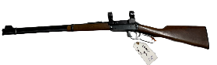

**Ballard Pace Estate**

**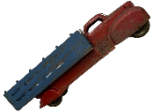

**Presented by Freeland Auction Services, LLC**

**10:30AM SATURDAY, August 13**

**3007 S. Poseyville Rd, Midland, MI**

**(Corner of Poseyville & Freeland Rd West of Freeland)**

**2006 Ford F150 Truck HAY WAGONS PRIMITIVES ANTIQUES FURNITURE**

We have been commissioned to conduct an absolute LIVE ONSITE auction for the PACE FAMILY ESTATE. Mr. Pace operated a unique roadside fruits and vegetable stand for several decades. He has since retired and Is moving closer to family. Hundreds of items on the property are being sold at an **ABSOLUTE LIVE ONSITE GOOD OLE’ FASHIONED AUCTION** that you will want to make sure you attend! Please contact us if you have any questions. **10:30AM START!**

**ITEMS INCLUDE: 3 Wood Sheds/Small Barns, 1993 GMC Box Truck with Aluminum Box, 2006 FORD F150 Truck (Very Nice), 2 Hay Wagons (1 with steel roof), Husqvarna Riding Lawn Mower, Push Mower, Tools from the barn, Lawn Tools, 1980 HONDA Motorcycle, TEN LONG GUNS including Winchester 30/30 Model 94, Savage, and Thompson, WW2 German Officer Sword and Dagger, Vintage toys including pressed steel trucks, Household wooden furniture including very nice bedroom set (Large King Bed), Hundreds of wooden and plastic trays for vegetables, wooden crates, Christmas and Holiday decorations, Over 50 Pieces of FENTON Glassware, Roseville Pottery, and more!**

Please take a look at the hundreds of photos to give you a preview of items that will be in the auction! We will continue to update this as well as provide a more detailed description of items as we dig through the decades and generations of items being sold. More pictures can be seen on Auctionzip.com, GoToAuction.com and Estatesales.net.

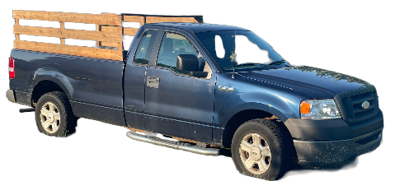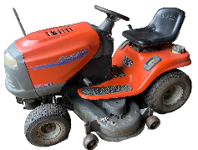 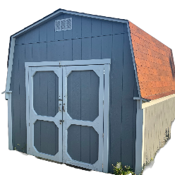 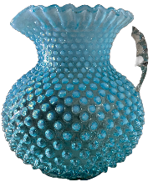

**FreelandAuctionServices.com**

**Shawn Hawkins (989) 878-2487 Barry Huckeby (989) 878-3308**