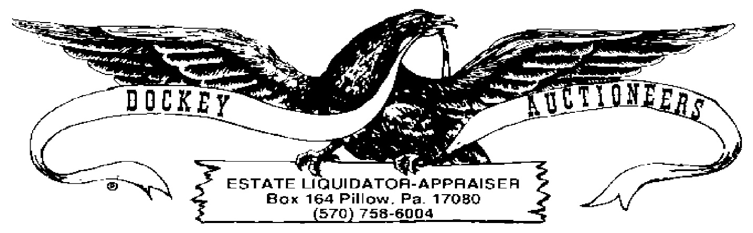

**COINS AT PUBLIC AUCTION**

**FRIDAY, 28 AUGUST 2020 ~ 6:00 P.M.**

**CROSSROADS MARKET & AUCTION, 5415 ROUTE 25, LYKENS, PA**

1. American Campaign & National Defense Tokens
2. Lot-Foreign Coinage
3. (2) Large Foreign Pennies, 1920 & 1921
4. Lot-Foreign Coinage
5. Lot-$12.00 Sacagawea Dollar Coins
6. Lot-$11.00 Sacagawea Dollar Coins
7. Lot-$8.00 Susan B. Anthony Dollar Coins
8. Lot-$7.00 Bicentennial Half Dollars
9. Good Conduct Medal
10. Lincoln Book-(72) Cents, 1975-2015
11. Jefferson Nickel Book-(70) Nickels, 1962-1995
12. Jefferson Nickel Book-(24) Nickels, 1996-2010
13. Roosevelt Dime Book-(39) Dimes, 1987-2007
14. Washington Quarter Book- (42) 1965-1988
15. Washington Quarter Book-(22), 1988-98
16. State Quarter Book, (29) P&D, 1999-2001
17. State Quarter Book, (29) P&D, 2002-2005
18. State Quarter Book, (17), P&D, 2006-2008
19. Kennedy Half Dollar Book, (1) 1964, (4) 1966-69 & (18) 1970-1985
20. Kennedy Half Dollar Book, (8) 1986-1994