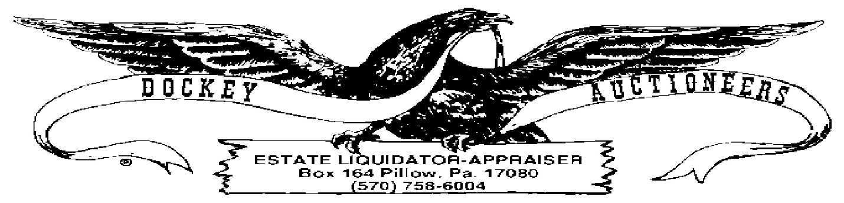

**CROSSROADS MARKET & AUCTION WEEKLY PUBLIC AUCTION**

**COIN LISTING-05 AUGUST 2022-7:00 P.M.**

HALF DOLLARS

1. 1934 Standing Liberty
2. 1935 Standing Liberty
3. 1939 Standing Liberty
4. 1947 Standing Liberty
5. 1947 Standing Liberty

SILVER DOLLARS

1. 1884-CC Morgan, Slabbed MS63
2. 1888 Morgan
3. 1899-O Morgan

TRADE DOLLARS

1. 1840
2. 1876-S
3. 1893 Columbian Exposition Half Dollar

MISC. SILVER COINAGE

1. 1980-1985 Free The Eagle 2-Troy Ounce Coin
2. 2017 Silver Eagle 1-Ounce Silver Dollar
3. Golden State Mint 1929 1-Ounce Silver Liberty Coin
4. Ten Dollar Token-Prairie Meadows .999 Silver Coin
5. 1983 Franklin Mint Christmas Silver Ingot
6. 1983 Franklin Mint Christmas Silver Ingot
7. US Bicentennial Silver UNC Set
8. 8-pc Framed Coinage (1921 Morgan, 1926 Peace, 1943 Standing Liberty Half, 1964 Kennedy Half, 1935 Washington Quarter, 1908 V-Nickel, Silver Dime & Indian Head Cent)
9. 1964 Kennedy Half in Paperweight

20-A. 1979, P,D,S-Susan B. Anthony Dollar Coins

DIMES

1. 1877 Seated Liberty
2. 1839 Seated Liberty
3. (5) UNC Roosevelt Dimes, Buyer’s Choice

CENTS

1. 2-Cent Coin-hole
2. 1852 Large Cent
3. 1830 Large Cent-hole
4. Lot: (3) Large Cents, no dates
5. Partial Book: (1) Flying Eagle & (28) Indian Head Cents
6. Lot: (8) Indian Head Cents (1889, ’90, ’91, ’93)
7. Lot: (8) Indian Head Cents (1895, ’96, ’97)
8. Lot: (8) Indian Head Cents (1897, ’98, ’99)
9. Lot: (8) Indian Head Cents (1899, 1901)
10. Lot: (8) Indian Head Cents (1901, ’02, ’03, ’04, ’07)
11. Lot: (8) Indian Head Cents (1884, ’87, ’96, 1906, ‘07, ’08)
12. Lot: (206) Wheat Cents
13. Lot: (42) Steel Cents

SILVER DIMES

1. Lot: (33) Mercury Dimes
2. Lot: (30) Mercury Dimes
3. Lot: 1914 Barber Dime & 1935-D Mercury Dime
4. Lot: (15) Roosevelt Dimes
5. Lot: (12) Washington Quarters

NICKELS

1. Lot: (20) Buffalo Nickels (1913, ’18, 20, ’20-S, ’24, ’27, ’27-S, ’28)
2. Lot: (20) Buffalo Nickels (1928, ’29, ’29-D,’30, ’30-S, ’30-D, ’34, ’35)
3. Lot: (20) Buffalo Nickels (1935, ’36, ’36-D, ’36-S)
4. Lot: (17) Buffalo Nickels (1936, ’36-D, ’37, ’37-D, 37-S, 38-D)
5. Lot: (41) Buffalo Nickels, Assorted Dates
6. Lot: (23) Buffalo Nickels, Assorted Dates
7. Lot: (1) Jefferson & (1) V-Nickel