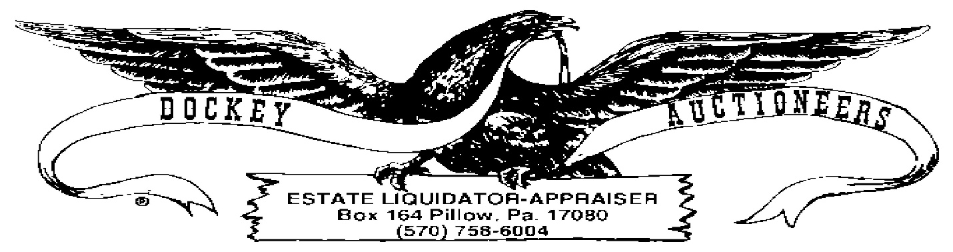

**CROSSROADS MARKET & AUCTION WEEKLY PUBLIC AUCTION**

**25 MARCH 2022 6:00 P.M.**

1. 1879 Morgan Silver Dollar
2. 1885 Morgan Silver Dollar
3. 1889 Morgan Silver Dollar
4. 1889 Morgan Silver Dollar
5. 1921 Morgan Silver Dollar
6. 1921 Morgan Silver Dollar
7. 1922 Peace Dollar
8. 1922 Peace Dollar
9. 1924 Peace Dollar
10. 1835 Liberty Capped Half Dime
11. 1852 Silver 3-Cent Nickel
12. 1907 & 1914 Barber Dimes
13. $5.00 Lot-1964 Silver Kennedy Halves
14. $5.00 Lot-1964 Silver Kennedy Halves
15. $10.00 Lot-Kennedy Clad Halves, Assorted Dates
16. $10.00 Lot-Kennedy Clad Halves, Assorted Dates
17. $5.00 Lot-Walking Liberty Halves, 1940’s Assorted Dates
18. $5.00 Lot-Washington Silver Quarters, Assorted Dates
19. $5.00 Lot-Washington Silver Quarters, Assorted Dates
20. $5.00 Lot-Roosevelt Silver Dimes, Assorted Dates
21. Book: Kennedy Halves-$6.50 Face (1-1964 & 12 Clad)
22. Book: Washington Quarters-$4.00 Face (16 Coins, 1965-1974)