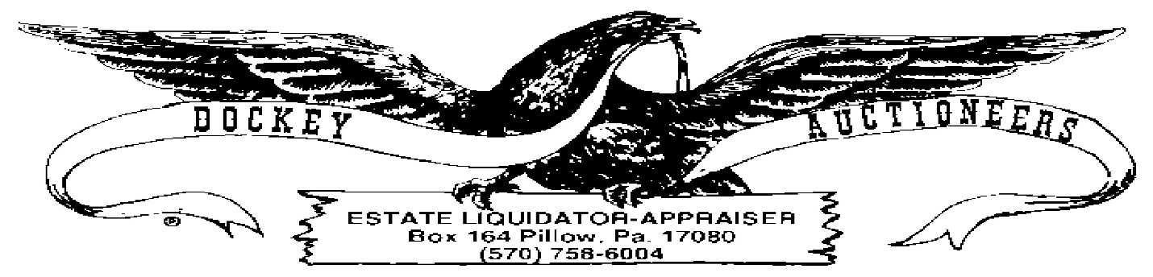

**CROSSROADS MARKET & AUCTION WEEKLY PUBLIC AUCTION**

**COIN LISTING-11 MARCH 2022-6:00 P.M.**

1. $10.00 Kennedy Clad Halves, Assorted Dates
2. $10.00 Kennedy Clad Halves, Assorted Dates
3. $7.00 Bicentennial Halves
4. $7.00 Bicentennial Halves
5. $3.00 Wheat Cents, Assorted Dates
6. $3.00 Wheat Cents, Assorted Dates
7. $7.00 Eisenhower Bicentennial Dollars
8. $7.00 Eisenhower Bicentennial Dollars
9. $7.00 Bicentennial Quarters
10. $7.00 Presidential Dollars
11. (6) Rolls, UNC State Quarters (MN, IL, MO,AL,AR & KS), Buyer’s Choice
12. 1985 US Mint Set
13. 1985 Mint Set
14. 1988 UNC Mint Set
15. Book: Fifty State Commemorative Quarters, 1999-2008: $10.50 Face
16. Book: America The Beautiful Commemorative Quarters, Volume 1: $6.75 Face
17. Book: Presidential Dollars Coin Collector’s Kit: $16.00 Face
18. Book: Lincoln Cent Collection, #1: .26 Cents
19. Book: Lincoln Cent Collection, #2: .58 Cents