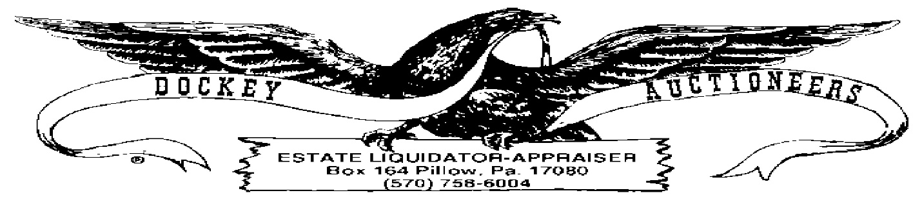

**COINS & CURRENCY**

**26 MARCH 2022 ~ 446 MAIN STREET, LYKENS, PA ~ 1:00 P.M.**

**SILVER DOLLARS**

1. 1883
2. 1886
3. 1886
4. 1886
5. 1890-O
6. 1921-D Morgan
7. 1922
8. 1922
9. 1924
10. 1924

**HALF-DOLLARS**

1. Lot: (3) Barber: 1897, 1907-D, 1908-O
2. Lot: (8) Standing Liberty: 1918, 1941, 1945, 1943, 1943-D
3. Lot: (7) Franklin: 1951, 1959, 1961, 1962, 1963

**QUARTERS**

1. Lot: (3) Washington: 1935, 1957, 1962
2. Lot: (4) Barber: 1894-S, 1898, 1902, 1908-O
3. Lot: (4) Barber: 1908, 1909-S, 1916-D

**DIMES**

1. 1887 Seated Liberty
2. Lot: $2.30 Assorted Roosevelt
3. Lot: (11) Barber Dimes: 1902, 1906-D, 1910, 1911, 1911-D, 1912, 1913, 1914, 1916
4. Lot: (10) Barber Dimes: 1900, 1905-O, 1906, 1911, 1912, 1913, 1914, 1916
5. Lot: (4) Mercury Dimes: 1916, 1917, 1943, 1945

**NICKELS**

1. Lot: (21) Buffalo, Asst. Dates
2. Lot: (25) V-Nickels, Asst. Dates
3. Lot: (21) Nickels: (2) War & (19) Jefferson

**CENTS**

1. 1946 Lincoln & 1909 Indian Head
2. Lot: (10) Steel Cents
3. Lot: (3) Indian Heads
4. Lot: (132) Wheat Cents, Asst. Dates
5. Lot Assorted Foreign Coinage
6. Assorted Tokens (Lykens Valley Railway Company, etc.)

**PAPER**

1. (14) $2.00 Bills
2. Series 1953 $5.00 Red Seal
3. Series 1953 $2.00 Red Seal
4. Lot: (4) $1.00 Silver Certificates: 1935, 1957