ONLINE BIDDING BEGINS: FEBRUARY 4, 2021 @ 8:00 AM  
PREVIEW: FEBRUARY 10, 2021 FROM 9:00 AM – 5:00 PM  
LIVE AUCTION: FEBRUARY 11, 2021 @ 10:00 AM  
PICK-UP DATES (FIRM): FEBRUARY 12 & 13 AND 15–18, 2021  
FROM 9:00 AM – 5:00 PM

1097 OLD McDADE RD., ELGIN, TX 78621  
(US HWY 290 by WATER TOWER)

**TERMS:  
  
5% BUYERS PREMIUM ON-SITE / 10% BUYER’S PREMIUM ONLINE**

**FORMS OF PAYMENT: CASH, BUSINESS CHECK, CERTIFIED CHECK  
CREDIT CARDS ACCEPTED WITH A 4% CONVENIENCE FEE  
WIRE TRANSFERS ACCEPTED WITH A $10 FEE  
  
FULL DETAILS & CATALOG ONLINE @** [**WWW.WALLEEAUCTIONCOMPANY.COM**](http://WWW.WALLEEAUCTIONCOMPANY.COM)

**130 E. Tatom St., Trinity, TX 75862  
--------  
Col. Woody Wallace – 936.222.7588  
TX Auctioneer Lic #17533  
Steven Lee – 817.905.0567  
Matt Evans – 936.707.1598**

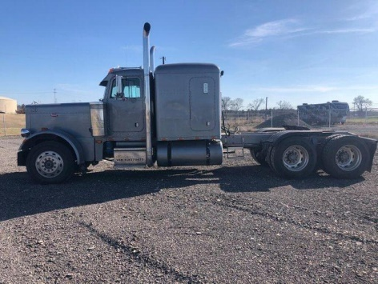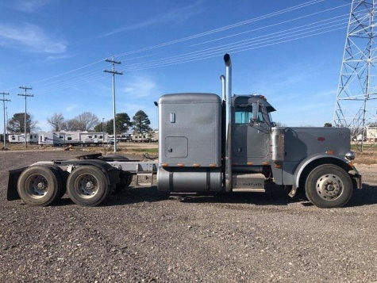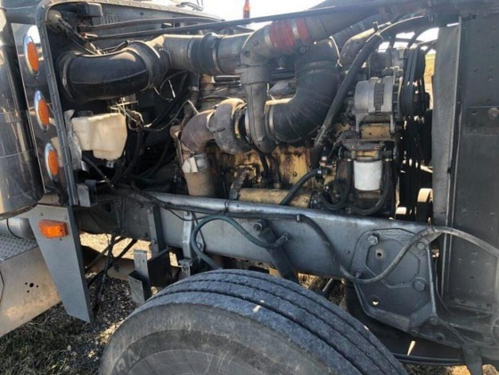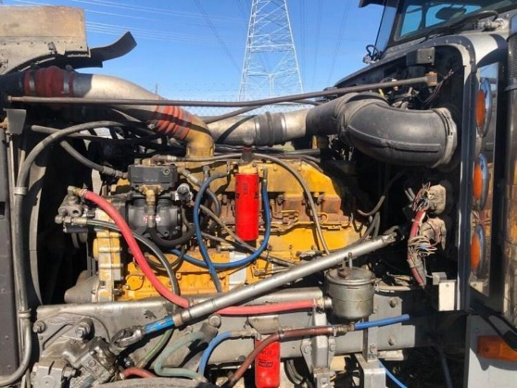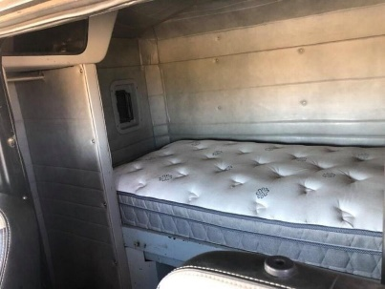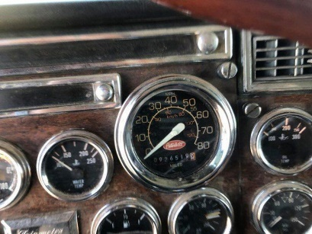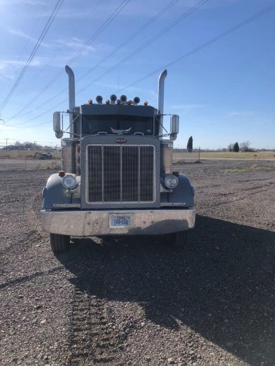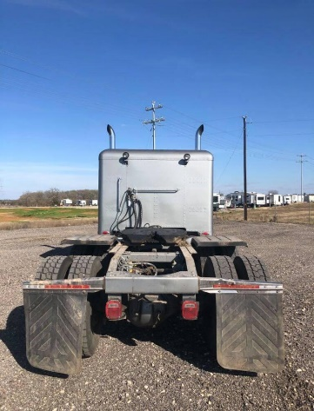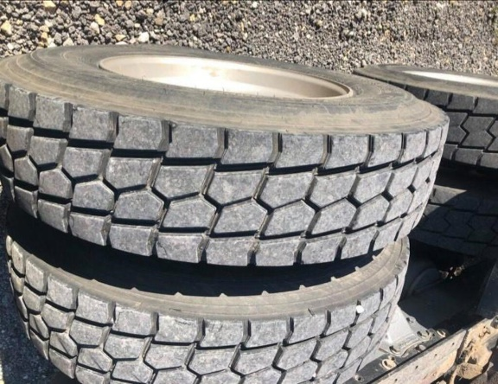

**CONSTRUCTION EQUIPMENT AUCTION  
1989 PETERBILT 379 W/ SLEEPER CAB**3406B 425HP Cat - 15 Speed Eaton against the dash over drive - 370 Eaton rear-end both new. Motor has brand new head and 60,000 on in-frame. Truck in great shape. Tires 80% - 980,000 original highway miles