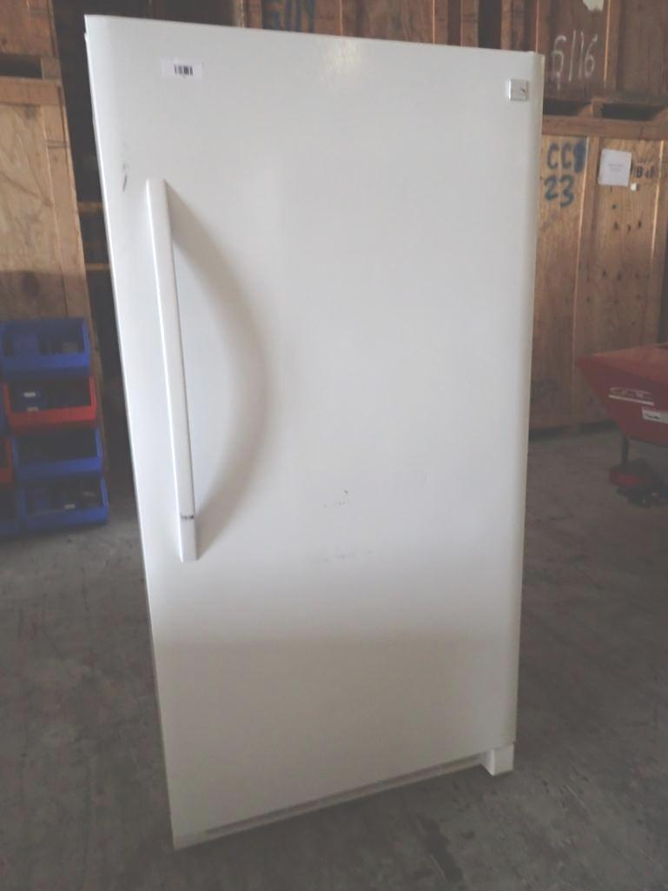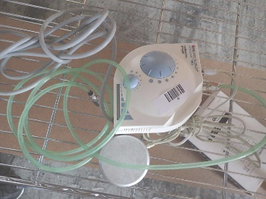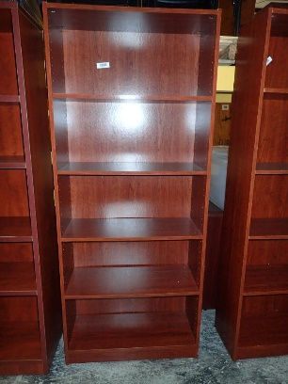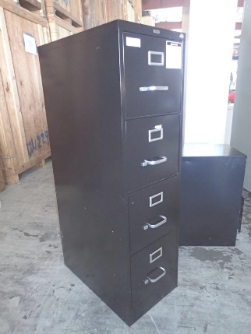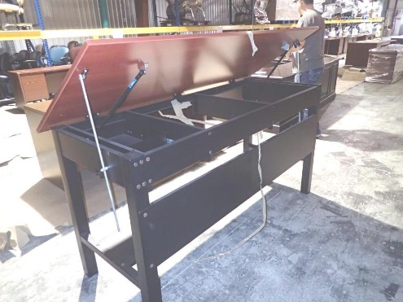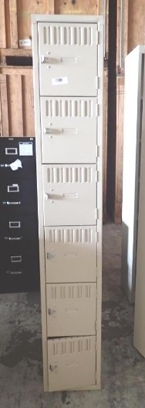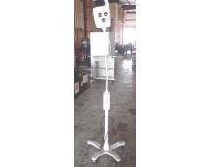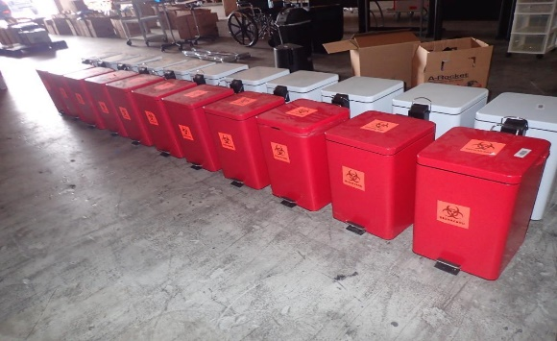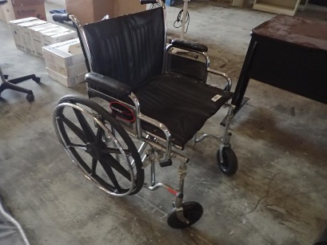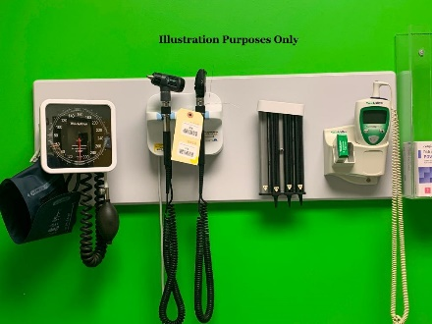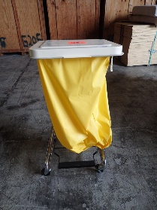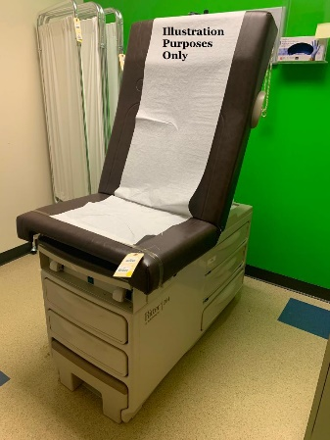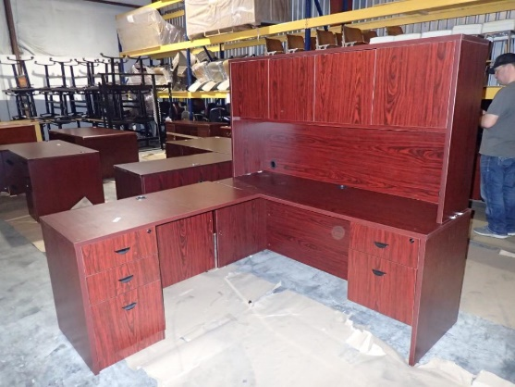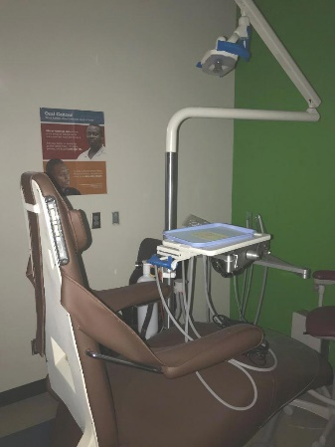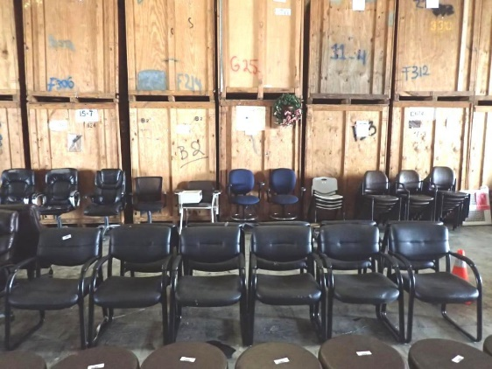

**TERMS:**10% BUYER’S PREMIUM

FORMS OF PAYMENT: CASH, BUSINESS CHECK, CERTIFIED CHECK  
CREDIT CARDS ACCEPTED WITH A 4% CONVENIENCE FEE  
WIRE TRANSFERS ACCEPTED WITH A $10 FEE **FULL DETAILS & CATALOG ONLINE @** [**WWW.WALLEEAUCTIONCOMPANY.COM**](http://WWW.WALLEEAUCTIONCOMPANY.COM)

**MEDICAL CENTER LIQUIDATION**

**ABSOLUTE ONLINE AUCTION FEATURING:**  
MEDICAL / DENTAL EQUIPMENT & SUPPLIES  
OFFICE FURNITURE, EQUIPMENT & SUPPLIES

**BIDDING OPENS:** Saturday, April 10, 2021 @ 8:00 AM  
**BIDDING CLOSES:** Saturday, April 17, 2021 @ 10:00 AM (soft close)

**130 E. Tatom St., Trinity, TX 75862  
--------  
Col. Woody Wallace – 936.222.7588  
TX Auctioneer Lic #17533  
Steven Lee – 817.905.0567  
Matt Evans – 936.707.1598**