CRAVEN AUCTIONEERING CRAVEN AUCTIONEERING CRAVEN AUCTIONEERING CRAVEN AUCTI0NEERING

We will offer for sale the following consigned items for the 31st annual show located at:
Morgan County Fair Show Arena
1749 Hospital Dr Martinsville, In 46151
Sunday, June 25th, 2023 @ 1:00 PM
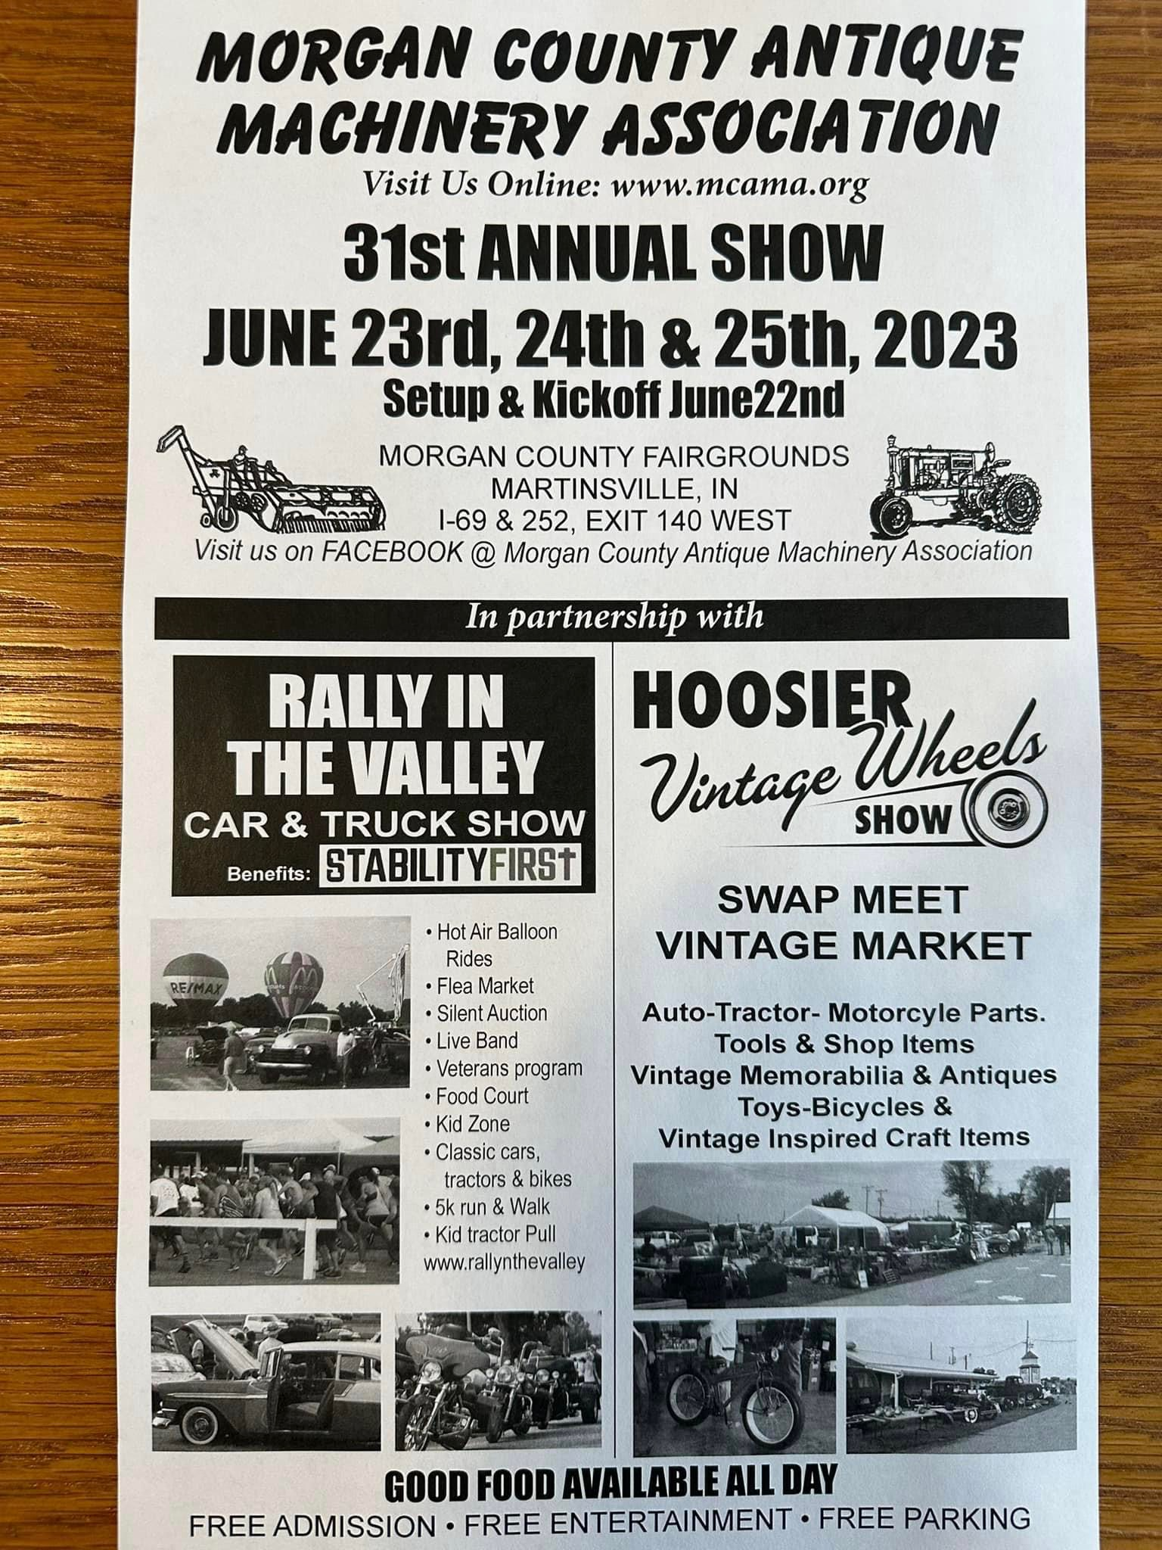

TERMS: Cash or check w/ proper ID. Nothing to be removed until settled for. Not responsible for accidents or theft. All sales Final sold as is/where is.
For photo’s visit
www.cravenauctioneering.com
Or www.auctionzip.com #1990
Auctioneers Note: Statements made day of sale take precedence over any prior information. Photos will be posted on sites above as items come in.
To Consign items in auction contact:

Roger Craven AU08800046 Curtis Craven AU10800113 Harris Craven AU01018866
(765)-346-1421 (765) 346-0622

