REMINDER AD
REAL ESTATE FARMLAND AUCTION
SATURDAY, JULY 21, 2018
TO BE SOLD AT 11 A.M.SHARP!!
LOCATION: 3798 IRENE RD. BELVIDERE, IL. 61008
Property will be sold in 3 separate parcels. Buy one or Combo!
- Tillable 129 Acres MOL
- Tillable 40. Acres MOL
- 2 Acres w/3 bedroom house, 2 full baths, very large open kitchen, all oak (Andco) cupboards, Bay window, first floor laundry room off garage, plumbed for bath in basement, newer furnace (95%) eff., gas hot water heat, gas dryer hookup, 2 stairways to basement. Built in 2000
For Further info or private showing by request call Lyle Lee @ 815-988-0249
Terms of sale for real estate: $20,000 down day of sale by cashiers ck or ck w/bank letter of guarantee. Closing in 45 days or less. Must have your financing in order. Title policy to be furnished at closing. Announcements day of sale prevail over written material. Not responsible for accidents. Property being sold “AS IS” with no warranties implied or expressed, no contingencies. Sale is subject to executor’s approval.
Owner: Howard & Phyllis Schumacher Trust
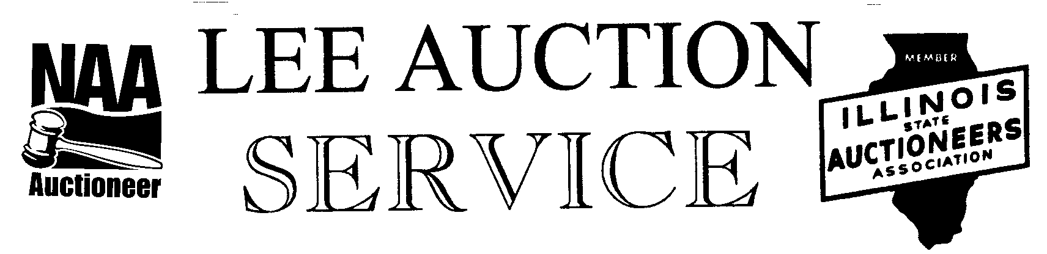
Belvidere, IL 61008
AUCTIONEER: LYLE LEE State License #440.000200 Wi. Li # 2863-52
CLERKS & CASHIERS: LEE AUCTION SERVICE
Check out our website at: www.leeauctionservice.com & auctionzip.com

