PUBLIC AUCTION
SATURDAY, JUNE 2ND, 2018
RUNNING TWO RINGS!
Lunch by: Relish the Dog 9:00 A.M. Comfort Station Available
LOCATION: Boone Co. Fairgrounds, 8847 IL. Rt. 76, 1 Mi. North of Belvidere. Located in the goat barn near south end. Plenty of Parking.
GUNS: JC Higgins Model 20, 12 ga. pump; Marlin Model 790, 22 bolt action rifle w/clip; JC Higgins Model 58316, 12 ga. bolt action; Crosman Model 760 pellet rifle; 338 auto pellet pistol; Harrison Richardson 38 revolver; Mossberg 500A 12 ga. shotgun; JC Higgins Model 60 12 ga. semi-auto; Hiawatha Model 130VR 12 ga pump; Remington 870 20 ga pump; Harrison Richardson Model 765 Pioneer 22 rifle; Carolina SS 12 ga; NR Davis & Sons dbl barrel 12 ga; Fine London Twist dbl 12 ga; Kimber Ultra Carry II 45 pistol w/laser grips; (2) 1000 round boxes of 22 shells; To be sold right after tractors, car & golf cart. .All Illinois gun laws apply. Il Residents must have FOID card.
VEHICLE, Motorcycle & Golf Cart: 1997 Honda Elantra, automatic, 169,215 miles; 1974 Honda CL200; E-Z-Go Elect. golf cart.
TRACTORS & EQUIPT: Ford Jubilee w/loader; JD 2240 w/loader, Diesel, fair rubber, 5’ brush hog; Sperry-Rand 510 manure spreader; JD 3 pt. blade; Howse brush hog; Tandem axel flatbed trailer; JD 212 w/tiller & mower deck; thatcher; spreader; Generac GP5500 generator; Toro Wheel Horse 244-H; Agri-Fab 17. cu’ yard cart; (2) old Wheel Horse; Snow Flight Lg. H.D. snow blower; large barn floor fan.
ANTIQUES & COLLECTIBLES: Oak ice box; Cast horse heads; full cast horse on stands; Cast dinner bell; Lawyers book case; round oak table; hand cultivator; Foster’s neon light; old Singer in cabinet; parlor heater; cane bottom chairs; wood chairs; ox yoke; copper boiler; milk can; Brass rail pipe; writing desk & chair; oak commode; walnut dresser; large giraffe & horse figurines; Black bear skin; Wood decoys; Ethan Allen gateleg drop leaf table; Fiesta Ware; Shirley Temple paper dolls; childrens books; egg crate; High Wake 22K gold trimmed dishes; stroller & much more.
SPECIALTY ITEMS: Largest Button Collection Ever! Several are prize winners(Illinois State Button Society) . Most mounted on cards. Every type of button imaginable! Several Native American artifacts- Head Dress, dream catchers, blankets, pottery, drums, rattles, prints etc; Stage coaches; English saddle & Western saddle; halters, saddle blankets & more; Engraving set; Maestro flute; rattan stool from New Dehli India; Boxes of glass balls, misc colors & sizes & much more!
HOUSEHOLD & MISC: Nice glider/rocker w/footstool; lamp end table; comforter sets; remote parlor heater; Keurig coffee pot; GE Deep Steam carpet cleaner; flat screen TV’s’ butcher block table; Ornate mirror; Hide a bed couch & love seat; coffee & end tables; oak hutch; wood corner desk; book shelves; file cabinets; maple book case; entertainment ctr; (2) green wrought iron bakers racks; turkey fryer; sleeping bags; Cue stick; Adult Western paperbacks; purses; folding table; boots; nic nacs; battery operated dartboard; Service for 12 Better Homes & Gardens stoneware; Singer sewing machine; wood shelf; futons (one very nice); full size bed; food processor; malt maker; wood d.r. table w/5 chairs & buffet; couch & love seat; entry table; drop leaf tables; framed pictures; (2) tile top tables; freezer; fridge; cedar chest; dehumidifier; Ansonia Decorative clock (doesn’t run); luggage; picture frames; baskets; very nice linens; lots of cookbooks by well known chefs; new lasagna baker/server ; microwave stand; (8) hand stitched Trapunto pillows of waterfowl; (2) 36” stereo speakers; (2) double strollers; corner fish tank; window a/c; (2) recliners-1 brown, 1-burgundy; headboards; quilt rack & pattern; doll furniture; tv trays; Presto Pizzazz Plus (NIB); & lots of Misc.
YARD & TOOL: Ariens 624E Snow blower; Ford F150 battery operated toy car; Craftsman table saw; Router; B & D miter saw; belt & disc sander; drill press; air compressor; car dollie; P/U topper; (4) sets golf clubs (like new Tommy Armour & Dunlop DDH); fishing tackle & rods; wheelbarrow; wrought iron bench; weight set; Pro-Form 585C treadmill; Power Rider; Lots of misc power & hand tools; Garden tools; Craftsman leaf blower; Yard Man lawn tractor w/4’ deck; Husqavarna 455 Rancher chain saw; Redwood patio furniture; Lincoln Welder; Echo small garden tiller; Bean bag game & boards; yard cart; wash tubs; misc. patio chairs; extension ladders; croquet set; buckets of golf balls; misc. nuts & bolts; wrought iron table & chairs; Bikes-men & women’s (Schwinn, Diamond Back, Bianci) ; 3 wheel bike; wet wheel grinder; Jeep parts-bumper & appliques; pancake air compressor; jack up car dollies; dog crates; set of nailers; plumbing & electrical supplies; Grill Pro gas grill; pull behind fertilizer cart; jig saw; power hack saw; weight equipt; snow blower & much, much more.

Owners: D. Engstrom, W. McMackin, J. Blasdell, B. Lowman, R. Schultz, T. Walling, D. Streit , B & M Hyrkas, S. Terrilewithee & Mullens Family
Terms: Cash or checks w/proper I.D. Visa, Mastercard & Discover accepted. 9% Buyers Premium w/ 4% discount for cash or check. No property to be removed until settled for. All items sold “AS IS”. Number system will be used. Must have driver’s license for registration. Not responsible for accidents or items after purchase. Announcements day of sale prevail over written material.
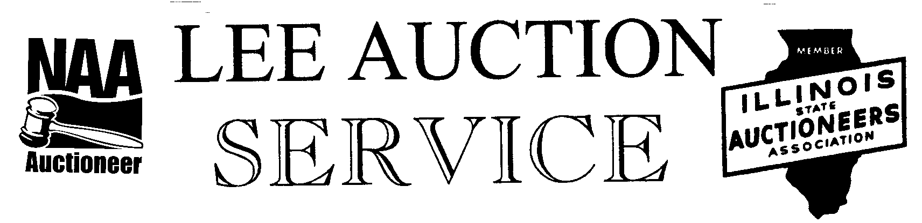
Belvidere, IL 61008
815-988-0249 cell
AUCTIONEER: LYLE LEE, IL. State License #440.000200 WI. # 2863-52 &
CLERKS & CASHIERS: LEE AUCTION SERVICE
Visit our web site at www.leeauctionservice.com & check out AuctionZip

