VERY LARGE PUBLIC AUCTION
SATURDAY, APRIL 28TH, 2018
RUNNING 2 RINGS
Lunch by: Relish the Dog 9:00 A.M. Comfort Station Available
LOCATION: BOONE CO. FAIRGROUNDS, 8847 Il. RT. 76 BELVIDERE, IL. 61008
Located in the Goat Barn near south end. Plenty of parking.
GUNS, ANTIQUES, COLLECTIBLES, HOUSEHOLD, YARD , PRECISION TOOLS
OTHER TOOLS & MUCH MISC.
GUNS: Winchester Mode 1890 Hex Barrel pump 22 rifle; Browning 20 Ga. pump shotgun. TO BE SOLD AT 11:00 SHARP!! All Il. gun laws apply. To be handled by RSM Guns.
ANTIQUES & COLLECTIBLES: 76 Pieces of Sterling (Service for 12 plus serving pieces); Dry sink; tin bread boxes; (2) Remington typewriters; cookie cutters; oil on canvas Spaniard; Lionel train set & tracks; Records; Crest O Gold 22K dishes; Library table; Singer Treadle; Bowman wood milk boxes; wood planes; wood clamps; buck saw; enamel top cupboard; wind up toys; painting; mixing bowls; youth chair; meat grinders; wicker buggy; Beautiful hand crafted old Victorian wood doll house with all accessories; Marie Osmond dolls; Retro blonde dresser & chest of drawers; wood dresser w/mirror; Vintage Kay guitar; football cards; Primitive tools; Mesa Ware dishes from Vermont (fruit pattern) w/serving pieces; Cricket paddle from Africa; Collector spoons; Boyd’s Bears figurines; J. F. Kennedy newspapers & memorabilia; 1932 Anderson’s Fairy Tales; 1965 Mechanix Illustrated; kids toys; tin lunch boxes; battery powered Charley Weaver Bartender; Radio Flyer wagon; Lego-Star Wars 7151 Infiltrator; Vintage & primitive furniture; wood shaft golf clubs; snow shoes; Bombay Co. Mahogany; oil paintings & Much more!
HOUSEHOLD: Bathroom medicine cabinet (NIB); 3-light vanity (NIB); under counter microwave; plug in cooler; braided rugs; area rugs; sewing cabinet; lots of misc. dishes, flatware & glassware; wood chairs; tables; stools; wood drop leaf table w/2 chairs; wood rocker; book cases; books; games; video games; some jewelry; King size quilt w/3 pillow shams; king bed frame; oak table; pine sofa table; Panasonic tower speakers; double wood headboard & frame; double cabinet; table & floor lamps; Corelle-fruit pattern; lighted Americana houses; barnwood wall sconces; roaster; dresser; Hamilton Beach convection oven; (2) Sentry safety fireboxes; (2) elect. floorboard heaters; towerl bar; NIB HP photo paper & as always, Much, Much More!
YARD & TOOL:Electric start Sno-Tek by Ariens, snowblower 24”-like new; Craftsman Rototiller (used twice); Char-Broil Infrared gas grill (1 yr old); Ever-Pure whole whole water filtration system (NIB); David White transit w/tripod; Stihl chainsaw MS 250; air compressor; Dove Tail furniture maker; worm drive saws; bench grinders; Hydraulic lift cart; appliance cart; NIB Craftsman 3 gal. air compressor; torch cart; surface plate; chipper/spreader; NIB Bostitch roofing nailer; lots of misc. hand & power tools; 3 generations of tool makers tools; Carpenters tools & boxes; cross cut saw; C clamps; drill bits; Sandblaster; wod bar clamp; minnow bucket; Lg. wood birdhouse; Nordic-Trak eliptical; Weber charcoal grill; golf walking cart; metal framed hammock swing; wheel chocks for motorcycle trailer; snow ski’s; lots of misc. yard & garden tools; 12 volt tire inflator & lots more!

Owners: K.Kowal, M. Walker, F. Babashka, R & D Weigel, B. Lockhart, R & D Kelly, G. Gessner,
L. Elliott, J. Fischer, C. Wickson, L. Strawn, T. Walling, R. Case & The B. Wennerberg Estate
Terms: Cash or checks w/proper I.D. Visa & Mastercard accepted. 9% Buyers Premium w/ 4% discount for cash or check. No property to be removed until settled for. All items sold “AS IS”. Number system will be used. Must have driver’s license for registration. Not responsible for accidents or items after purchase. Announcements day of sale prevail over written material.
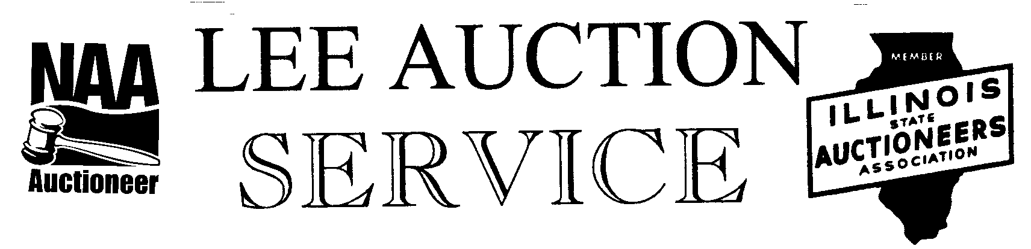
Belvidere, IL 61008
815-988-0249 cell
AUCTIONEERS: LYLE LEE IL.State License #440.000200/ WI # 2863-52
& TROY RUDY
CLERKS & CASHIERS: LEE AUCTION SERVICE
Visit our web site at www.leeauctionservice.com

