SUPER PUBLIC AUCTION
SATURDAY, MARCH 24TH , 2018
RUNNING 2 RINGS BOTH STARTING AT 9, ONE W/COINS
Lunch by: Relish the Dog 9:00 A.M. Comfort Station Available
LOCATION: Boone Co. Fairgrounds, 8847 IL. Rt. 76, 1 Mi. North of Belvidere. Located in the goat barn near south end. Plenty of Parking. Dress Accordingly!
GUNS: Taurus PT 945 pistol; Spain 38 revolver w/holster; Thunder Bersa 45 cal. Ultra compact Pro pistol; Hi-Point Firearms Model JCP 40 S & W pistol; Hi-Point Firearms Model 4595 45 cal Carbine. All Il. Gun laws apply. Paperwork to be handled by RSM Guns of Belvidere, IL.
COINS: Silver dollars, halves , quarters & dimes; Buffalo nickels; pennies; Red Seal $2 bills and more.
ANTIQUES & COLLECTIBLES:Lots of Shawnee pieces; Hull, USA; Autumn Tea Leaf; John Force die cast metal cars; Jeff Gordon Nascar standup poster; piggy banks; Railroad Magazines 1949-1953; jewelry; dolls; bottles; signs;School house clock; GE & Zenith record players; 45’s; albums; Kodak slide projector & screen; Playboys (incl collectibles- 1975 on up); Royal typewriter; Bob Hope book-Last Christmas show; watch fobs & watches; Nylint trucks; floor lamps; Allstate Motor oil can; fishing lures & reels; Hamm’s glasses; school desk; Watt pottery; croquet set; Arcade coffee grinders; feed sacks; #2 Red Wing crocks; Chalk Pinnochio; Fire King dishes; Coca Cola trucks, cases, collector plate, ornaments & more; Bill Mohr decoy; old spoons; Cherised Teddies figurines; Ty Beanies (frogs); wooden horse on wheels; slot machine; oil lamps; box of door knobs; record player; tins; scale; cabbage slicer; die cast cars 1:18 scale; milk stool; porcelian drop leaf table; Native American dolls, canoes etc; set of plastic cowboy dishes & other collectibles; porcelain tiny dolls & more!
HOUSEHOLD & MISC: Armoires; rocking chairs; coffee & end tables; sofa table; computers & monitors; 55: dlp tv; Misc. small kitchen appliances; bar stools; hand crafted computer desk & drop front desk; blanket chest; table & floor lamps; very nice matching hutches & corner cabinets; Nice wood D.R. table w/glass top & 6 chairs; hutch; mahogany server/side table; wood book shelves; upholstered chair; misc. pictures; night stands; clothes racks; area rugs; bench seat; hot/cold bottled water dispenser; White Rotary , Singer & Deluxe sewing machines;video games; board games; puzzles; football table; Ronco rotisserie; popcorn machine; Category 5 computer cable; lots of misc. kitchen items; beauty shop chairs (2/dryers); decorations for EVERY Season & Holiday and much, much more.
YARD & TOOL: Simplicity rear tine tiller; MTD snow blower; Toro 421 snow blower; Troy Bilt power washer; heaters; Catcher for Cub Cadet rider; yard cart; push mower; edger; Rigid miter box saw; DeWalt planer; Craftsman air compressor; pancake compressor; Craftsman drill press; Rigid table saw; scroll saw; belt & disc sanders; hand truck; 20’ fiberglass ladder; planer; jet filtration system; shop vac; pole pruners; tarps; straps; saw horses; wheel barrow; floor jack; jack stands; bench grinder; Craftsman tool chest; all kinds of Craftsman tools; hose & reel; misc. car parts; Misc power & hand tools; lots of wrenches etc; Sorta bins (full); Craftsman wet/dry vac 6.25 hp; tailgate carrier & ramps; roof vents; cherry picker lift; Delta diamond plate pick up tool box; misc. yard tools; boat anchors; life jackets; rain suit; lots of rods, reels, fishing lures, trolling motors, gear; golf clubs; shop lights; Stainless Steel prep table; (2) patio sets; Weber gas grill; Bikes; scroll saw; drill press; animal crates; wooden shop table; truck mud flaps; plumbing & electrical parts; Ryobi drill press; Gas remote control airplane & boat; misc. hardware & much more!
VEHICLES & MOTORCYCLES: 2013 Ford Mustang 2-dr, purchased new, only 16k miles, 6 cyl. automatic, Sport pkg; Dark granite in color; great gas mileage & excellant condition; 1996 CORVETTE, C4 LT1, 350 300 hp, T-top hatchback, brand new tires, clean; 2006 Harley-Davidson Heritage Edition, 25,500 miles, new tires, brakes & battery. Extra exhaust pipes, studded saddle bags, foot boards & service manual; 2005 Harley Sporster 883 w/6422 miles. Stage One Screamin Eagle kit & exhaust. Add’tl upgrades include touring seat, saddle bags, leather tank storage, custom handle bars, windshield, forward controls & 11” rear shocks. The stock seat, stock handle bars, mid controls & 13” shocks are available w/bike. New battery just installed.
VEHICLES & MOTORCYCLE TO BE SOLD AT 11:00 SHARP! FOLLOWED BY GUNS.
ALL ILLINOIS GUN LAWS APPLY. PAPERWORK TO BE HANDLED BY RSM GUNS
Owners: K. Forsell, T. Walling, C. Wickson, J. Berger, J. Fischer L. Bowers, S. Jordan
S. Babashka, S. Freund, C. Ogden, N. Schwegler & the Estate of J. Joe
Terms: Cash or checks w/proper I.D. Visa, Mastercard & Discover accepted. 9% Buyers Premium w/ 4% discount for cash or check. No property to be removed until settled for. All items sold “AS IS”. Number system will be used. Must have driver’s license for registration. Not responsible for accidents or items after purchase. Announcements day of sale prevail over written material.
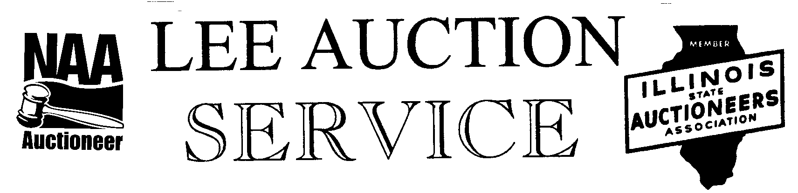
Belvidere, IL 61008
815-988-0249 cell
AUCTIONEER: LYLE LEE IL. State License #440.000200 & WI # 2863-52
JOHN EDWARDS
CLERKS & CASHIERS: LEE AUCTION SERVICE
Visit our web site at www.leeauctionservice.com

