ANOTHER GREAT PUBLIC AUCTION
SATURDAY, OCTOBER 7TH, 2017
RUNNING 2 RINGS
Lunch by: Relish the Dog 9:00 A.M. Comfort Station Available
LOCATION: BOONE CO. FAIRGROUNDS, 8847 IL. RT. 76 BELVIDERE, IL. 61008
Located in the Goat Barn near south end. Plenty of parking.
ANTIQUES, COLLECTIBLES, FISHING TACKLE, HOUSEHOLD, YARD , TOOLS & MISC.
ANTIQUES & COLLECTIBLES: Tereen ware; Party Lite collection; Nascar collection; Illinois license plate collection; lg bell collection; “Josef” originals birthday figurines; Johnson Brothers dishes; Metlox pottery (Poppy Trail), made in Ca.; antique housewares; oil lamps; wood advt boxes; toy trucks; fire extinguishers; old lures & poles; 55 gal. advt drum; Strohs beer clock; Squirt bottles; comics; toy soldiers; vintage brass door stop; dresser set (comb, brush, mirror); shells & much, much more
HOUSEHOLD: Beautiful oak roll top desk & chair; Like new Yamaha Personal Electronic Piano YPP50; sheet music & more; Frigidaire side X side w/water & ice in door; nice rocker/recliner; lots of book cases/shelves; Twin XL bed/frame complete (lightly used) ; night stand; lingerie chest; Lane cedar chest; oak fern stand; oak bread box; Simplicity tank vacuum; Kirby upright w/attachments; wrought iron bar stools; hall tree; wood cabinet; lots of really nice folk art nic nacs & pictures; new in box card table & chairs; I MAC 20” monitor & keyboard; Lots of Computer games, supplies, programs; speakers; etc; 7 ½ ‘ Christmas tree; ent. centers; Boxes & Boxes of Movies, DVD’s, VHS (Disney), Brand new hard cover books, Audio books etc; Games; Lego sets; (3) Octogan poker table tops & chips; Ergonamic desk; floating shelves; Recumbent bike (Marcy); Plaid recliner couch; Nice heavy wood D.R. set w/6 chairs & hutch; nice wood computer desk; corner hutch; (white) twin beds, chest of drawers & nightstand; Saginaw Furniture expandable table in cabinet; Dressers, chest of drawers & nightstands; GPX stereo system complete; wood server; (2) nice futons; jewelry chest; costume & other jewelry; lots of framed pictures-folk style & others; Amish style nic nacs-horse/buggy’s & lots more; Baskets-some Longagerger; flatware; pots/pans; lots of misc dishes & glassware; linens and Tons more!
YARD & TOOL: Sears Craftsman 6 hp, 60 gal air compressor; U.S. General 7.5 hp, 80 gal air compressor; Yard Machine 6 spd lawn tractor w/catcher,& mulching attachment, 38” deck; Troy Bilt Storm 2410 snow blower (used twice); log splitter; Makita chopsaw; Rigid shop vac; miter box; B & D weed eater; B & D work mate; Troy Bilt gas trimmer; Flo Pro filter; work benches, 1/w vice; Lawn Boy snow thrower w/elect. start; truck seats; van bench seat; parts washer; hydraulic press; Craftsman tool chest; jacks; Ryobi small tiller; aluminum rims; 3 pc. painted wrought iron patio set; lawn furniture; cement figurines; flower pots; MT Sport SX & Road Master men’s bikes; Rotary tool kit; metal storage cabinets; light stands; B & D elect. edger; alum. ext. ladder w/stand offs; 6’ multi position ladder; hand cart; wheel barrow; lots of misc. power tools; Power lawn tools; parking bumpers; weights; Cadillac rims (4) 1970’s & Lots, lots more!
Owners: J. Klock, M. Pescinski, S. Dunker, C. Woods, K. Kowal, M. Curry, L. Henderson
G. Gessner, L. Elliott, C. Wickson & R. Case
Terms: Cash or checks w/proper I.D. Visa & Mastercard accepted. 9% Buyers Premium w/ 4% discount for cash or check. No property to be removed until settled for. All items sold “AS IS”. Number system will be used. Must have driver’s license for registration. Not responsible for accidents or items after purchase. Announcements day of sale prevail over written material.
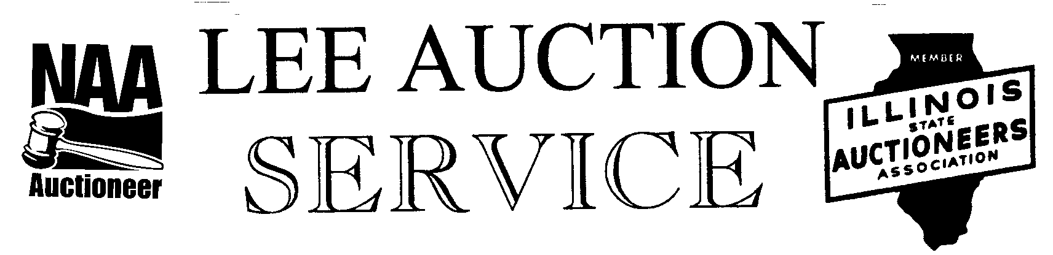
Belvidere, IL 61008
815-988-0249 cell
AUCTIONEERS: LYLE LEE IL.State License #440.000200/ WI # 2863-52
Jeff Marrs # 441.001813
CLERKS & CASHIERS: LEE AUCTION SERVICE
Visit our web site at www.leeauctionservice.com

