PUBLIC AUCTION
SATURDAY, JUNE 3RD, 2017
RUNNING TWO RINGS!
Lunch by: Relish the Dog 9:00 A.M. Comfort Station Available
LOCATION: Boone Co. Fairgrounds, 8847 Rt. 76, 1 Mi. North of Belvidere. Located in the goat barn near south end. Plenty of Parking.
COINS, ANTIQUES, COLLECTIBLES, HOUSEHOLD, YARD & TOOL
Owners:L.Elliott, B. Zilke, G. Jones,T. S. Faut, J. Engelsen, J. Brenthaver, R. Svoboda
D. Greiner, M. Maaske & T. Greco
COINS:
ANTIQUES & COLLECTIBLES: Walking plow w/o hdwr; school desk; humidifier from wood stove; buck saw; Judy Ford pennant; 15 gal. crock; collector plates; milk can; glass paneled door; coal shuttle; wooden wgg crates; box from WWII; oil lantern; oil paintings; dressers; post card & sticker albums; small roll top writing desk; dry sink; National Cash Register; mirrors w/etched glass; Longenberger baskets; Early 1900’s desk; weather vane from the 30’s; spindle leg lalmp table; Heisey glassware & other; Belvidere Tornado book of photos; More to be listed. Please check back.
HOUSEHOLD & MISC.: Hutch; (4) sofa tables; coffee table w/3 lg. storage baskets underneath; corner hutch; Beautiful computer desk unit; Lg. pantry unit; Electric corner fireplace; wood desk; Hitachi 42” Ultravision Digital; Stoneware dishes; armoir; misc. wood chairs; jewelry chest; punch bowl set; books; linens; Double leather recliner; drop leaf table w/4 leaves; sm. quilting frame; unfinished church pew; Misc. tables; set of “Golden Hands” handicraft magazines; sewing & knitting magazines & much more to come!
YARD & TOOL: J.D. 345 rider w/54” mulcher compatable Hydro w/543 hrs. 4’ mounted snowblower & weights; J.D. D110 w/bagger (only 56 hours!) like new; J.D. 10 yard cart; pull type Rotary manure spreader; Briggs & Stratton Elite Series portable generator, 6200 running watts, 8750 starting watts; Troy Bilt 6.5 hp self propelled mower; Several tool chests (Craftsman & others); Drill presses; Lots & lots of Craftsman wrenches, sockets etc and more; Weber grill; 35CC McCulloch chain saw; sm. air compressor; 20’ alum. ext. ladder; storage cabinet; masonry wheel barrow; round bale feeder; old metal gliders; shelves; lg. dog crate; canoe paddles; Nordic Trak; Equipt for making golf clubs & lots, lots more!
OWNERS: B. Zilke, G. Jones, S. Faut, J. Engelsen, J. Brenthaver, R. Svoboda, T. Greco
D. Greiner & M. Maaske
Terms: Cash or checks w/proper I.D. Visa, Mastercard & Discover accepted. 9% Buyers Premium w/4%
Discount for cash or check. No property to be removed until settled for. All items sold “AS IS”. Number system will be used. Must have driver’s license for registration. Not responisble for accidents or items after purchase. Announcements day of sale prevail over written material.

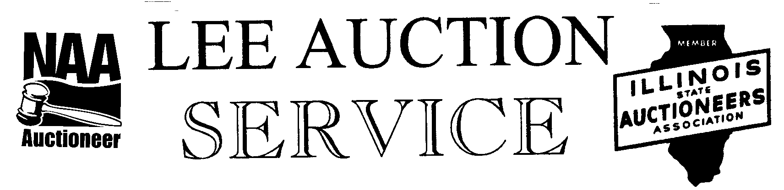
Belvidere, IL 61008
815-988-0249 cell
AUCTIONEER: LYLE LEE, IL. State License #440.000200 WI. # 2863-52 &
JEFF MARRS # 441.001813
CLERKS & CASHIERS: LEE AUCTION SERVICE
Visit our web site at www.leeauctionservice.com & check out AuctionZip for terms & more info.

