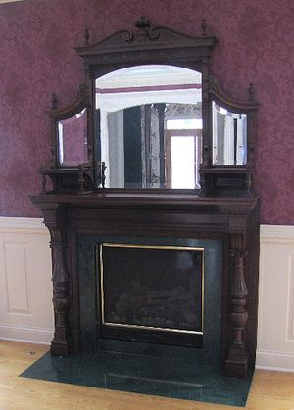
Seller’s Antique Narrative

Victorian Fireplace Mantel

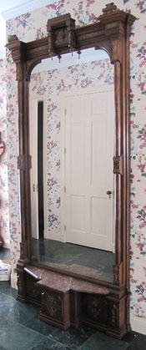
Purchased from a Victorian home located in Buffalo NY. It is solid Mahogany with extensive carving, finials, and columns. This piece is from the late 1860’s. Mantel has been professionally refinished by Jerry Hensler. Pier Mirror in sale is from the same house.

Pier Mirror

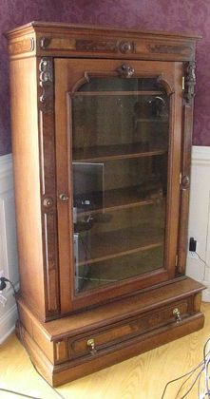
Purchased from a Victorian home located in Buffalo NY. The frame is made from solid walnut, and the columns are burl walnut. The marble on the base is understood to be original. There is significant relief carving on the sides and top. This piece is from 1870 or before. The glass is original and understood to be made at the end of the period when mirror glass was made using a mercury process. This piece was restored by Jerry Hensler. Fireplace mantel in sale is from the same house.

Bookcase

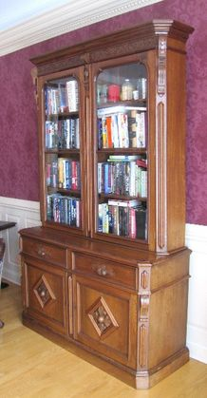
This bookcase is from Boston, Massachusetts. It was made during the 1870’s and was still in the original house when purchased. The bookcase glass is original as are the acorn drawer pulls and base cabinet knobs. This unit has original finish. There are nice carvings across the top of the upper cabinet.

Hutch

This hutch is solid walnut with extensive burl walnut appliqués. It was originally in the Stroh’s mansion in Detroit, Mi. The carvings and drawer pulls are original to the piece. It was professionally restored by Jerry Hensler. This piece is from the 1870’s or early 1880’s.

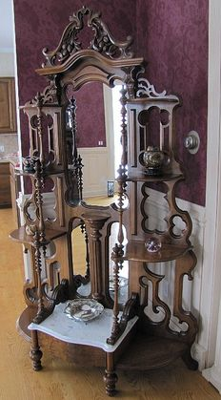
Étagère

This piece was originally in a Victorian home in Detroit, Mi. When purchased by us it had been painted white and incurred some damage over the years. It is from the 1890’s and is solid walnut. This piece was professionally restored by Jerry Hensler and is now in excellent condition. The marble on the piece is not original.

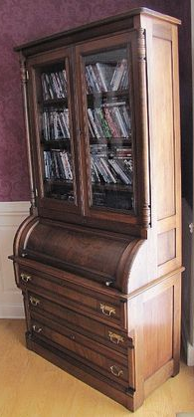
Desk/Bookcase

This piece was originally in a Victorian home in Calumet, Michigan. It was purchased from an estate that had been in the same family for 90+ years. It is made of walnut with nice Burl Walnut features. It is from the 1890’s era and is
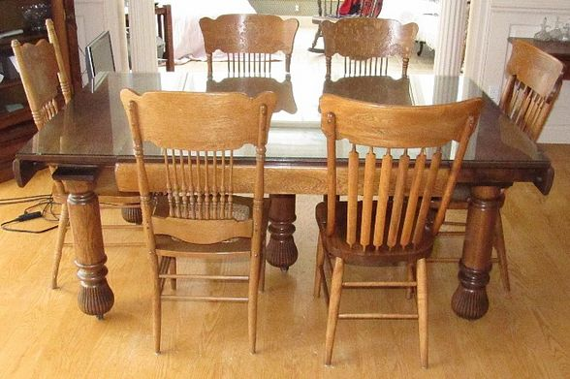
Oak 5-Leg Table

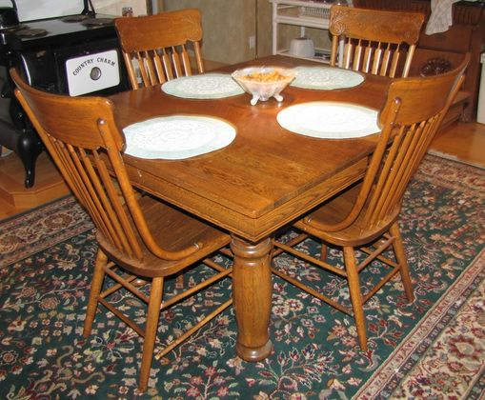
This 42” x 72” table is in excellent condition. I believe it was manufactured by the Grand Rapids Furniture Company in the early part of the last century. It has self storing leaves & has a glass top to protect the surface. It is in excellent condition. Was refinished by Jerry Hensler.

Oak 5-Leg Table

This table is 42 inches square without. Four leaves are included. This piece has been refinished and is also in excellent condition. It was produced in the early part of the last century.
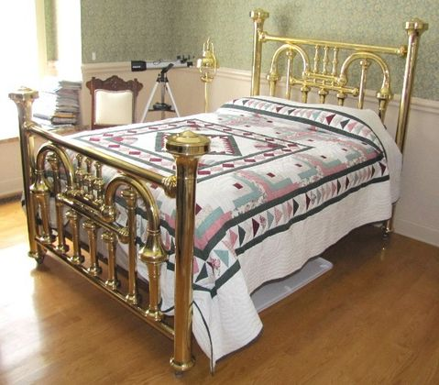
Brass Trumpet Bed

This bed is the only one I have ever seen of this construction. The brass pieces of the bed are huge and over the top impressive. When purchased from an estate in Detroit it was almost black. It was taken apart piece by piece and cleaned, polished, lacquered, and then baked to make the finish permanent. The refinish effort was a $2500 expense but the result was well worth it. I’m told this piece is from the civil war era. It is really an excellent piece that anyone should be pleased to own.
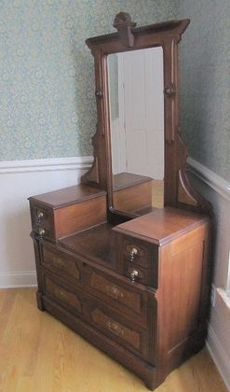
Walnut Chest with Mirror

This piece came to me in a box and was painted white. My primary interest was in whether or not it could be saved. Jerry Hensler took on the challenge and the result is a very nice 1890’s piece. It is in excellent condition now and is a real eye catcher.
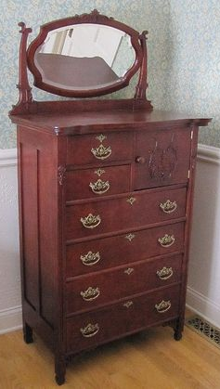
Cherry Chest of Drawers

This piece is without a doubt the nicest chest of drawers I’ve had over the years. Although it looks like the nicest of Cherry Wood dressers, I believe the wood is really poplar or maple. It was originally stained cherry so when it was restored I had it done the same way. The result is a beautiful piece of furniture that anyone can enjoy to look at or use.

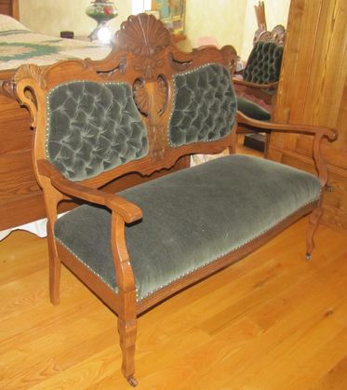
Settee

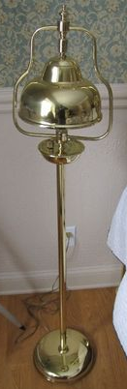
This settee is very nice and restored to original condition. I believe the wood is ash or maple. It is stained to look like walnut as it was originally. The upholstery was done by a lady in Saginaw, Michigan who specializes in antique restoration. This is an 1890’s piece and shall be appreciated by the most discriminating eye.

Brass Lamp / Brass Dome Shade

This lamp was purchased from an estate sale in Detroit. I bought it to go with the Brass Trumpet bed. It was professionally refinished and re-wired. It is a really attractive light and goes well in any setting.

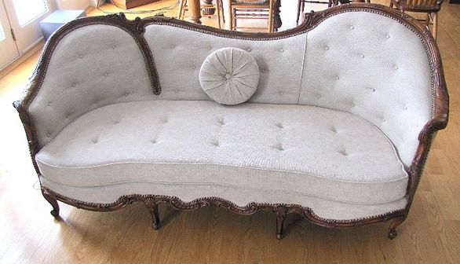
Sofa

This sofa is a French Country style from the late 1800’s. It was purchased from an estate in Grand Blanc. It has been fully restored from the frame up by Jerry Hensler. The wood features and trim have a light walnut finish. The springs, padding and upholstery were done by a person who specializes in antiques. The covering is a tan (ish) neutral color and will go with almost any décor.

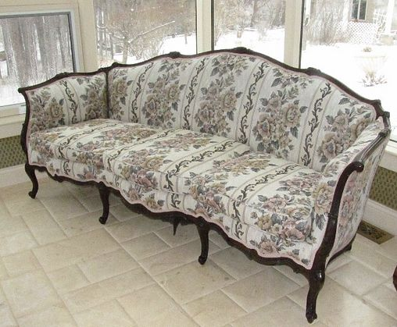
Sofa

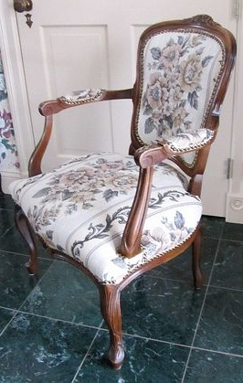
This sofa is from the 1920’s or 30’s. I rescued it from a garage in Almont, Michigan. When I purchased it, it had the original covering. It has been fully restored from the frame up by Jerry Hensler. The wood features have a dark walnut finish. The springs, padding, and upholstery were done by a person who specializes in antiques. The covering is neutral in color and will go with almost any décor.

Side Chair

This side chair is from the 1920’s or 30’s. I rescued it from a garage in Almont, Michigan. It matches one of the sofas in the sale. It has been fully restored from the frame up by Jerry Hensler. The wood features have a dark walnut finish. The springs, padding, and upholstery were done by a person who specializes in antiques. The covering is neutral in color and will go with almost any décor.

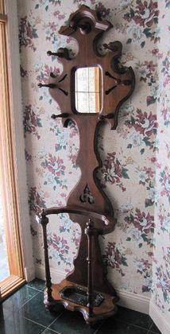
Umbrella Stand
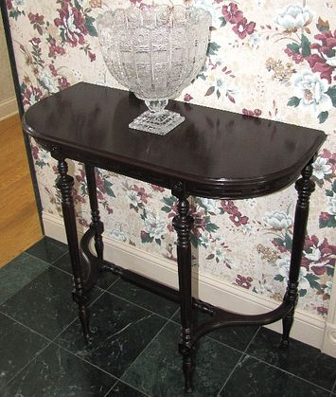
This umbrella stand is from the late 1890’s. I purchased it from an estate in Oxford, Michigan. It was professionally refinished by Jerry Hensler. The wood is walnut and has a medium walnut finish.

Wall Table

I bought this wall table in Saginaw from Jerry Hensler. It is from the 1940’s. It has been in our foyer under the foyer Crystal sconce. It is stained with a dark finish. Although it is somewhat plain it looks striking in the right setting.

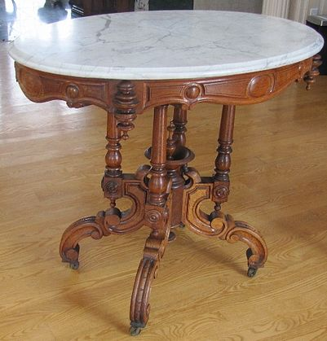
Victorian Marble Top Table

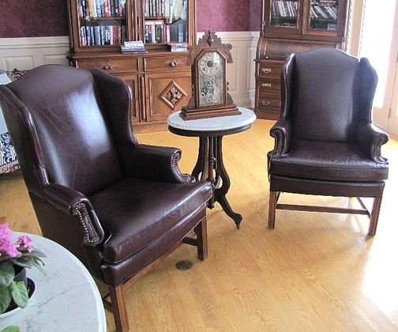
This table came from the same estate as the Étagère in the sale. I purchased it in Detroit, Michigan. It is from the 1890’s. The intricate design and finials make this table unique and extremely desirable. The marble is original. It was fully restored by Jerry Hensler. The wood is walnut and has a medium finish.

Victorian Lamp Table

This table is from the same estate as the Étagère in the sale. I purchased it in Detroit, Michigan. It is from the 1890’s. The marble top is original. It was fully restored by Jerry Hensler. The wood is walnut and has a medium finish.

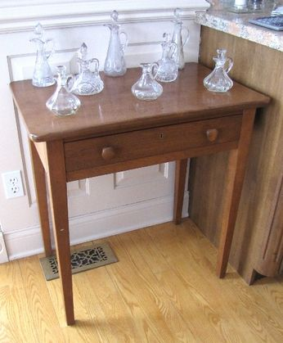
End table

This little end table came from an estate sale in Calumet, Michigan. It is from the 1880’s or before. Its simple design is timeless in appearance. It is made of walnut wood and has a medium walnut finish. This table is just an outstanding piece. It was fully restored by Jerry Hensler.

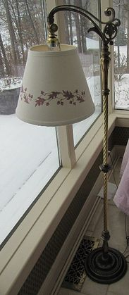

Brass Floor Lamp

This lamp is from the 1920’s or 30’s. I had it fully restored and polished by a person specializing in antique brass restoration. It has 4 individual lights that can be adjusted for intensity by a switch.

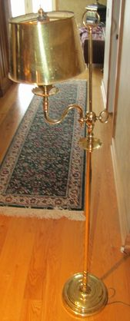
Brass Floor lamp

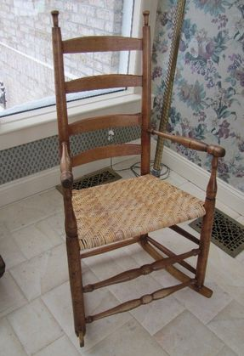
This lamp is from the 1920’s or 20’s. It has been fully restored and polished by a person specializing in antique brass restoration. It has one light and works very well as a reading light in our family room.

Rocking Chair

This rocking chair is of Shaker design and may very well be one of the earliest pieces in our collection. When I bought it, it had slight traces of the original blue finish. This piece has been fully restored by Jerry Hensler. I believe this piece dates to the early
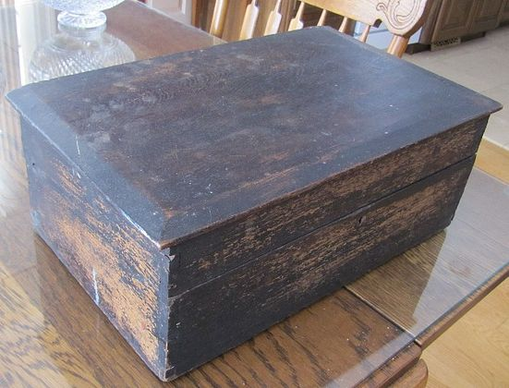

Children’s Lap Desk

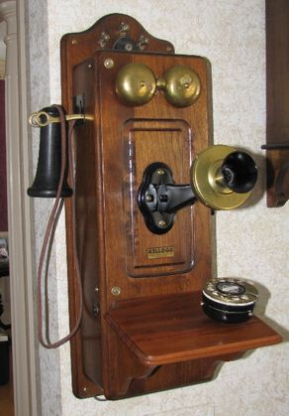
This lap desk is from the early days of One Room School Houses. It has the original finish and has had some minor repair. There is a section of an old newspaper serving as a liner that dates to the late 1800’s. This is a great conversation piece.

Wall Phone

This wall phone is made of walnut and that makes it rather rare and hard to find. The manufacturer is Kellogg Switchboard. I had it fully restored and made operable by adding a dial mechanism. Imagine a phone that’s a 100 years old that you can still use. This is a great piece and has brought many hours of enjoyment.
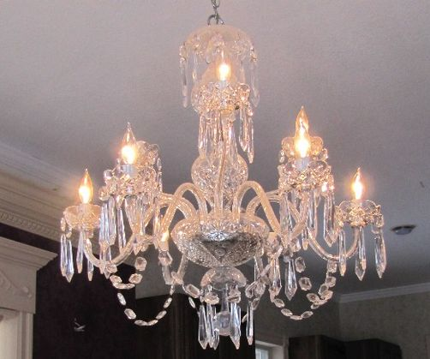

Waterford Cranmore Chandelier

This is a nine light Waterford Chandelier. We purchased it in 1986 and it has hung over our Dining room table every since. It is the most collectable of all Waterford Crystal nine light chandeliers. It is simply beautiful and should be appropriate in most any elegant setting.

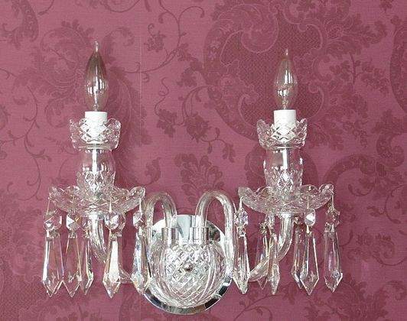

Waterford Sconces

There are two Waterford two light sconces that match the Cranmore Chandelier. We have had them in our foyer and living room. They are as beautiful in appearance as the chandelier and are quite rare.

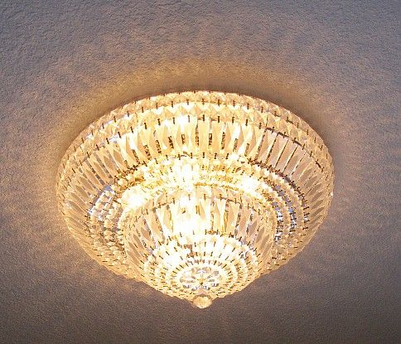
Schoenbeck Ceiling Fixture

This Schoenbeck ceiling light is crystal and is very attractive. It has been in our foyer and makes a statement all of its own. It is made up of hanging crystal prisms. This fixture is sure to please anyone.
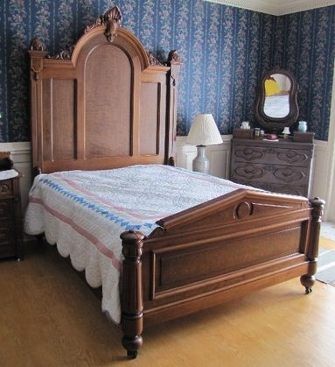
Victorian Bed

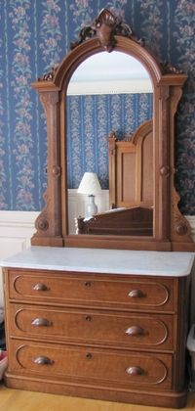
This bed is from the same estate as the large bookcase in the sale. It was purchased in Boston. There is a matching dresser with mirror in the sale. It is from the 1870’s era. The bed is made of walnut and has the original sideboards. The headboard is almost eight feet in height and the footboard is approximately 38 inches high. The bed has nice burl accents, carvings, and scroll work. It is queen size in width. It was professionally refinished by Jerry Hensler.

Victorian Dresser with Mirror
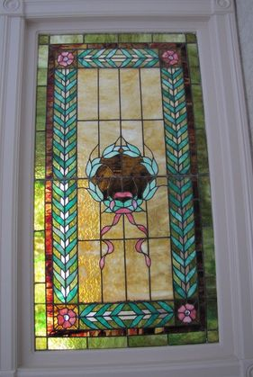
This dresser is from the same estate as the bookcase in the sale. It was purchased in Boston and is from the 1870’s era. It is almost eight feet in overall height. There are nice burl accents, carvings, and scroll work. The wood is walnut. The marble is original. It was professionally refinished by Jerry Hensler.

Ribbons and Bows

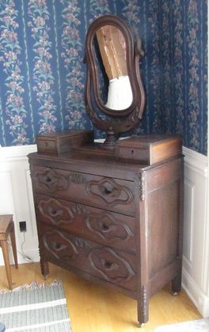
This is a magnificent piece of ribbons and bows stained glass. It was purchased from the Boston estate and is also from the early 1870’s. The colors are vibrant and the piece is in excellent condition. It was used by us as an inset to a divider wall. This size and quality of stained glass in this design is very desirable and is quite collectable.

Dresser with Mirror

This is probably the oldest piece in our collection. I believe it to be from the 1830’s. It has the original finish and glass. All of the hardware and drawer pulls are believed to be original. It is solid walnut and has a great patina.

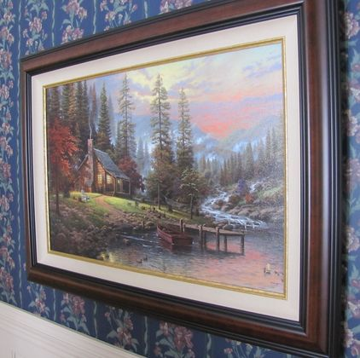
Thomas Kincaid Painting

This is an international print with apprentice highlighting and a master sketch on the reverse side. We bought it on a trip to Toronto several years ago. It has a beautiful lake setting and as with all Kincaid paintings has striking light effects. It is a sold out print and with its international status and highlights it is quite collectable.
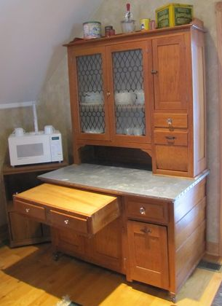
Hoosier style Cabinet

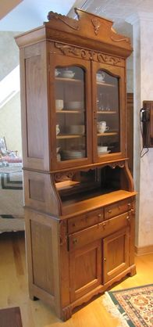
This is a Hoosier style cabinet unlike any I have ever seen. It actually has a pullout table or work surface. The metal on the piece is original as are all the glass, handles, drawer pulls. I bought this at an estate sale in Wisconsin. My primary reason for buying it was that I had never seen anything like it. It is just a great piece.

Oak Hutch

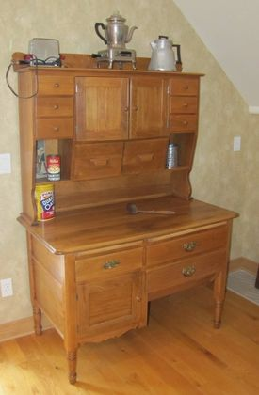
This hutch was actually purchased from the previous owner of the Lets Talk Auction. It was from a local Bontrager family estate. It separates into three pieces and when fully assembled stands over seven feet tall. All of the glass, hardware, door pulls, etc. are original. It was refinished by Jerry Hensler. This is probably the nicest late 1800’s early 1900’s hutch I have ever seen.

Baker’s Cabinet

This baker’s cabinet is unusual primarily because it appears to be made from Elm wood. It is nicely refinished by Jerry Hensler and wood make a statement in any homes kitchen area.

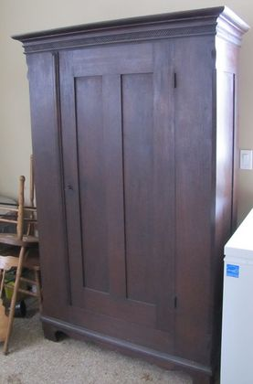

Wardrobe Closet

I bought this at an estate sale in Alpena, Michigan. I was the only one there interested and I couldn’t believe it. This piece has the most elaborate and detailed joinery and craftsmanship I have ever seen in an early 1800’s wardrobe. It still has the original finish. It is in a medium to dark finish. I believe the primary wood is ash.
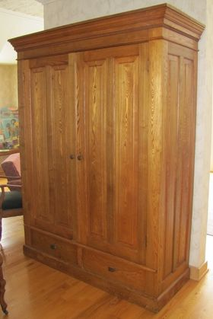

Wardrobe Closet

This is the largest wardrobe closet I have ever seen. I purchased this piece at an estate sale in Alpena, Michigan. It stands over seven feet high and is almost 4 ½ feet wide. It has original hardware. This is truly a stately looking piece.

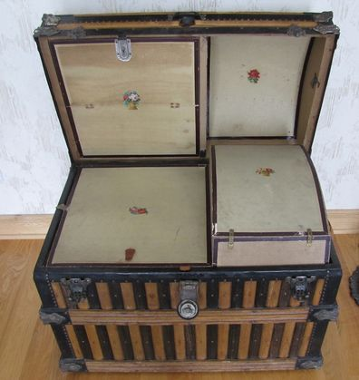
Wooden Trunk

I always passed on the opportunity to buy a wooden trunk until I saw this one. It has the original finish on the outside and on the inside all the original compartments are intact and in excellent condition. The heavy brass hardware is original. This is beyond a doubt the nicest trunk I have ever seen in original condition.

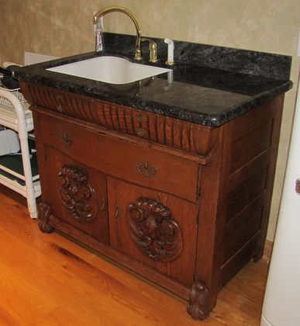
Wet Sink

This is an old sideboard that I bought from an estate in Almont, Michigan. It is made of oak wood and has nice carvings on the doors. I had it modified to accommodate a kitchen sink with a marble top. It is quite unique while at the same time being functional and a great conversation piece.
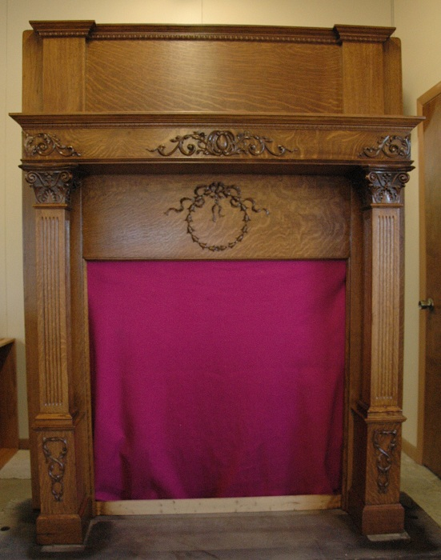

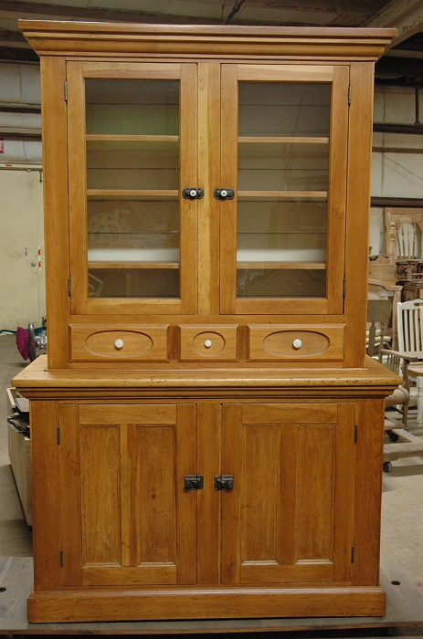
Oak Fireplace Mantel
This is a Mantel that was originally in a home in the Boston Edison district of Detroit, Michigan. I purchased the mantel and other pieces of the home at the same time in the early 1990's. This Mantel is in absolutely perfect original condition and was recently refinished by Jerry Hensler. The Mantel is from the late 1890's or possibly the early 1900's. It is one of the nicest mantels I have ever seen and is sure to please even the most discerning collector.
Pine Cupboard
This cupboard was bought from an estate in the Fairview, Michigan area. It is from the early 1900's and is likely a local craftsman or homemade piece. When I got it there was a small piece of molding missing otherwise it was complete and in original condition. It has been refinished by Jerry Hensler and as a result is in excellent condition. It will surely be a compliment to any home.

