8th Annual Michigan Auctioneers Association Exclusive!

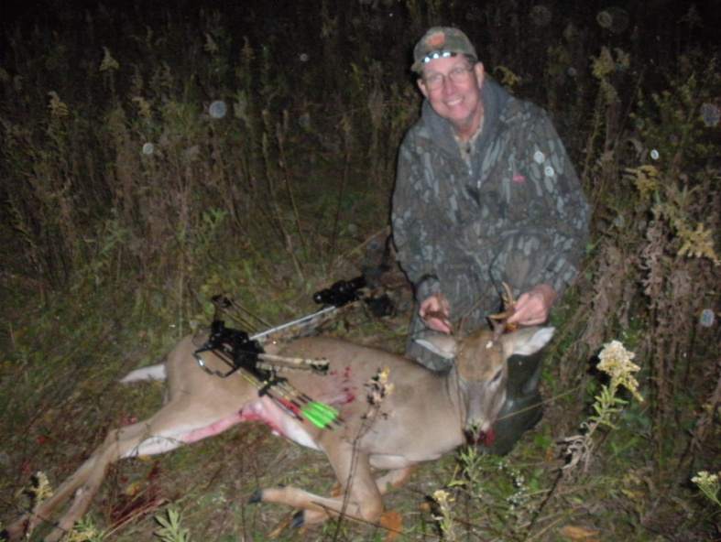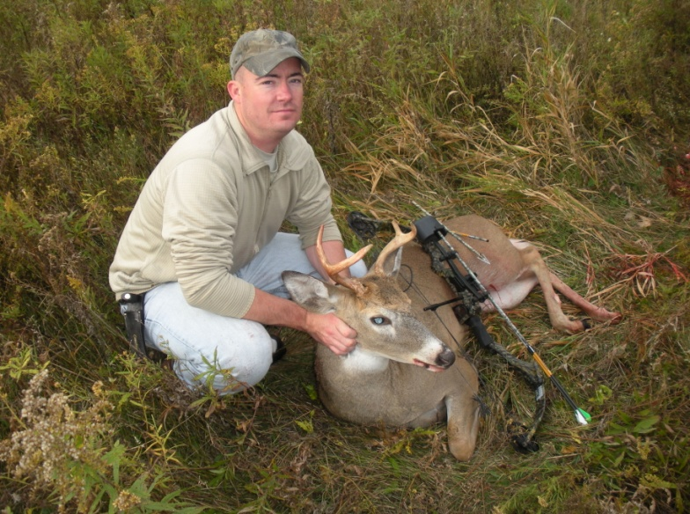Hibs Memorial Bow Hunt 2012

* Guided 2-Person Hunt for a M.S.A.A. Member and Guest.
* Three days and two nights of hunting farmland Whitetails!
* Meals and Lodging included.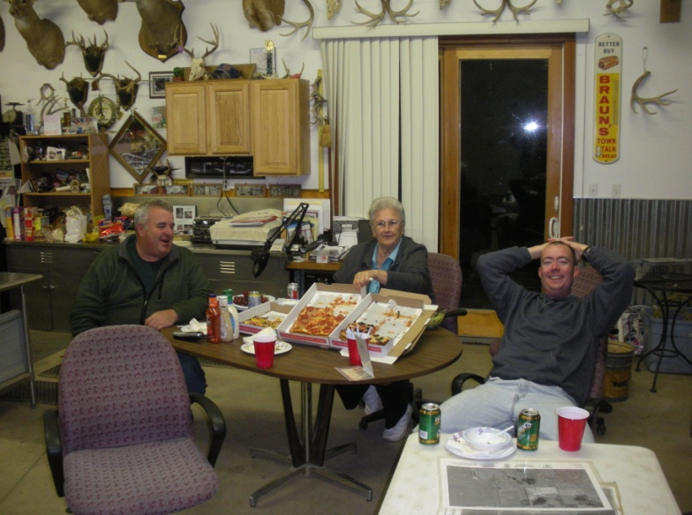
* 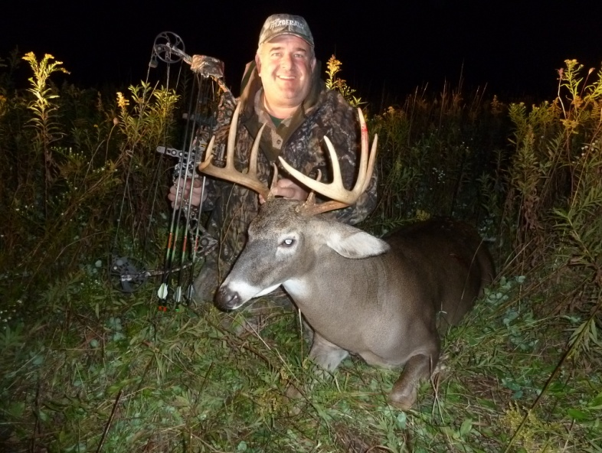This private land hunt will be held in Ann Arbor, Michigan

Hunt made possible by Joyce Braun (Meal planner, property manager, game recovery specialist and seasoned trophy photographer) and Brian L. Braun (Guide)

Braun & Helmer Auction Service, Inc.

Braunandhelmer.com