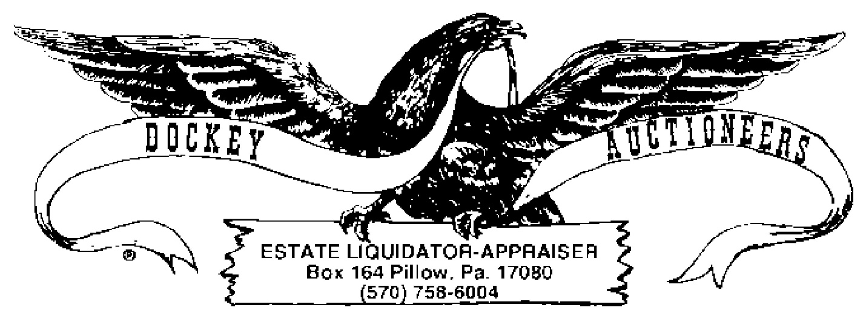

***COIN AUCTION ~ 15 DECEMBER 2023 ~ 6:00 P.M.***

1. LOT: (20) WASHINGTON SILVER QUARTERS (1946-1956)
2. LOT: (16) WASHINGTON SILVER QUARTERS (1957-1964D)
3. LOT: (10) WASHINGTON QUARTERS (1971-1971)?
4. LOT: (24) KENNEDY HALVES (1971-1991)
5. LOT: (9) STEEL CENTS
6. LOT: (20) WHEAT CENTS (1909VDB-1953S)
7. LOT: (13) LINCOLN CENTS (1944D-1985)
8. (3) $2.00 LOTS-LINCOLN/WHEAT CENTS, BC
9. (2) ROLLS 1970 UNC CENTS, BC
10. LOT: (6) SACAGAWEA DOLLAR COINS
11. LOT: (6) PRESIDENTIAL DOLLAR COINS
12. (2) PROOF SETS: 1964 & 1964D, BC
13. PROOF SET: 1965
14. PROOF SET: 1966
15. PROOF SET: 1967
16. (3) PROOF SETS: 1968, 1968D & 1968S, BC
17. (7) PROOF SETS: 1969 & 1969S, BC
18. (3) PROOF SETS: 1970D, 1970S, 1970P
19. LOT: 1919 CANADIAN LARGE CENT & PERRY CO. SESQUICENTENNIAL COIN
20. LOT: CURRENCY REPLICAS & CONFEDERATE BANK NOTES
21. PAPERWEIGHT COINAGE
22. BOOK LOT: 71-JEFFERSON NICKELS (1938-1964) 22A. BOOK LOT: 10-JEFFERSON NICKELS (1965-)
23. LOT: (59) BUFFALO NICKELS
24. LOT: (87) LINCOLN CENTS