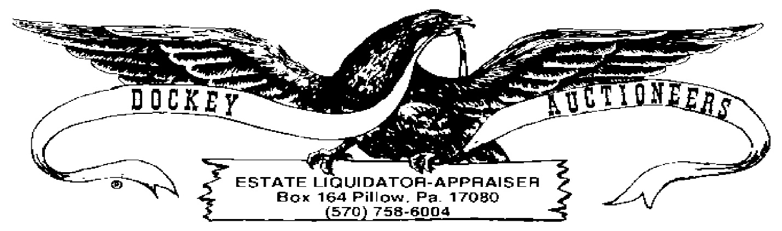

**CROSSROADS MARKET & PUBLIC AUCTION WEEKLY PUBLIC AUCTION**

**COIN LISING FOR 08 JULY 2022-6:00 P.M.**

1. 1858 Flying Eagle
2. 1858 Flying Eagle
3. 1866 2-cent Coin
4. (4) Large Cents, unknown dates, Buyer’s Choice
5. (2) $7.00 Lots Eisenhower Dollars, Buyer’s Choice
6. (2) $7.00 Lots Combination Eisenhower Dollars & Susan B Anthony Dollars, Buyer’s Choice
7. (5) $7.00 Lots Bicentennial Halves, Buyer’s Choice
8. $4.75 Combination Bicentennial Halves & Quarters
9. (4) $7.00 Lots Bicentennial Quarters, Buyer’s Choice
10. $7.00 Jefferson Nickels
11. $1.60 Jefferson Nickels
12. (12) Indian Head Cents
13. (9) Indian Head Cents
14. (35) Steel Cents
15. Assorted US Coinage, as is
16. (412) Wheat Cents
17. Partial Book: (39) Jefferson Nickels, Book 1 (1938-1961)
18. Partial Book: (20) Jefferson Nickels, Book 1
19. Partial Book: (9) Jefferson Nickels, Book 2 (1962-)
20. Partial Book: (18) Jefferson Nickels, Book 2
21. Partial Book: (80) Fifty State Quarters (1999-2008)
22. Partial Book: (20) Indian Head Cents
23. Partial Book: (31) Lincoln Cents, Book 1 (1909-1940)
24. Partial Book: (72) Lincoln Cents, Book 2 (1941-)
25. Partial Book: (57) Lincoln Cents, Book 2
26. $20.00 Green Seal, 1950-C Series Bill (over)
27. $4.35 Assorted Canadian Coinage
28. $6.50 Assorted Canadian Coinage
29. 80-cents Canadian Nickels
30. (82) Canadian Cents
31. 100 Mark Deutsch Note
32. (10) Foreign Coins
33. (31) Foreign Coins
34. (16) Tokens
35. (12) Tokens
36. (5) Packs Littleton Stamp & Coin Company Coins
37. (11) Rolls UNC State Quarters, Hot Springs National Park, Virgin Island & Guam Rolls, Buyer’s Choice