**PUBLIC AUCTION**

**4355 ELLWOOD ROAD; NEW CASTLE, PENNSYLVANIA 16101**

**SATURDAY, SEPTEMBER 3, 2022 at 9:00 am**

**\* TOOLS * COLLECTIBLES * JEWELRY * GUNS * HOUSEHOLD \***

**COPPER, ALUMINUM PIPE, SCRAP, PIPE FITTINGS, COPPER & BRASS FITTINGS; PILE COPPER TUBING, SEARS CRAFTSMAN COLORMATIC 230 AMP ARC WELDER W/BOOK, EXTRA LEADS, RODS; ELECTRIC ACCESSORIES; PLUMBING ACCESSORIES; ALUMINUM TRAILER FRAME; SIDING /ROOF PIECES; PLASTIC PIPE; RIDGID 24, 18, 14 PIPE WRENCHES; SOLID STEEL WORK BENCH 8 FT; MAGNETIC LOCATOR/METAL DETECTOR; GARDEN CART; HAND CULTIVATOR; ROOF SNOW REMOVAL SHOVEL; PRUNER, CLIPPERS; SLEDGE; MATTOCK; ALUMINUM SHOVEL; POST SNOW SHOVEL; POST HOLE DIGGER; RAKES; FORKS; HAMMERS, HATCHETS; SAW; SNAKE; TOILET OGGER; BOLTS; WOOD CLAMPS; PROPANE TANKS; EXTENSION CORDS; FOOT PUMP; ELECTRIC MOTORS; ESQUIRE AMP; CROSS CUT SAW; BRASS WATER LINE METER NEW IN BOX; CUM-ALONG NEW; BOX ROLLER CHAIN & LINKS; HOMOLITE HEDGE TRIMMER; POLAN PRO LEAF BLOWER; WEEDEATER WACKER; PNEUNIC AIR GUN; SANDING DISCS, ABRASIVE SAW; SANDING WHEEL; SANDER; NOMATIC STAPLER; SPRAYER; HOSE ON CART; 16 FT ALUMINUM EXT LADDER; LADDER; C CLAMPS; KENDALL OIL METAL CAN; OLD BUCKET OF GEAR OIL; FUEL CANS; EDGER; SPRAYER; DOORS; WHEELS; LOG CHAIN; TROLLING MOTOR; BUCKET;**

**STAND; STACKABLE TABLES; MARBLE TOP END/COFFEE TABLE SET; LOVESEAT ROCKERS SET METAL & WOOD; 4 WICKER CHAIRS; ICE CREAM TABLE SET 2 CHAIRS; PLAID LOVESEAT W/STOOL; FULL BED; FASHION TREND DRESSER W/MIRROR; SHOE CUPBOARD;FIREPLACE SET; BUCKET; CARD TABLE W/3 CHAIRS;**

**TRUNK;NEWPORT CIGARETTE SIGN 1987; TOY AUTO COLLECTION; KAWASAKI PHONE; ELLWOOD PURE MILK BOTTLE;OGLE HORN; AMERICAN FARM SCALE;YARD STICKS; KODAK CAMERA; GRIFFIN SHINE MASTER SHOE KIT; METAL CAN OF GLASS WASHING POWDER;MURRAY SPECTRA BICYCLE;MCCOY WISHING WELLS AND FIGURINES; USA VASES; HONEY CROCK; FIREKING CONDIMENT SET FROM KIRK AND HUTTON;**

**ROYAL MAJESTIC SET DISHES SERVICE 8; FRENCH DAUPHINE CHINA SET; 63 YR OLD FENTON TYPE CANDY BOWL W/LID; TEA POTS; TEA CUPS; NIPPON; FINE CHINA; MINIATURE TEA SET; KITCHEN CABINET; CHICKEN COLLECTION; CHICKEN PLATES; COOKIE CUTTERS; BASKETS; POPCORN POPPER; SKILLET; SMITH CORONA TYPEWRITER IN CASE; NECCHI SEWING MACHINE; NATIVITY;**

**SINGERLAND QUALITY DRUM/SNARE SET; CASE DAVE MAC ALBUMS; MICROPHONE ASTATIC HAMM RADIO DESK TYPE MINI DISC PLAYERS W/REMOTE; LENTAR MOVIE PROJECTOR IN BOX;**

**1960’S SET PEARLS W/GOLD ENHANCER (W/RESERVE) BLACK ONYX, OPAL, JADE & PEARL 14K GOLD RINGS (W/ RESERVE) CONSUME JEWELRY; EARRINGS, 70’S NECKLACE, STERLING NECKLACES; TURQUOISE ETC STERLING RINGS, CROSS NECKLACE,**

**SINGLE SHOT SAVAGE MODEL 228 16 GAUGE**

**MARLIN 22 LONG RIFLE W/WEAVER SCOPE MODEL 65 GLENFIELD**

**AMMO W/BELT**

**2003 SHADOW HONDA BIKE 6200 MILES 600CC; VOYAGER KIT CONVERTIBLE BALL HITCH**

**ROUND GLASS PATIO TABLE;YARD CHAIRS;CHAISE LOUNGE; WINDMILL;PALLET AMERICAN FLAG;**

**CEMENT BIRD BATH;TOMATO CAGES;ALUMINUM BALL BAT…**

*Bring a chair. Refreshments available. Sorry No Restroom facilities available.*

***Dave and Pauline McCandless, Owners***

TERMS: CASH or Good Local CHECK

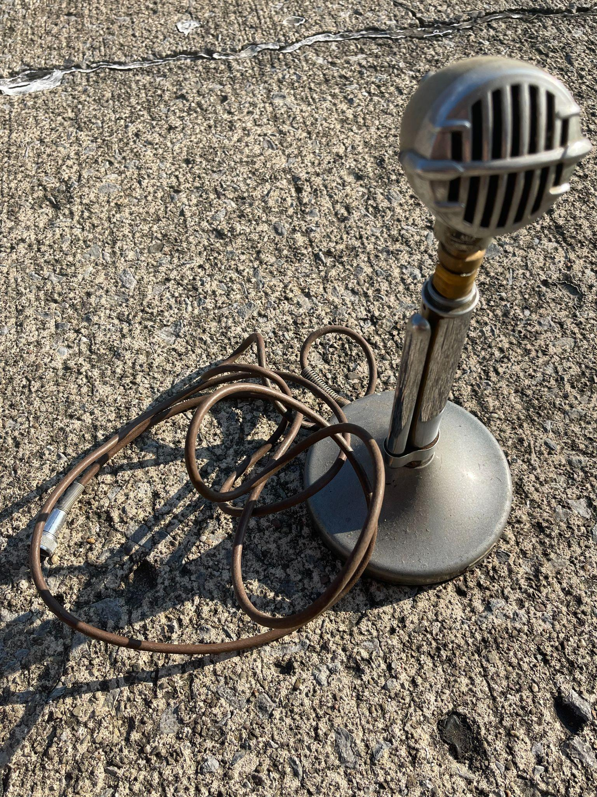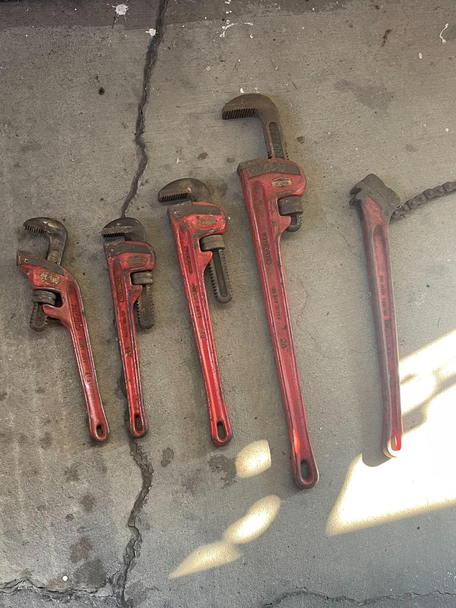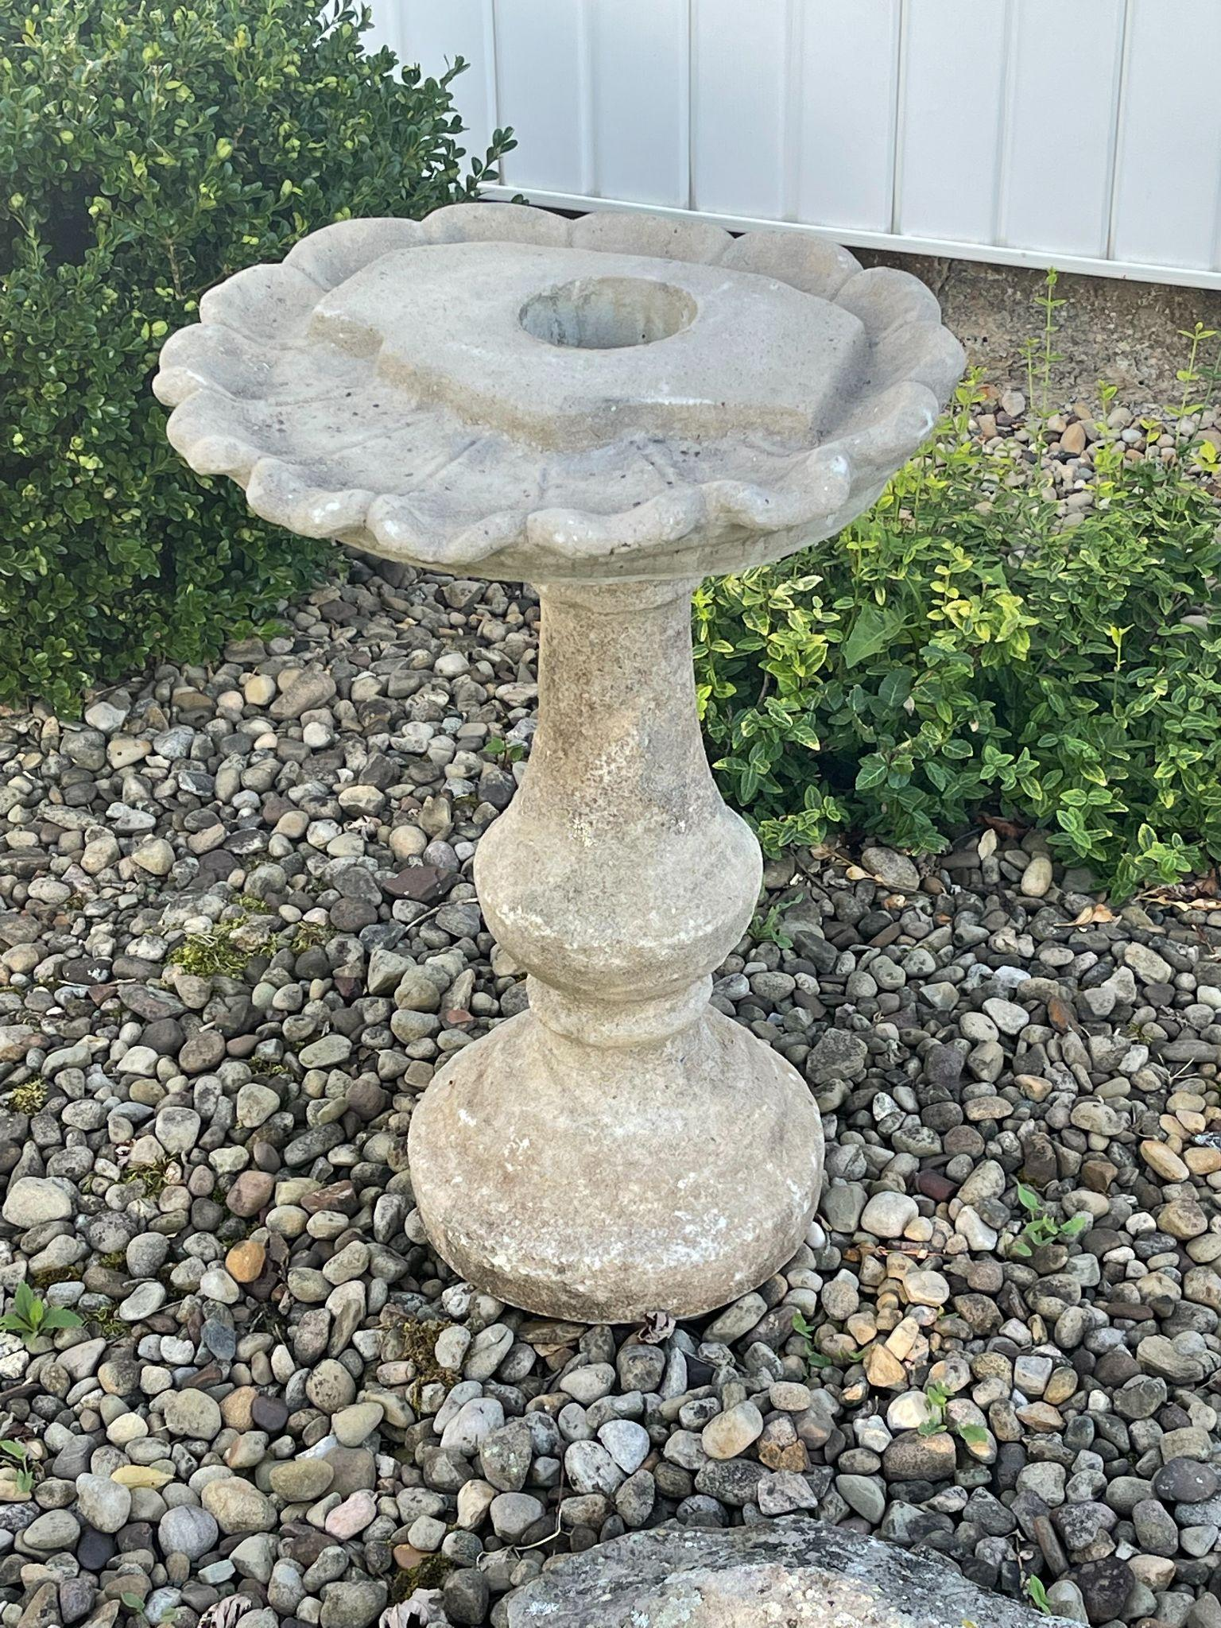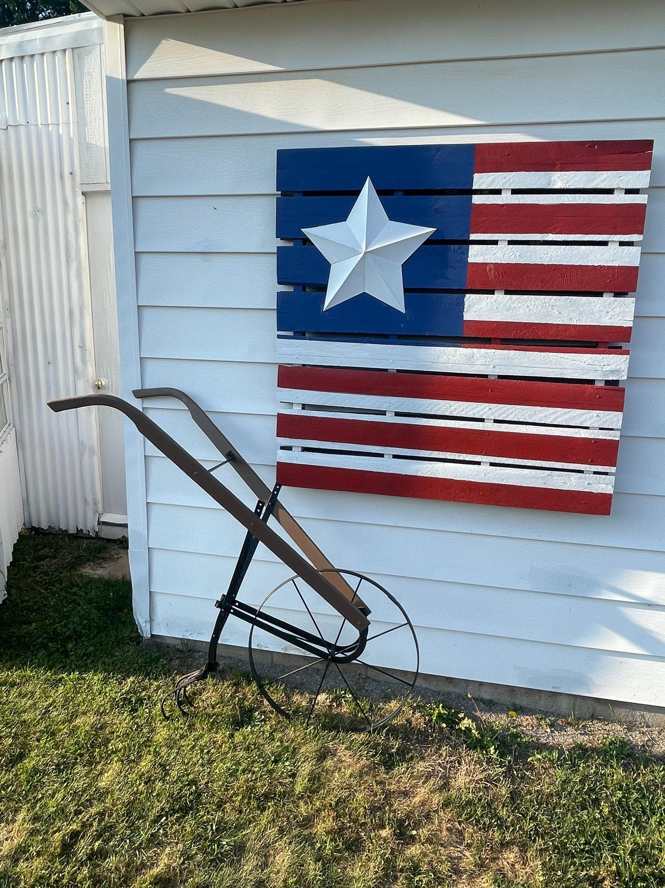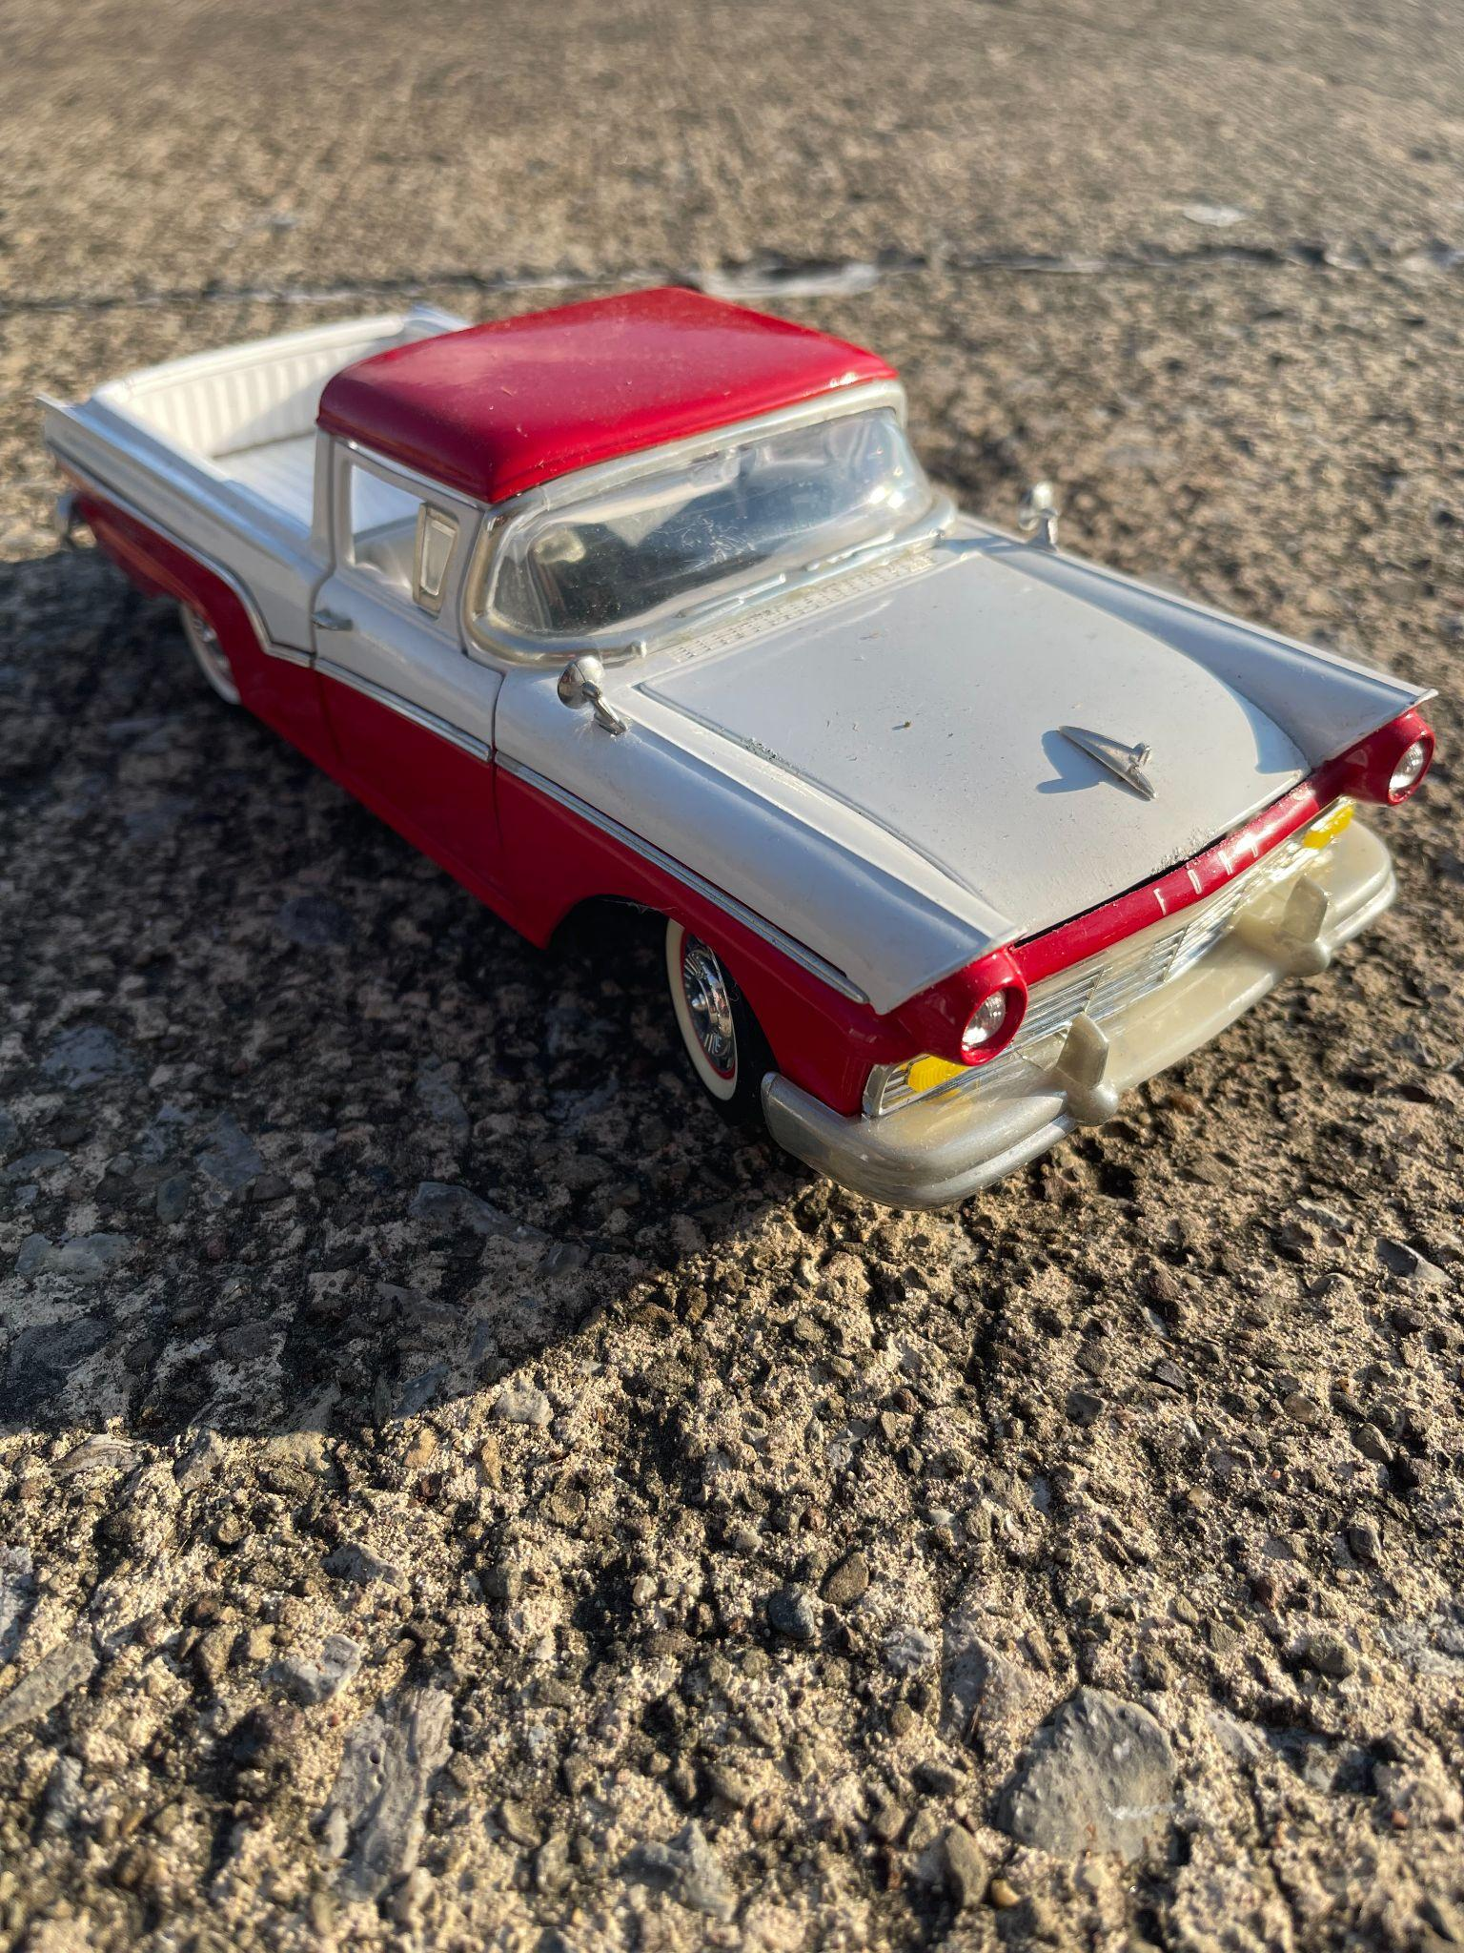

**Still digging and photographing updates on AuctionZip.com or gotoauctions.com**

**MARK CUNNINGHAM, AUCTIONEER AU 3364 (724) 674-8755**