***Real Estate Auction***

Court Ordered Guardianship Auction

**Monday, September 17th, 2018 @ 6:00pm**

**1334 Virginia Street East, Charleston, WV**

**AUCTION TO BE HELD ON SITE AT 1334 VIRGINIA STREET EAST**

**Directions: Downtown Charleston take Virginia Street East. Property located on left. Signs posted.**

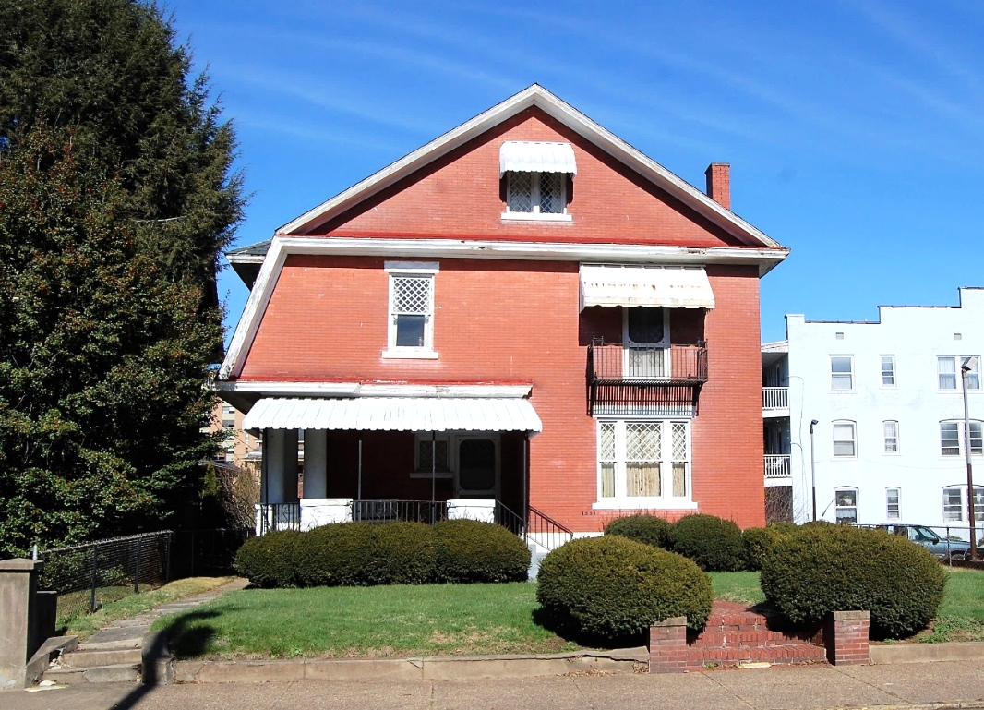

*Auctioneer: Stacy L. Cooper #1517 Auctioneer/Agent: Roger Mullins #1703*

*www.MOUNTAINEERAUCTIONS.com*

or [www.auctionzip.com](http://www.auctionzip.com) ID #4152 or #4158 for terms & photos

BEDROOMS: **5**

BATHS: **2**

SQ. FEET: **Approx. 2,850sqft under roof**

COUNTY: **Kanawha**

TYPE: **2 story modified Dutch Colonial**

YEAR BUILT: **Approx. 1900’s**

CONSTRUCTION: **Brick**

ROOF:  **Slate**

HEAT: **Updated forced air**

WATER: **City**

WALLS: **Plaster**

WINDOWS: **Original wood Tudor style**

FLOORS: **Oak hardwood & tile**

A/C: **None**

SEWER: **City**

|  |
| --- |
| LOT: **LT 51X164 VIRGINIA ST 1334** |
| **- CHAS E District – Kanawha County WV** |

ADDITIONAL: **Large level Virginia Street lot – House needs major & significant restoration – Excellent location & potential – Historic East End - Zoned R-10**