*Real Estate Auction*

For the Estate of Constance Jacobs

Monday, October 14, 2024 @ 5:00pm (on site)

67 Cloverleaf Circle, Malden, WV 25306

SHOWN BY APPOINTMENT–CALL TODAY FOR YOUR OWN PRIVATE SHOWING

Directions: From Route 60/Midland Trail take Malden/Rand Exit, turn toward Kanawha River to Right on Malden Road, then 500ft. to left on Cloverleaf Circle 500ft to #67 on left.

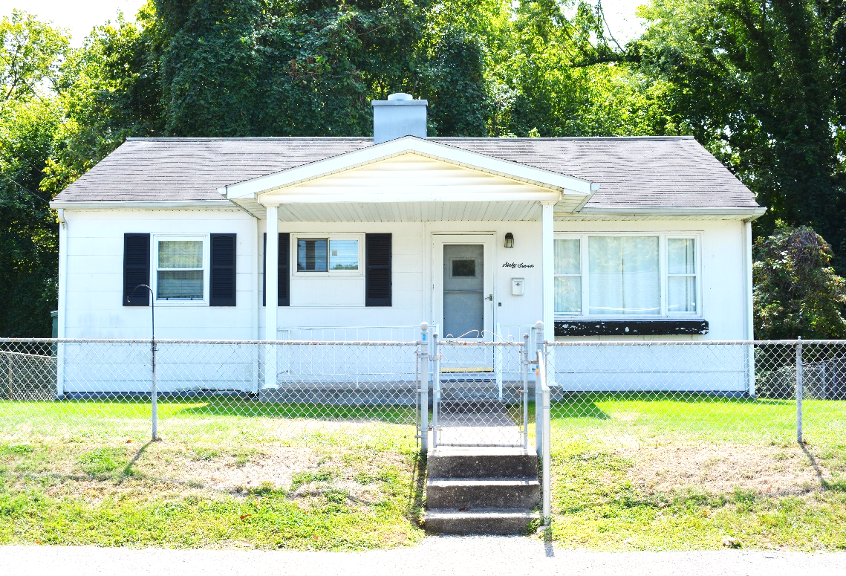

*Auctioneer: Stacy L. Cooper #1517 Auctioneer/Agent: Roger Mullins #1703*

*www.MOUNTAINEERAUCTIONS.com*

BEDROOMS: **3**

BATHS: **Full**

SQ. FEET: **Approx. 815 main level**

COUNTY: **Kanawha**

TYPE: **Ranch**

YEAR BUILT: **1954**

CONSTRUCTION: **Block/Wood/Siding**

ROOF: **Asphalt Shingle**

HEAT: **Gas warm air**

WATER: **City**

WALLS: **Panel board**

WINDOWS: **Partial vinyl replacement**

FLOORS: **Oak/Vinyl/Carpet**

A/C: **Central**

SEWER: **Public**

LOT: **Lot 9 CASH ADN MALDEN; Malden District, Kanawha County, WV**

LEGAL DESCRIPTION: **Deed Book: 1101 Page Number: 0285**

ADDITIONAL: **One owner original condition ranch – needs some updating - Nice established neighborhood – walking distance to the Kanawha River**