Real Estate Auction

Court Ordered Conservatorship Auction

Monday, September 30, 2024 @ 5:00pm (on site)

212 Pine Circle, Dunbar, WV 25064

SHOWN BY APPOINTMENT–CALL TODAY FOR YOUR OWN PRIVATE SHOWING

Directions: From I64 Dunbar intersection turn north on Tenth Street to Roxalana Road then 1mile to Left on Garnett Drive, then 300ft to right on Walnut Street 700feet to Right onto Pine Circle . #212 on right.

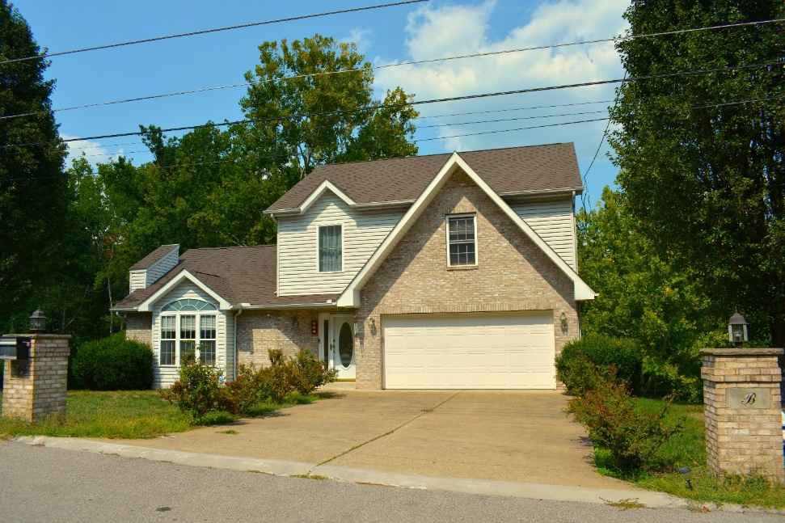

Auctioneer: Stacy L. Cooper #1517 Auctioneer/Agent: Roger Mullins #1703

www.MOUNTAINEERAUCTIONS.com

BEDROOMS: 4

BATHS: 2 Full on upper level ½ on main level 1 Full lower level

SQ. FEET: Approx. 545 garage Approx. 1,300 main & upper levels
Approx. 1,200 lower level

COUNTY: Kanawha
TYPE: Modern w/full basement
YEAR BUILT: 2000
CONSTRUCTION: Block/Siding/Brick
ROOF: Dimensional Shingle (new)
HEAT: Electric warm air
WATER: City
WALLS: Sheetrock
WINDOWS: Wood & Casement
FLOORS: Oak/Tile/Vinyl/Carpet
A/C: Central
SEWER: Public
LOT: 40/100A M/L PT LTS 31-32 SEC 2 OAKVIEW EST; Dunbar Corp, Kanawha County, WV

LEGAL DESCRIPTION: Deed Book: 2514 Page Number: 976

ADDITIONAL: 4BR/3.5BA – Full finished basement w/bath & laundry – 2car garage with concrete driveway – Propane fireplace - Located in a prime residential area – Large lot – New dimensional roof (July 2024)

