*Real Estate Auction*

For the Estate of Janet H. Trigaux & Judith Haid, Executrix

Monday, November 11th, 2019 @ 5:00pm

1213 Indian Lake Drive, Elkview, WV 25071

***PROPERTY VIEWING SUNDAY - Oct. 20, 27, Nov. 3 & 10 2-4PM***

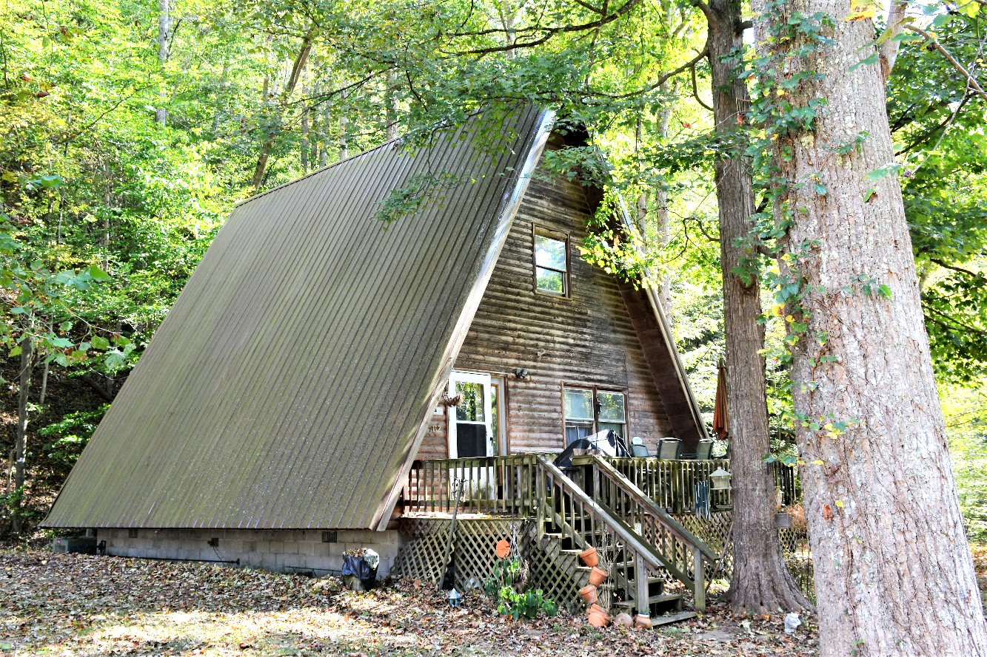

*Auctioneer: Stacy L. Cooper #1517 Auctioneer/Agent: Roger Mullins #1703*

*www.MOUNTAINEERAUCTIONS.com*

or [www.auctionzip.com](http://www.auctionzip.com) ID #4152 or #4158 for terms & photos

BEDROOMS: **3**

BATHS: **1**

SQ. FEET: **Approx. 1,300 sq. ft.**

COUNTY: **Kanawha**

TYPE: **Wood A-Frame**

YEAR BUILT: **1986**

CONSTRUCTION: **Frame/Log siding**

ROOF: **Metal**

HEAT: **Propane**

WATER: **City**

WALLS: **Paneling/sheetrock**

WINDOWS: **Wood**

FLOORS: **Laminate & carpet**

A/C: **Duct work installed for central air**

SEWER: **Public**

LOT: **33Acres M/L - Elk District-Kanawha County WV**

ADDITIONAL: **Updates & remodeling needed**