*Real Estate Auction*

For the Estate of Janet H. Trigaux & Judith Haid, Executrix

Monday, November 11th, 2019 @ 5:00pm

1203 Indian Lake Drive, Elkview, WV 25071

***PROPERTY VIEWING SUNDAY - Oct. 20, 27, Nov. 3 & 10 2-4PM***

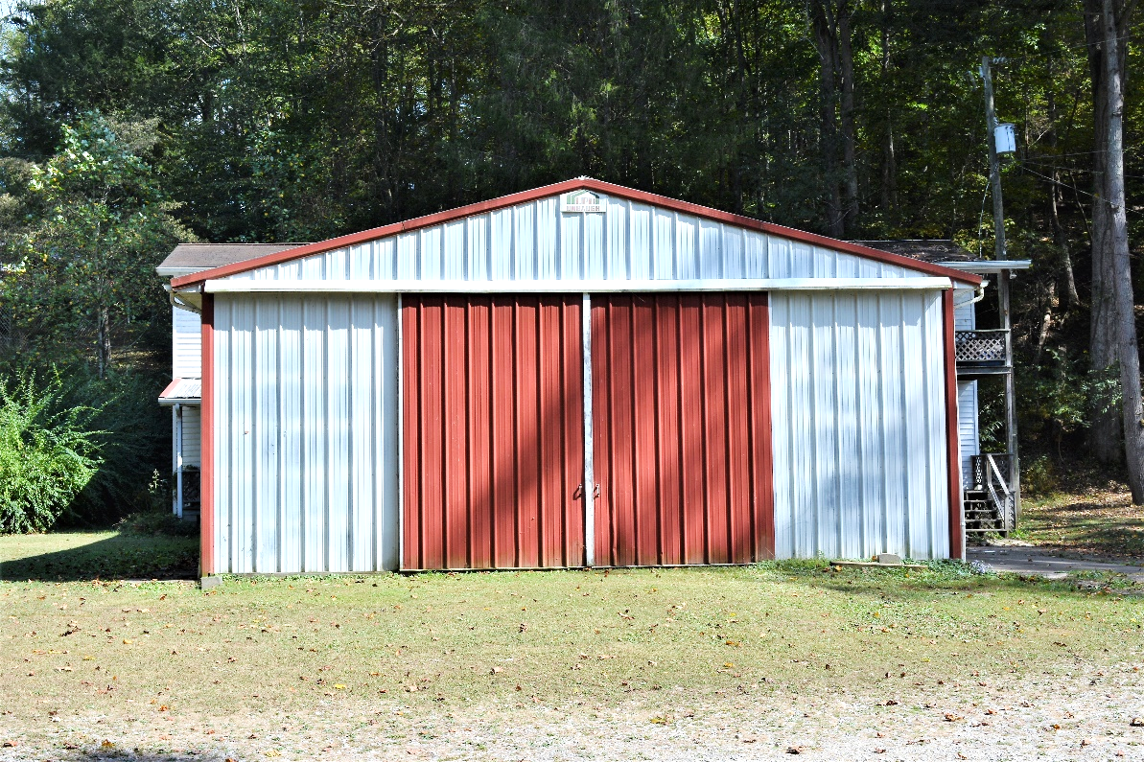

*Auctioneer: Stacy L. Cooper #1517 Auctioneer/Agent: Roger Mullins #1703*

*www.MOUNTAINEERAUCTIONS.com*

or [www.auctionzip.com](http://www.auctionzip.com) ID #4152 or #4158 for terms & photos

Metal Utility Building

BEDROOMS: **N/A**

BATHS: **1**

SQ. FEET: **Approx. 1,500 sq. ft.**

COUNTY: **Kanawha**

TYPE: **Metal Building**

YEAR BUILT: **1980**

CONSTRUCTION: **Pre-fabricated wood & insulated metal building**

ROOF: **Metal**

HEAT: **Electric overhead units**

WATER: **City**

WALLS: **Insulated metal**

WINDOWS: **Aluminum**

FLOORS: **Concrete**

A/C: **N/A**

SEWER: **Public**

LOT: **1-89/100A M/L SURF INDIAN CK;  
MH SITE-Elk District-Kanawha County WV**

ADDITIONAL: **Well built metal building suitable for storage/rental**