*Real Estate Auction*

For the Estate of Janet Trigaux & Judy Haid, Executrix

Monday, November 11th, 2019 @ 5:00pm

1203 Indian Lake Drive, Elkview, WV 25071

***PROPERTY VIEWING SUNDAY - Oct. 20, 27, Nov. 3 & 10 2-4PM***

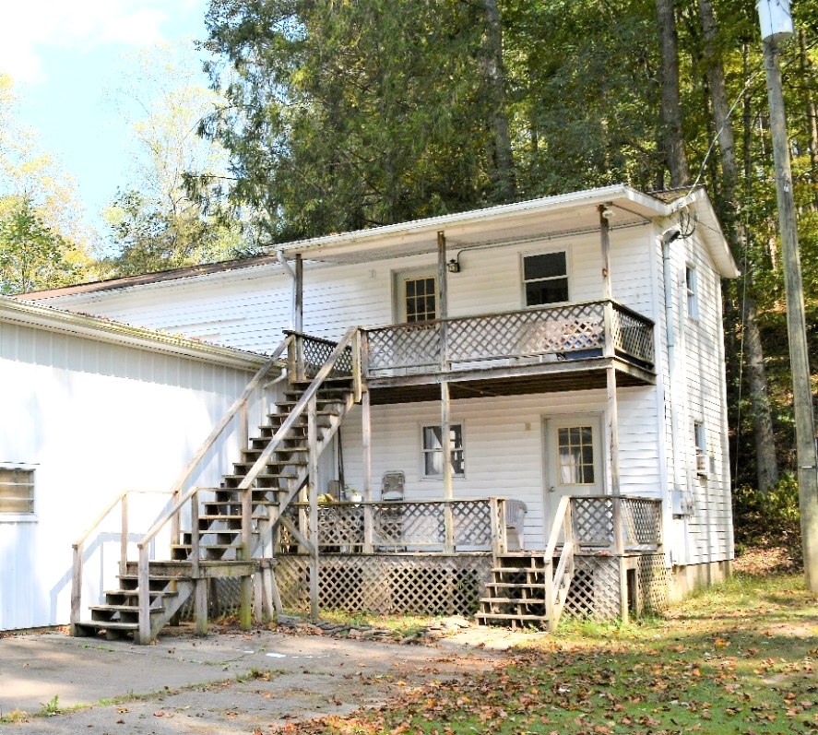

*Auctioneer: Stacy L. Cooper #1517 Auctioneer/Agent: Roger Mullins #1703*

*www.MOUNTAINEERAUCTIONS.com*

or [www.auctionzip.com](http://www.auctionzip.com) ID #4152 or #4158 for terms & photos

Apartment Building

BEDROOMS: **1**

BATHS: **1**

SQ. FEET: **Approx. 1,200 sq. ft.**

COUNTY: **Kanawha**

TYPE: **2story**

YEAR BUILT: **1990**

CONSTRUCTION: **Wood w/vinyl siding**

ROOF: **Asphalt shingle**

HEAT: **Electric baseboard**

WATER: **City**

WALLS: **Drywall**

WINDOWS: **Wood**

FLOORS: **Laminate**

A/C: **Window**

SEWER: **Public**

LOT: **1-89/100A M/L SURF INDIAN CK;  
MH SITE-Elk District-Kanawha County WV**

ADDITIONAL: **1BR/1BA efficiency 1st floor apartment – Large 2nd story storage/craft room – Could be converted to additional apartment**