*Real Estate Auction*

For the Estate of Janet H. Trigaux & Judith Haid, Executrix

Monday, November 11th, 2019 @ 5:00pm

1127 Indian Lake Drive, Elkview, WV 25071

***PROPERTY VIEWING SUNDAY - Oct. 20, 27, Nov. 3 & 10 2-4PM***

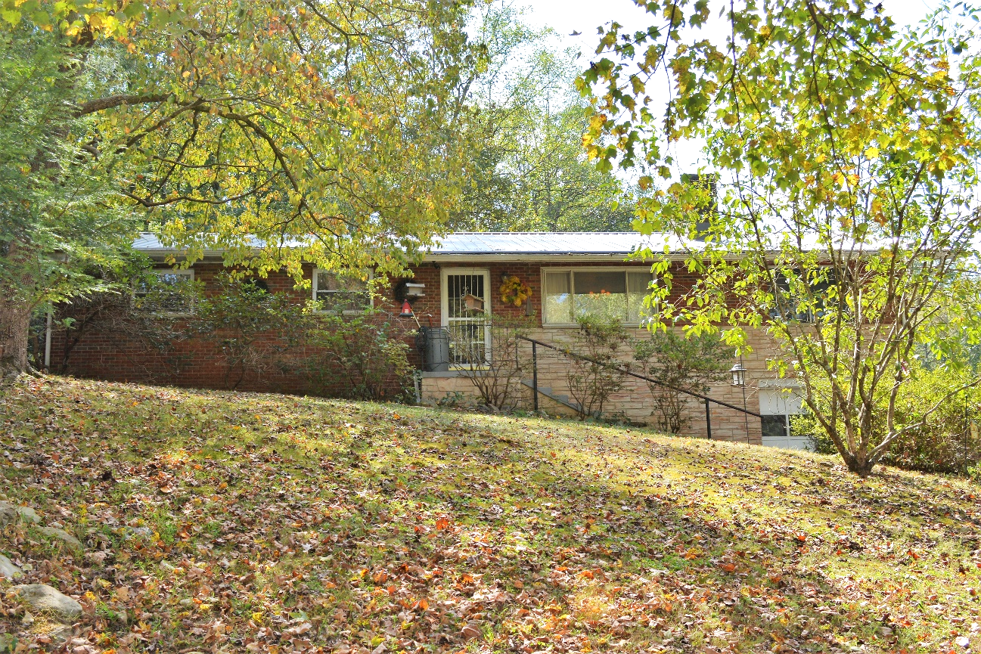

*Auctioneer: Stacy L. Cooper #1517 Auctioneer/Agent: Roger Mullins #1703*

*www.MOUNTAINEERAUCTIONS.com*

or [www.auctionzip.com](http://www.auctionzip.com) ID #4152 or #4158 for terms & photos

BEDROOMS: **4**

BATHS: **1 ½**

SQ. FEET: **Approx. 1,750 sq. ft.**

COUNTY: **Kanawha**

TYPE: **Ranch**

YEAR BUILT: **1963**

CONSTRUCTION: **Block**

ROOF: **Metal**

HEAT: **Gas forced air**

WATER: **City**

WALLS: **Plaster**

WINDOWS: **Aluminum double insulated**

FLOORS: **Oak hardwoods under carpet**

A/C: **Central**

SEWER: **Public**

LOT: **1-89/100A M/L SURF INDIAN CK;  
MH SITE-Elk District-Kanawha County WV**

ADDITIONAL: **Fenced back yard – Garage**