Real Estate Auction

For the Campbell Estate

Monday, December 4, 2023 @ 4:00pm

38 Strawberry Path Lane, Clendenin, WV 25045

(Falling Rock, WV Coordinates 38.47255$°N, 81.39664°W$)

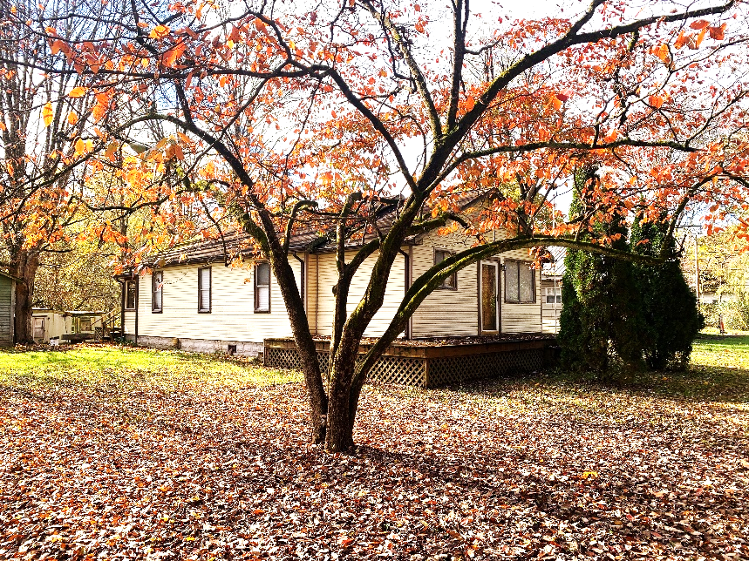

Auctioneer: Stacy L. Cooper #1517 Auctioneer/Agent: Roger Mullins #1703

www.MOUNTAINEERAUCTIONS.com

BEDROOMS: 2

BATHS: 1 Full

SQ. FEET: Approx. 820 total

COUNTY: Kanawha
TYPE: Conventional Rambler
YEAR BUILT: Approx. 1940
CONSTRUCTION: Wood
ROOF: Shingle
HEAT: Gas forced air
WATER: Public
WALLS: Plaster & Drywall
WINDOWS: Metal frame replacements
FLOORS: Oak hardwood, Laminate, tile & carpet
A/C: Central
SEWER: Elk PSD
LOT: 1A 27POLES SURF LT 3 BOTTOM LAND PRICE ESTATE MH; Big Sandy District, Kanawha County (as assessed)

LEGAL DESCRIPTION: Deed Book: 2329 Page Number: 0064

ADDITIONAL: Over 1acre on Historic Elk River – Outdoor activities abound - fishing, kayaking, canoeing & river floating with take-out at Blue Creek - Property fronts Route 119 – Wood burning fireplace – Technologies available Front & back decks – Enclosed back porch - Possible 3rd bedroom – Location between new Clendenin Middle & Herbert Hoover High schools

