*Real Estate Auction*

For the Estate of Lester Davis

Monday, September 25, 2023 @ 5:00pm

1304 Village Drive, South Charleston, WV 25309

*** OPEN HOUSE SUNDAY September 3, 10, 17, & 24, 2023 2-4PM ***

Join us for an OPEN HOUSE or call us today to schedule your own private showing

Directions: From Kanawha Turnpike at Rock Lake turn onto Village Drive then stay right 1/2mile to 1304 located on left.

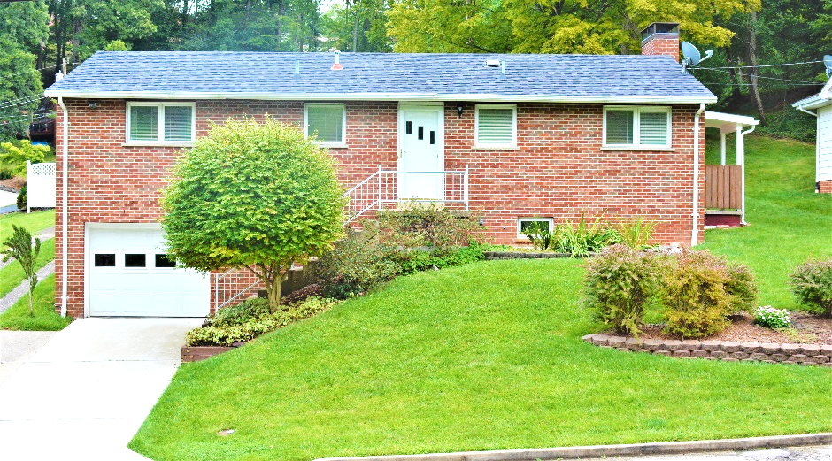

*Auctioneer: Stacy L. Cooper #1517 Auctioneer/Agent: Roger Mullins #1703*

*www.MOUNTAINEERAUCTIONS.com*

BEDROOMS: **3**

BATHS: **Full on main level Full in basement**

SQ. FEET: **Approx. 1,104 total**

COUNTY: **Kanawha**

TYPE: **Raised ranch**

YEAR BUILT: **1959**

CONSTRUCTION: **Brick**

ROOF: **Shingle**

HEAT: **Gas Forced air**

WATER: **City**

WALLS: **Plaster & Drywall**

WINDOWS: **Wood & metal w/original interior shutters**

FLOORS: **Oak/tile/laminate/carpet**

A/C: **Central**

SEWER: **Public**

LOT: **LT 15 RIDGEWOOD SEC 2 ROCK LAKE VILLAGE W VIL DRIVE 1304; Spring Hill Corp. District, Kanawha County, WV**

LEGAL DESCRIPTION: **Deed Book: 1287 Page Number: 409**

ADDITIONAL: **Finished basement with Bath – Original basement level garage – off-street parking - level rear yard – kitchen updated w/Williams Custom Cabinets – side porch - 2 fireplaces – Very neat, clean, & well-maintained original owner residence**