Real Estate Auction

Court Ordered Conservatorship Auction

Monday, August 14, 2023 @ 3:00pm

1526 Trace Fork Road, Charleston, WV 25309

*** Shown By Appointment – Call Today***
Directions: From Route 119 /Corridor G south of Southridge Center, turn onto Ruth Road 1/4mile to intersection with Trace Fork Road. 1526 Trace Fork Road is on right. Signs posted. 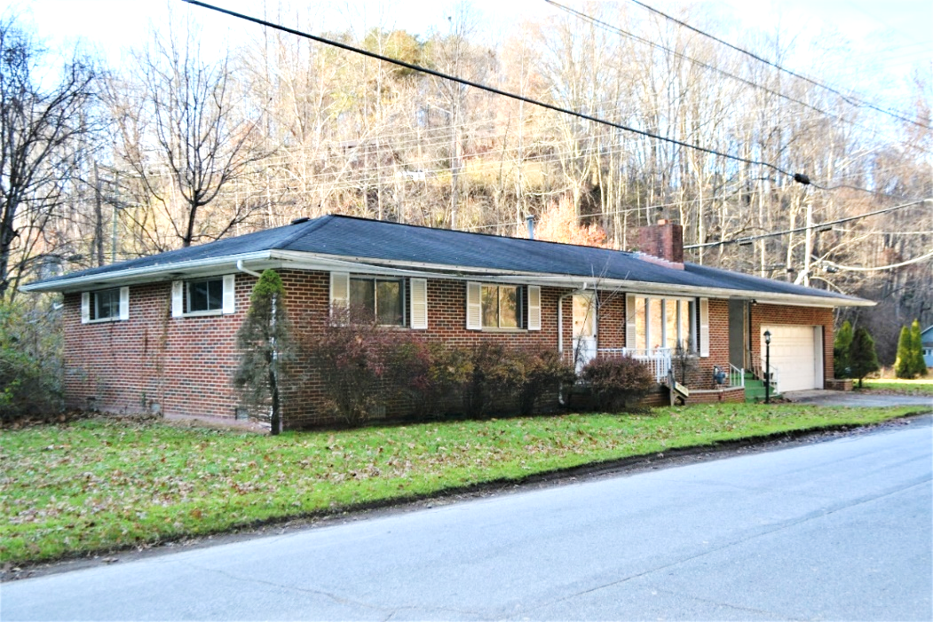

Auctioneer: Stacy L. Cooper #1517 Auctioneer/Agent: Roger Mullins #1703

www.MOUNTAINEERAUCTIONS.com

BEDROOMS: 3

BATHS: 1.5

SQ. FEET: Approx. 1,460 total

COUNTY: Kanawha
TYPE: Ranch
YEAR BUILT: 1959
CONSTRUCTION: Brick
ROOF: Shingle
HEAT: Gas Forced air
WATER: City
WALLS: Plaster
WINDOWS: Metal insulated
FLOORS: Oak/laminate/carpet
A/C: Central
SEWER: Public
LOT: 14/100 M/L TRACE FK DAVIS CK RT 8 BOX 376, Washington District, Kanawha County,

ADDITIONAL: 2car garage – stone fireplace – Breezeway – Laundry room – level lot located on banks of Trace Fork - House needs significant repair work

