*Real Estate Auction*

Court Ordered Conservatorship Auction

Monday, December 19, 2022 @ 3:00pm

801 Sherwood Road, Charleston, WV 25314

*** Open House Sunday 2-4pm ***

Call us today to schedule your own private viewing

Directions: From Route 119 /Oakwood Road turn right on Hickory Road 1/4mile to 801 Sherwood Road.

House is located on right.

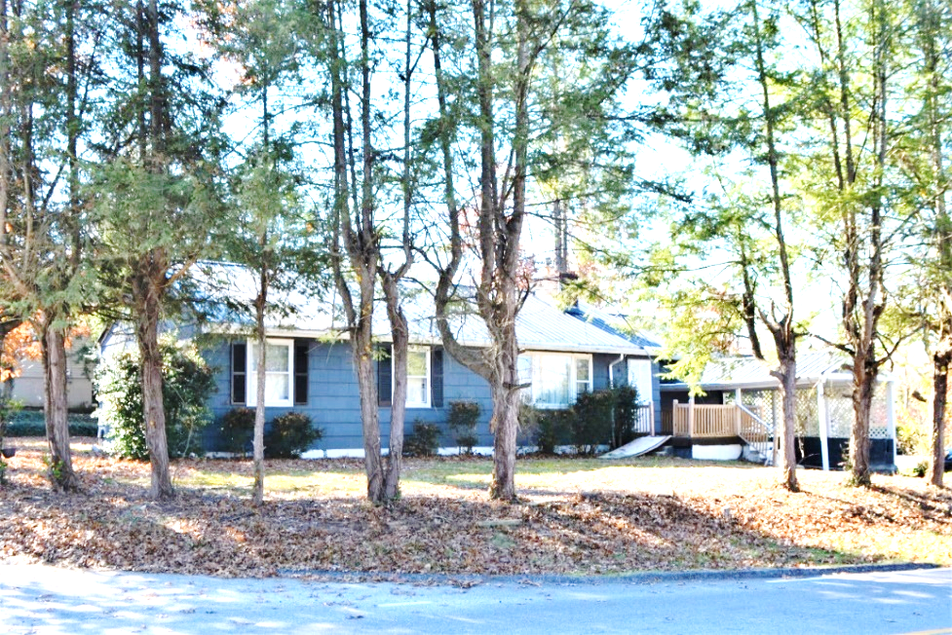

*Auctioneer: Stacy L. Cooper #1517 Auctioneer/Agent: Roger Mullins #1703*

*www.MOUNTAINEERAUCTIONS.com*

BEDROOMS: **3**

BATHS: **2**

SQ. FEET: **Approx. 1,650 main level**

COUNTY: **Kanawha**

TYPE: **Rancher**

YEAR BUILT: **1950**

CONSTRUCTION: **Wood**

ROOF: **Metal**

HEAT: **Gas Forced air**

WATER: **City**

WALLS: **Plaster**

WINDOWS: **Original wood w/storms**

FLOORS: **Oak hardwood/tile/vinyl/carpet**

A/C: **Forced air**

SEWER: **Public**

LOT: **FR PT LTS 10-11 BK & STRIP WILLOW WOOD SHERWOOD 801, CHAS SA District, KANAWHA County, WV**

ADDITIONAL: **Approx. 1/4-acre level corner lot on Sherwood Road, Hickory Road, & Willow Wood Place in desirable South Hills – Family owned & occupied for years – Fireplace - Carport – Family Room/additional bedroom – laundry room – covered patio – all one level**