*Real Estate Auction*

Court Ordered Conservatorship Auction

Monday, December 19, 2022 @ 12:00noon

5 Wisteria Road, Winifrede, WV 25214

*** SHOWN BY APPOINTMENT ***

Call us today to schedule your own private viewing

Directions: From I-77 Marmet Exit #89 turn onto Rt. 94 toward Kanawha River. Make a right on Rt. 61 MacCorkle Ave. 2.9miles to a right on Fields Creek Road 1.6 miles to a left on Cooper Hollow Road.

Cross Bridge to #5 Wisteria Road on right.

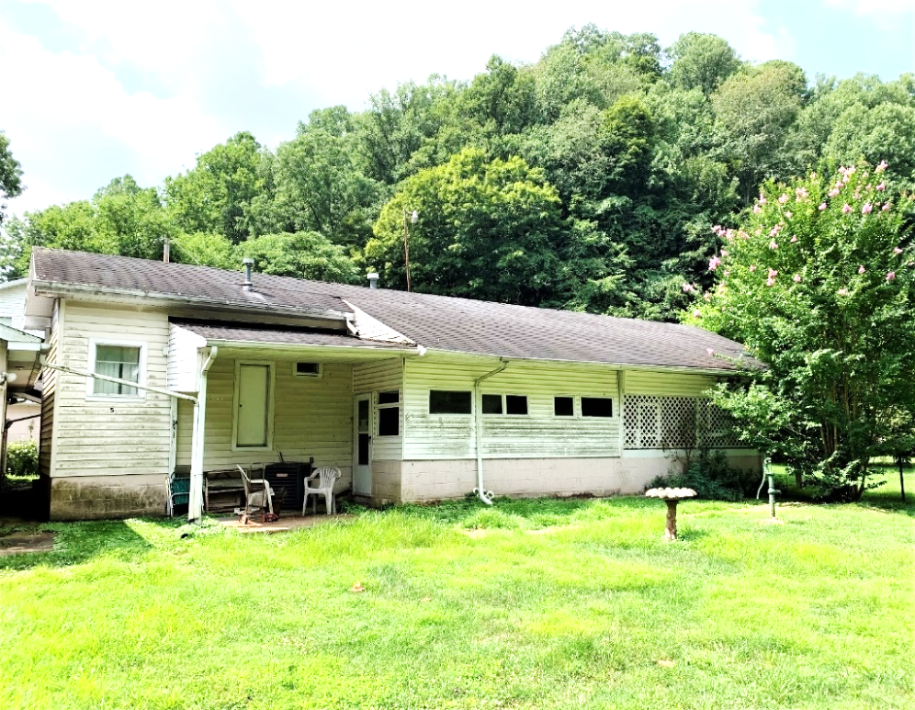

*Auctioneer: Stacy L. Cooper #1517 Auctioneer/Agent: Roger Mullins #1703*

*www.MOUNTAINEERAUCTIONS.com*

BEDROOMS: **2**

BATHS: **2**

SQ. FEET: **Approx. 700 main level**

COUNTY: **Kanawha**

TYPE: **Mobile Home**

YEAR BUILT: **1970**

CONSTRUCTION: **Metal**

ROOF: **Shingle**

WATER: **City**

WALLS: **Paneling**

WINDOWS: **Original metal & wood**

FLOORS: V**inyl/carpet**

SEWER: **Public**

LOT: **49/100 SUGAR CAMP BR FIELDS CREEK, CABIN CREEK District, KANAWHA COUNTY, WV**

ADDITIONAL: **Approx. 1/2-acre level lot - covered patio – 24’x35’ block 2bay detached garage with work area**