*Real Estate Auction*

Court Ordered Conservatorship Auction

Monday, September 12, 2022 @ 5:00pm

2106 Kanawha Blvd. East Unit B-414

Charleston, WV 25311

*** SHOWN BY APPOINTMENT ONLY***

Call us today to schedule your own private viewing

Directions: From I-77 take Greenbrier Street Exit # 99, turn toward Kanawha River. At Kanawha Boulevard stoplight, turn left on Kanawha Boulevard East to 2106 on left. Unit B-414 is 4th floor of west building.

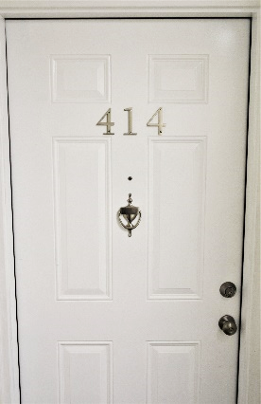 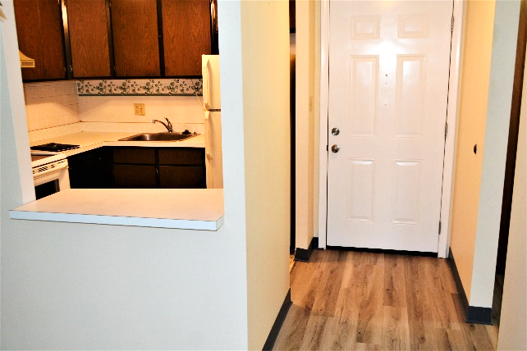

*Auctioneer: Stacy L. Cooper #1517 Auctioneer/Agent: Roger Mullins #1703*

*www.MOUNTAINEERAUCTIONS.com*

BEDROOMS: **1**

BATHS: **1**

SQ. FEET: **Approx. 626 main level**

COUNTY: **Kanawha**

TYPE: **Condominium**

YEAR BUILT:

CONSTRUCTION: **Block**

ROOF: **Rubber**

HEAT: **Electric wall unit**

WATER: **City**

WALLS: **Drywall**

WINDOWS: **Original double hung**

FLOORS: **Laminate/Carpet**

A/C: **Electric wall unit**

SEWER: **Public**

LOT: **UNIT 414 BLDG 2 TERRACE PARK EAST C/E 1.148 626 SQFT**

**11 - CHAS E District, Kanawha County WV**

ADDITIONAL: **Recent partial update to bathroom – Updated laminate flooring in bathroom/hall/foyer. Wonderful opportunity for home ownership, rental income, or to update and resell. Established HOA required for ownership. HOA is approximately $305/month for this unit. Current HOA regulations and information can be found at:**

**TERRACEPARKEAST.com**

**TERRACEPARKEAST.org**