***Real Estate Auction***

For the Estate of Richard Cowgill

**Monday, June 27, 2022 @ 6:00pm**

**7364 Pike Street, Mineral Wells, WV 26150**

**\*\*\* OPEN HOUSE SUNDAY June 5, 12, 19, & 26, 2022 2-4PM \*\*\***

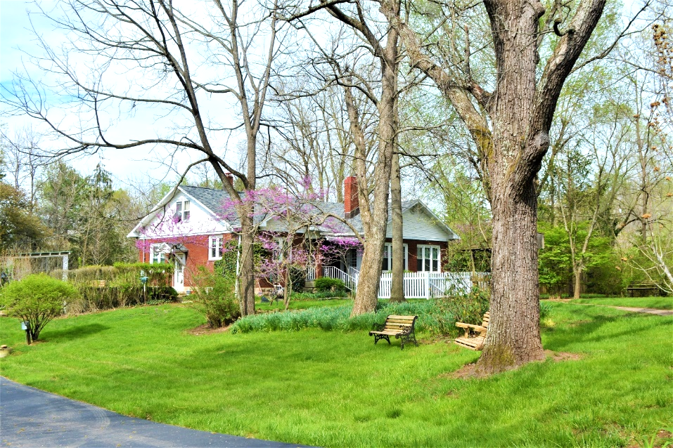

*2BR/1BA 1933 BUILT BRICK COTTAGE RANCHER ON SMALL PRIVATE FARM*

PRIVATE LOCATION – VERY EASILY ACCESSIBLE

LESS THAN 2 MINUTES TO I-77 MINERAL WELLS INTERCHANGE & HINO MOTORS

7.90 ACRES(+/-) WITH 2 STALL BARN

LARGE WORKSHOP & LIVE GAME COUP WITH GROUND LEVEL TRACTOR STORAGE

2ND COTTAGE HOUSE/SHOP/STORAGE WITH ATTACHED WORKSHOP & 2 BAY CARPORT

4-CAR PARKING PAD AT RESIDENCE

NEWER DOUBLE ENTRANCE GOVERNORS STYLE BLACKTOP DRIVEWAY & PARKING PAD

APPROXIMATLEY 6 ACRES PASTURES – ELECTRIC FENCED

LARGE PRIVATE POND WITH FOUNTAIN FOR FISHING/LIVESTOCK WATERING

LOCATED OUTSIDE OF FLOOD PLAIN

PROPERTY LOCATED BETWEEN PIKE STREET & ROUTE 14

UPDATES & UPGRADES INCLUDE: REPLACED WINDOWS & SLIDING DOORS

UPDATED HEATING & COOLING

GENERAC HOME GENERATOR

CONCRETE PATIO WITH JACUZZI HOT TUB

FRONT OF HOUSE DOG WALK SET UP

CROWN MOLDINGS WITH CORNER CAPSTONES

UPDATED BATH WITH WALK-IN SHOWER

2 TILE FIREPLACES WITH UPDATED INSERTS

UPDATED KITCHEN WITH GRANITE COUNTERS & STAINLESS APPLIANCES & MORE

SO MANY POSSIBLE USES & OPTIONS – THIS PROPERTY IS A MUST SEE

***DATA SHEET ON BACK***

***Real Estate Auction***

For the Estate of Richard Cowgill

**Monday, June 27, 2022 @ 6:00pm**

**7364 Pike Street, Mineral Wells, WV 26150**

**\*\*\* OPEN HOUSE SUNDAY June 5, 12, 19, & 26, 2022 2-4PM \*\*\***

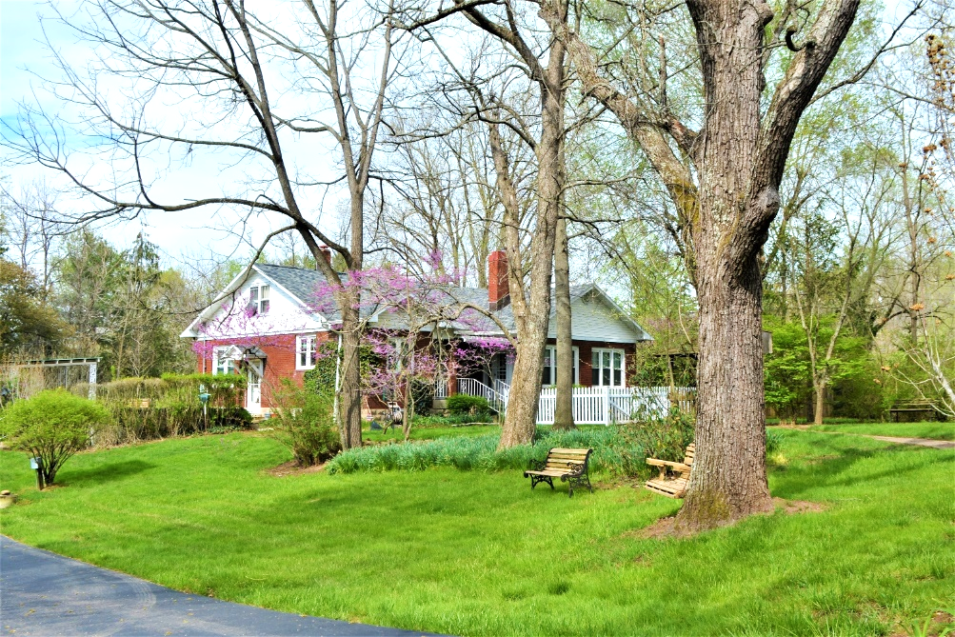

*Auctioneer: Stacy L. Cooper #1517 Auctioneer/Agent: Roger Mullins #1703*

*www.MOUNTAINEERAUCTIONS.com*

BEDROOMS: **2**

BATHS: **1**

SQ. FEET: **Approx. 1,612 main level Approx. 1,280 basement**

COUNTY: **Wood**

TYPE: **Cottage Rancher**

YEAR BUILT: **1933**

CONSTRUCTION: **Brick**

ROOF: **Shingle**

HEAT: **Gas Forced air**

WATER: **City**

WALLS: **Drywall/plaster**

WINDOWS: **Replacement double hung**

FLOORS: **Oak hardwood/tile/laminate**

A/C: **Forced air**

SEWER: **Public**

LOT: **TCT CONT 7.90-ACRES M OR L PARKERSBURG & ELIZABETH PIKE, Tygart District, Wood County - DB W165 PG 298**

ADDITIONAL: **2stall barn-nearly 6acres pasture-large operating pond-2nd cottage house/possible rental-new blacktop driveway & parking pad-Private yet 2 minutes to HINO Headquarters & I-77 Mineral Wells Interchange-Residential Updates galore: Upgraded kitchen w/granite counters & stainless appliances-new remodeled bath w/walk-in shower-GENERAC home generator-newer windows-newer roof-ceramic tile fireplaces with inserts & more**