*Real Estate Auction*

Court Ordered Guardianship Auction

Monday, October 25, 2021 @ 4:00pm

101 Elizabeth Street Unit #3, Charleston, WV 25311

*** OPEN HOUSE SUNDAY October 3, 10, 17, & 24 2-4PM ***

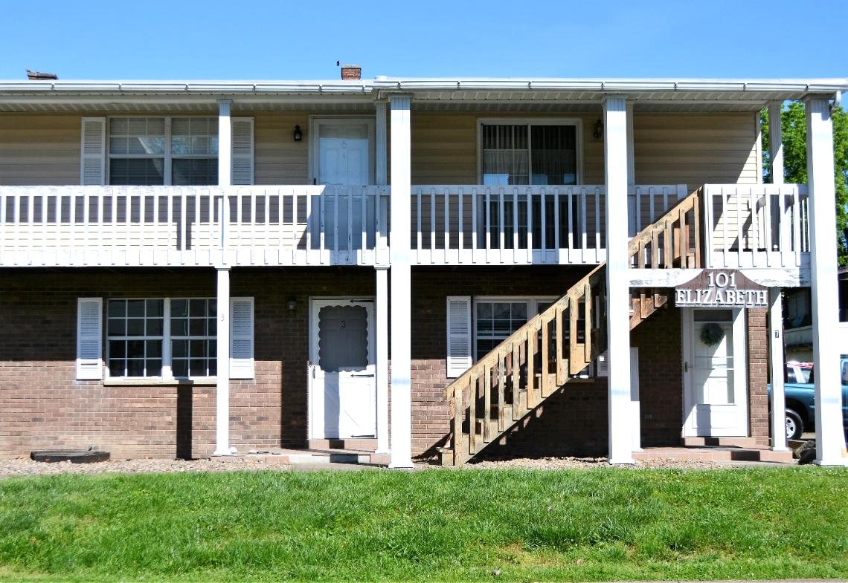

*Auctioneer: Stacy L. Cooper #1517 Auctioneer/Agent: Roger Mullins #1703*

*www.MOUNTAINEERAUCTIONS.com*

or [www.auctionzip.com](http://www.auctionzip.com) ID #4152 or #4158 for terms & photos

BEDROOMS: **1**

BATHS: **1**

SQ. FEET: **Approx. 612**

COUNTY: **Kanawha**

TYPE: **Condominium**

YEAR BUILT: **1985**

CONSTRUCTION: **Brick**

ROOF: **Shingle**

HEAT: **Electric Forced air**

WATER: **City**

WALLS: **Sheetrock**

WINDOWS: **Metal**

FLOORS: **Laminate**

A/C: **Forced air**

SEWER: **Public**

LOT: **UNIT 3 CAPITOL VIEW CONDO**

**612 SQ FT 12.5% C/E ELIZ ST District 11 - Chas E - Kanawha County WV**

ADDITIONAL: **Established neighborhood & convenient location - 1 block from State Capitol in Historic East End Charleston Tiled front porch – Off Street assigned parking - Low maintenance living – HOA in place**