*Real Estate Auction*

Auction for the Estate of Barbara Harmon

Saturday, September 11, 2021 @ 12:30pm

2796 Cox’s Fork Road, Danville, WV 25053

**Directions: From Rt. 119 (Corridor G) just south of Danville, turn onto Mud River Road 1/2mile to left on Cox’s Fork Road for 1mile to sale site on right. Watch for signs.**

*** OPEN HOUSE SUNDAY August 15, 22, 29 & Sept. 5 2-4PM ***

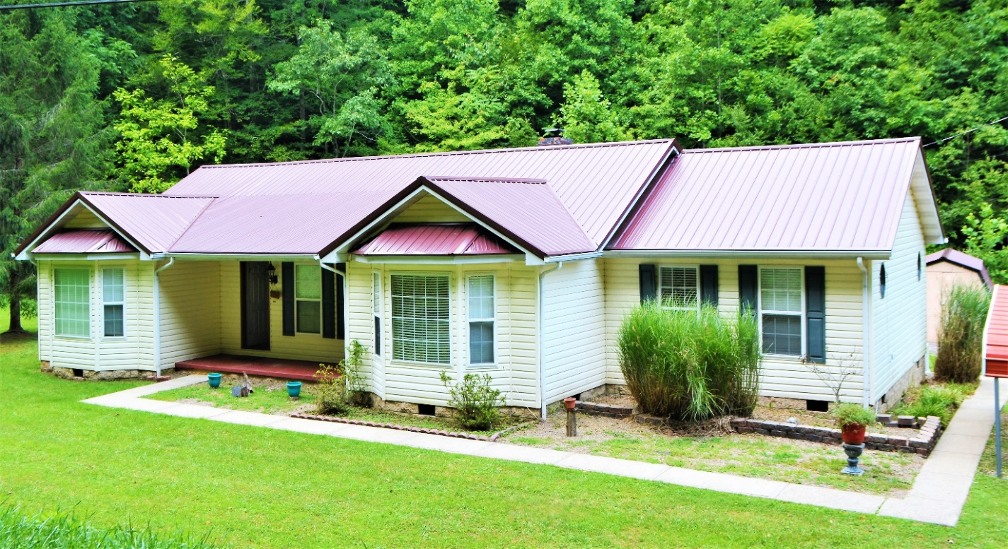

*Auctioneer: Stacy L. Cooper #1517 Auctioneer/Agent: Roger Mullins #1703*

*www.MOUNTAINEERAUCTIONS.com*

or [www.auctionzip.com](http://www.auctionzip.com) ID #4152 for terms & photos

BEDROOMS: **3**

BATHS: **2**

SQ. FEET: **Approx. 2,080 sq. ft.**

COUNTY: **Boone**

TYPE: **Ranch**

YEAR BUILT: **1994**

CONSTRUCTION: **Frame**

ROOF: **Metal (approx. 5 years old)**

HEAT: **Electric Heat pump**

WATER: **City**

WALLS: **Sheetrock**

WINDOWS: **Vinyl**

FLOORS: **Carpet, floating, & tile**

A/C: **Central forced air**

SEWER: **Septic**

LOT: **223x112x225x130',Sf.; Turtle Creek, Washington District – Boone County Wv**

ADDITIONAL: **Over ½ acre level lot – Whole house generator – Brick Fireplace with insert - Rear deck - Storage shed - Above ground pool**