***Real Estate Auction***

Court Ordered Guardianship Auction

**Monday, May 13th, 2019 @ 6:00pm**

**5257 Midland Drive, Charleston, WV 25306**

**Directions: I64/I77 South to Rt. 60 Midland Trail Exit to Malden/Rand Exit.**

**Left at Stop sign 1.2 miles to 5257 Midland Drive. Property located on left. Signs posted.**

**\*\*\* PROPERTY VIEWING SUNDAY 2-4PM \*\*\***

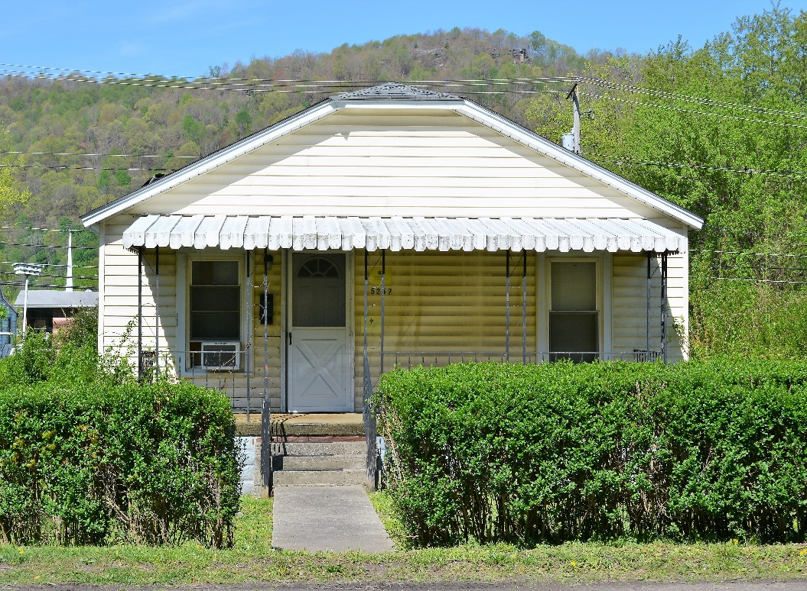

*Auctioneer: Stacy L. Cooper #1517 Auctioneer/Agent: Roger Mullins #1703*

*www.MOUNTAINEERAUCTIONS.com*

or [www.auctionzip.com](http://www.auctionzip.com) ID #4152 or #4158 for terms & photos

BEDROOMS: **2**

BATHS: **1**

SQ. FEET: **Approx. 800 sq ft. main level**

COUNTY: **Kanawha**

TYPE: **Single level**

YEAR BUILT: **Approx. 1926**

CONSTRUCTION: **Wood w/vinyl siding**

ROOF: **Asphalt shingle**

HEAT: **Gas heater**

WATER: **City**

WALLS: **Paneling**

WINDOWS: **Vinyl replacement**

FLOORS: **Carpet, Linoleum**

A/C: **Window unit**

SEWER: **Public**

LOT: **LTS 15 BK Q LEVI  
Malden District-Kanawha County WV**

ADDITIONAL: **Updated vinyl siding & windows – Flat level lot – road frontage**