LARGE PUBLIC AUCTION
SATURDAY, NOVEMBER 3RD, 2018
RUNNING TWO RINGS- STARTING AT 9:00
Lunch by: Relish the Dog 9:00 A.M. Comfort Station Available
LOCATION: Boone Co. Fairgrounds 8847 IL. Rt. 76, 1 Mi. North of Belvidere. Located in the goat barn near south end. Plenty of Parking. Dress Accordingly!
GUNS, COLLECTIBLE TOY TRACTORS, ANTIQUES, COLLECTIBLES, HOUSEHOLD, YARD, 3 PT. SNOWBLOWER, MOTORCYCLE, TOOLS & MISC.
SALE IS STARTING WITH TOYS PROMPTLY AT 9:00 A.M.
MOTORCYCLE & 3 PT SNOWBLOWER AT 11:00 SHARP FOLLOWED BY GUNS!!
GUNS: Remington 22 pump rifle w/scope; Remington Nylon 66 semi-auto 22 rifle; Cruso SS 22 rifle; Italian Carcano 1938 Model 38 7.35 cal. Rifle; Cg-Haenel Model 09, 1914 rifle; Waffenfabrik Bern M.81; Springfield Armory Model 1884 4570 cal. Trapdoor carbine; Hex barrel rifle; Badger Gun Co. Shotgun. TO BE SOLD RIGHT AFTER MOTORCYCLE & SNOW BLOWER AT 11:00
TOY TRACTORS & OTHERS: International Harvester Display Case; J.D. tractor seat; At least 45 pieces of J.D. tractors-Precision Series A & B, 50th Ann. 12A combine 1940; J.D. plow; Massey Harris; Farmall- (2) F20 Precision Series, Samuelson Family F20-Signed by Orion (in box); Oliver Super 77 precision & others; Case; Fords (lots of Ertl’s); Graham-Bradley 1937 & 38; Massy Ferguson; MM; International 1993 Cockshutt; J.D. 97 Car; Water Boy; Kenworth cattle semi; Tonka car hauler; Annie Limousine; General Lee car; Elvis car; Farmall & JD signs; (2) Jim Beam cars & much more!
MOTORCYCLE: 1974 Yamaha, no title (parts only but does run)
ANTIQUES: Oak ice box; Duncan Phyfe D.R. set w/4 chairs & buffet; Queen size bed frame & dresser; buffet; Very nice set of Community flatware; silver candleholders; Noritake china (Mayfair pattern); pink depression pitcher & glasses; Carnival glass pieces; stacking (Lawyers) Barrister bookcase; Farmers Bank from Veroqua, Wi.; wood pulleys; primitive tools; small settee; Barbie & Ken doll case & Vintage Barbies; barn lanterns; oil lamps; Lots of Coca Cola collectibles incl. Christmas dishes & umbrella; cistern pump; cash register- National Cash Register Co.; Schwinn men’s bike; wooden high chair; end table; kids rocking horse; vintage oil cans; porcelain pots; paper maps; ukulele; steel toy phones; one cent peanut vendor machine & other; doll furniture; Lighted Pepsi sign; Dickens Christmas Village Houses w/boxes; rocking chair; walnut table; golf clubs; white wicker planter stand; collector plates; (3) butter churns; St. Nicholas Square villages & more; Lg. hat collection; baseball gloves; cream separator; Vintage clothing; kids card table & chairs; ox yoke; hand planter ; Clarinet; Records & much more!
HOUSEHOLD & MISC: Very nice love seat & ottoman; small oak linen cabinet; coffee table; walnut adjustable shelves; area rugs; lg. braided rug; Bernina sewing machine; fans in boxes; linens; lots of assorted glassware; lg. punch bowl & cups; Lots of Holiday decorations; Primetime Ent. table; Lots of small kitchen appliances; Pyrex; Corning Ware; Kirby vacuum; Robot vacuum; Electrolux w/attachments; lighted corner hutch; Laz-Z-Boy sleeper sofa; (2) small lighted curio cabinets; lamps; full size bed frame, dresser w/mirror; queen size frame, headboard, chest of drawers & (2) nightstands; sofa table; dresser w/mirror; night stand; M.W. sewing machine; cups & saucers; 2-drawer file cabinet on wheels; tablecloths & runners; plant holder; books; quilt rack; Costume & other jewelry barrel keg ice cream maker & Lots more!
YARD & TOOLS: Woods (almost new) SB54S, 3 pt. snow blower, 540 PTO, Category 2; Honda snowblower; Craftsman edger; tool cart; Craftsman 220 volt air compressor; yard fountain; Troy-Bilt 5550 generator engine; Karche 1400 PSI Elect. pressure washer; Craftsman 5/22 snow thrower; 2 wheel cart; Craftsman work bench on wheels; Craftsmann tool chest; hand crafted wishing well (great for Christmas gift); Lots of animal cut outs & patterns-fences w/animals etc; hand crafted benches; metal trellis; metal work bench; storage rack ; fishing poles, reels & lures; shop vacs; exercise equipt. & much more!
Owners: J. Kruse, M. Dunn, J. Anderson, G. West, T. Walling, L. Mohr, C. Baenziger & D. Turner
TERMS: Cash or checks with proper I.D. Visa, Mastercard & Discover accepted. 9% Buyer’s premium with 4% discount for cash or check. No property to be removed until settled for. All items sold “AS IS”. Number system will be used. Must have driver’s license or ID for registration. Lee Auction Service is NOT responsible for accidents or merchandise after purchase. Announcements day of sale prevail over written material.
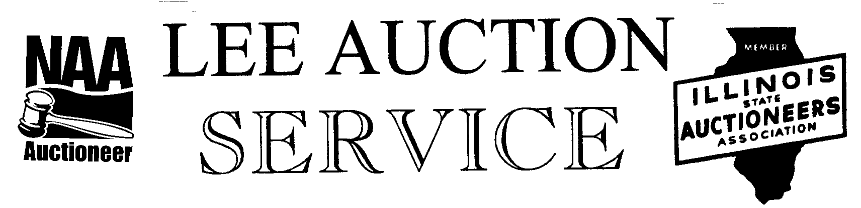
Belvidere, IL 61008
815-988-0249 cell
AUCTIONEER: LYLE LEE IL. State License #440.000200/ WI # 2863-52 & TROY RUDY
CLERKS & CASHIERS: LEE AUCTION SERVICE
Visit our web site at www.leeauctionservice.com

