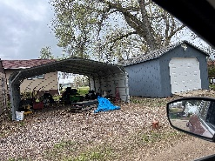
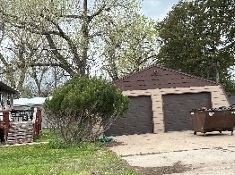
LIVE & ONLINE REAL ESTATE AUCTION
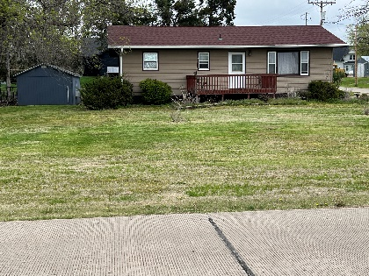
SUNDAY JULY 21, 2024 @ 2:00 PM
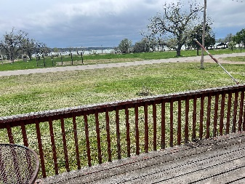
DIRECTIONS: OACOMA SD: 200 WEST MAIN STREET-WATCH FOR FLAGS AND SIGNS
CHECK OUT THE PICTURES AND ONLINE BIDDING AT www.luckettauctions.com
NO BUYERS PREMIUM ON THIS REAL ESTATE.

REAL ESTATE:
A BEAUTIFUL HOUSE WITH A BEAUTIFUL VIEW OF THE MISSIOURI RIVER. THIS 2 BEDROOM, FULL BATHROOM, LIVING ROOM, KITCHEN & LAUDRY ROOM ON MAIN FLOOR. FULL BASEMENT WITH LOTS OF STORAGE. ELECTRIC CENTRAL FURANCE AND AIR CONDITIONER, MARATHON WATER HEATER, WATER SOFTNER, AND FULL BATHROOM. DECK ON FRONT AND BACK OF HOUSE. NICE HUGE CORNER LOT. LOT SIZE 25’X134’ ACCORDING DEPARTMENT OF EQUALIZATION.
A DOUBLE GARAGE 24’X24’ ONESIDE IS FINISHED WITH HEAT AND AIR. ELECTRIC GARAGE DOORS, CONCETE DRIVEWAY TO STREET, PORTABLE CANOPY W/ ELECTRIC 18’X 21’, 14’X24’ SHED W/ELECTRIC GARAGE DOOR, RAMP, SPRAY FOAMED, HEAT AND AIR
LEGALS: LEGAL DESCRIPTION-OACOMA TOWN GLADSTONE ADDITION BLOCK 14 LOTS 11, 12, 13 & 14. PHYSICAL ADDRESS: 200 WEST MAIN STREET. THE TAXES WILL BE BASED ON $2045.37 PER YEAR AND WILL BE PRORATED ON THAT AMOUNT TO THE DAY OF THE AUCTION. SELLER HAS THE RIGHT TO REJECT ALL BIDS.
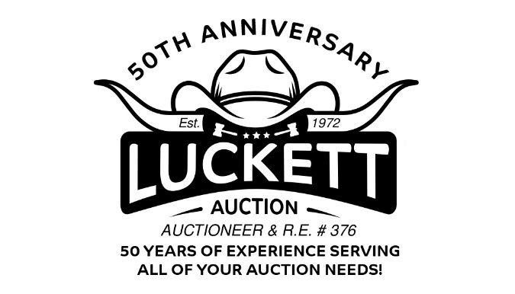
CLOSING/DOWN PAYMENT: CLOSING COST WILL BE SPLIT 50/50 BETWEEN THE BUYER AND SELLER. CLOSING WILL BE DONE BY JERAULD COUNTY TITLE COMPANY IN WESSINGTON SPRINGS. DOWNPAYMENT DAY OF THE AUCTION WILL BE $15, 000.00 AND BALANCE DUE IN APPROX 45 DAYS AT THE TIME OF CLOSING. DOWN PAYMENT WILL BE HELD IN TRUST BY JERAULD COUNTY TITLE COMPANY 605-539-1541.
OPEN HOUSE FOR VIEWING WILL BE HELD JULY 12, 2024 FROM 9:00 AM TIL 5:00 PM
VERNON COOK ESTATE, OWNER
MORE INFO CALL VAL LUCKETT R.E.#376, 605-770-2991

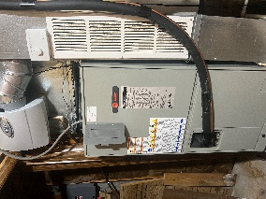
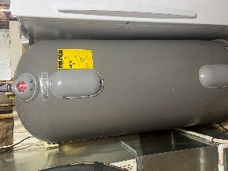
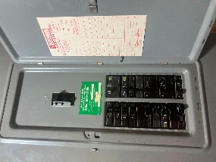
AUCTIONEERS:
VAL LUCKETT R.E. #376-605-770-2991
DAN CLARK R.E.#13615-605-842-6075
DON’T MISS THIS GREAT OPPORTUNITY TO PURCHASE A PLACE WITH RIVER FRONT VIEW.

